BECKY HILL ANNOUNCES RELEASE DATE, TITLE & TRACKLISTING FOR DEBUT STUDIO ALBUM TODAY

BECKY HILL’S ONLY HONEST ON THE WEEKEND WILL BE RELEASED ON 20TH AUGUST 2021

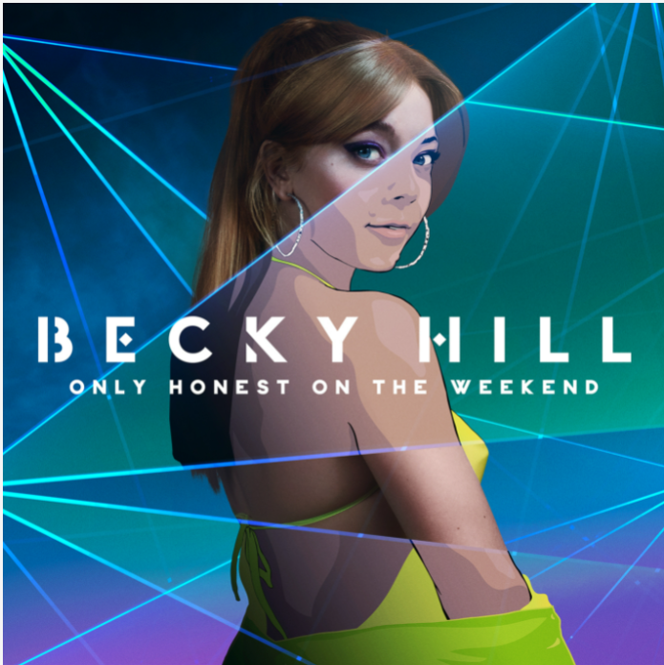​

WATCH/SHARE THE TRAILER FOR ONLY HONEST ON THE WEEKEND HERE

PRE-ORDER BECKY HILL’S ONLY HONEST ON THE WEEKEND HERE

“From the second I saw Becky and her talent about 10 years ago, I always knew her to be an exceptional talent. It’s been beautiful to see her and her taste grow. She’s an unashamed pop fan now but is also a fan of dance music, and the fact that she finally found a way of blending the two to make her own undeniable sound. It’s also been amazing to see her grow as a songwriter. We’ve written many songs together, and I must say, beyond her incredible vocal, she has a pen that will put many to shame.” – MNEK

“One of the very rare queens of dance of music.” – David Guetta

“Statistically, she’s one of the most successful artists we've ever produced and that is testament to her sheer talent. Her ability to draw for big, universally relatable hooks and her unmistakeable powerful vocals are why I refer to her only as Queen Becky Hill” - Mista Jam

“Becky Hill is the full package - a brilliant writer and soulful singer. I love her passion for, and knowledge of dance music which also sets her apart from her pop contemporaries - she has collaborated with the biggest and best names in the game, and released anthem after anthem. - Sister Bliss

“I personally feel like Becky’s voice is the one of the best in the industry right now. Becky’s writing and voice fits perfectly in today’s dance music, and she’s gonna be hard to copy which is going to keep her unique for years “ - MK

“Becky is one of the few artists who is loved by the underground scene as much as she is the mainstream. - DJ Zinc

“Becky’s catalogue of undeniable hits has cemented her reputation as one of Britain’s most influential artists in the world of Dance.” – Sigala

“There is no voice on earth quite like Becky's… so it's no surprise she has left such an impressive and inspirational mark on the history of dance music." - Matoma

15th July 2021, London UK: Today show-stopping vocalist, hitmaking songwriter and dance music trailblazer Becky Hill announces that her debut studio album Only Honest On The Weekend will be released on 20th August 2021 via Eko Records/ Polydor. The announcement comes hot on the heels of Spotify UK revealing Becky as their July artist for EQUAL, their programme to promote parity within the music industry.

“I’ve been waiting nearly 10 years to be able to say this! Finally, I get to introduce you to my album, my first complete body of work that I’m so in love with, proud of and excited to be putting out. With everything I’ve learnt in the music industry and in life, Only Honest On The Weekend reflects all that hard work, graft and growth. Ii feel so relieved, grateful and proud of myself, my team and my label for getting to this point. Here’s to many more albums and loads more success!” – Becky Hill

Becky Hill’s Only Honest On The Weekend will feature guest appearances from 220 Kid, Banx & Ranx, David Guetta, Shift K3Y, S1mba, Sigala and Topic. Becky has written or co-written every track on the album and enlisted the production skills of a broad and eclectic range of producers from Lost Boy and Billen Ted to MK, MJ Cole and MNEK.

The fifteen strong tracklisting of Only Honest On The Weekend (listed in full below), will encompass Becky’s string of hits released throughout 2020 and 2021, including: the recently released “Remember”, Becky’s highest charting lead solo record to date, “Better Off Without You” ft. Shift K3Y, (which is Certified Platinum after accumulating over 600,000 sales), “Heaven On My Mind”, (which has accumulated over 133 Million streams globally, and is now Certified Gold), and her Spring ‘21 Top 40 hit, “Last Time”. Becky Hill’s debut studio album, Only Only Honest On The Weekend will follow her long player Get To Know, the 2019 released 13 track collection of singles she either released herself or wrote and guest performed on. Get To Know is now certified Gold after being confirmed by Official Charts UK as one of the three biggest selling albums by a British female artist or act in 2020 and peaking at no.16 on the Billboard Dance/Electronic Albums Chart in the US.

In addition to the release of Only Honest On The Weekend, the summer will see Becky perform a string of festival dates (including a headline slot at Camp Bestival, Reading & Leeds Festival, TRNSMT and Isle of Wight Festival), ahead of embarking on her UK & Ireland headline tour in the Autumn. See below for details of all dates/shows. Tickets for Becky’s headline tour are available to purchase here.

With an irrefutable aptitude for writing chart smashing pop songs and a reputation as a pioneer in the electronic music scene, Becky Hill is one of Britain’s most in-demand musical exports of the moment. She has over 180 songs registered with ASCAP - no mean feat considering only 17% of PRS for Music's registered songwriters are female - and an impressive string of hits to her name. Having written and performed on thirteen singles which charted in the top 40 of the UK Official Singles Chart, (including two top 10 singles, one number 1 and nine platinum records), Becky has now amassed over 2 billion streams on Spotify alone, and 1 billion streams in the UK. She has over 17 million monthly listeners on Spotify after being crowned the 2nd most-streamed British Female Solo Artist on Spotify UK in both 2019 and 2020.

ONLY HONEST ON THE WEEKEND TRACKLISTING

1. I Got You
2. Last Time
3. Make It Hard To Love You
4. Better Off Without You (ft. Shift K3Y)
5. Remember (&David Guetta)
6. Perfect People
7. My Heart Goes (La Di Da) (ft. Topic)
8. Could Be My Somebody (ft. S1mba)
9. Business (ft. Ella Eyre)
10. Waiting Not Looking
11. Distance
12. Lessons (ft. Banx & Ranx)
13. Heaven On My Mind (with Sigala)
14. Is Anybody There
15. Through The Night (ft. 220 Kid)

BECKY HILL FESTIVAL DATES SUMMER 2021
Sun 18 July - British Grand Prix, Silverstone
Fri 30 July - Camp Bestival (Headlining), Dorset
Thu 5 August - Times Square, Newcastle
Sat 14 August - Boardmasters, Newquay
Sun 15 August - Depot in the Park, Swansea
Sat 28 August - Reading Festival, Reading
Sun 29 August - Leeds Festival, Leeds
Fri 3 September - Highest Point Festival, Lancaster
Sat 4 September - Mighty Hoopla, London
Sat 4 September - Sundown Festival, Norwich
Sat 11 September - TRNSMT, Glasgow
Sun 12 September - Parklife, Manchester
Fri 17 September - Isle Of Wight Festival, IOW
Fri 24 September - Nass Festival, Shepton Mallet

BECKY HILL AUTUMN 2021 UK & IRELAND HEADLINE TOUR DATES
Wed 29 September - Engine Shed, Lincoln
Fri 1 October - o2 Victoria Warehouse, Manchester ***sold out***
Sat 2 October - o2 Academy, Leeds ***sold out***
Sun 3 October - o2 Academy, Glasgow ***sold out***
Tue 5 October -o2 Academy, Newcastle ***sold out***
Wed 6 October - o2 Academy, Sheffield ***sold out***
Tue 7 October - Rock City, Nottingham ***sold out***
Sat 9 October - o2 Academy, Liverpool ***sold out***
Mon 11 October - Dome, Brighton
Tue 12 October - o2 Academy, Oxford ***sold out***
Wed 13 October - o2 Academy Brixton, London
Fri 15 October - UEA, Norwich ***sold out***
Sat 16 October - o2 Academy, Birmingham ***sold out***
Sun 17 October - Great Hall, Cardiff ***sold out***
Tue 19 October - o2 Academy, Bristol ***sold out***
Wed 20 October - o2 Academy, Bournemouth ***sold out***
Thu 21 October - Pavilions, Plymouth​
Thu 18 November – Olympia Theatre, Dublin ***sold out***

BECKY HILL’S ONLY HONEST ON THE WEEKEND, RELEASED VIA EKO RECORDS/ POLYDOR, IS AVAILABLE TO PRE-ORDER NOW
https://BeckyHill.lnk.to/OnlyHonestOnTheWeekend

WATCH/ SHARE THE TRAILER FOR BECKY HILL’S ONLY HONEST ON THE WEEKEND HERE
https://BeckyHill.lnk.to/AlbumTrailer

DOWNLOAD ARTWORK & PRESS SHOTS HERE
ARTWORK
PRESS SHOTS

Follow Becky Hill here:
INSTAGRAM
TWITTER
FACEBOOK

For more information please contact warren@chuffmedia.com on 07762 130510

