GRAMMY NOMINATED SINGER AND SONGWRITER JULIA MICHAELS REVEALS NEW DETAILS FOR HIGHLY ANTICIPATED DEBUT ALBUM

NOT IN CHRONOLOGICAL ORDER ARRIVING APRIL 30

NEW SONG “LOVE IS WEIRD” DROPS WITH ALBUM PRE-ORDER LAUNCH TODAY

COVERS EUPHORIA MAGAZINE

LISTEN TO “LOVE IS WEIRD” HERE
WATCH “LOVE IS WEIRD” LYRIC VIDEO HERE
PRE-ORDER NOT IN CHRONOLOGICAL ORDER HERE

“The way that I saw the track listing in my head, a lot of the heartbreak came in the middle, and finding new love came at the end. That's the arc of this album: I'm not bitter about love anymore. I know what functional love is like and being in love and being hesitant about that love because it feels so perfect.”

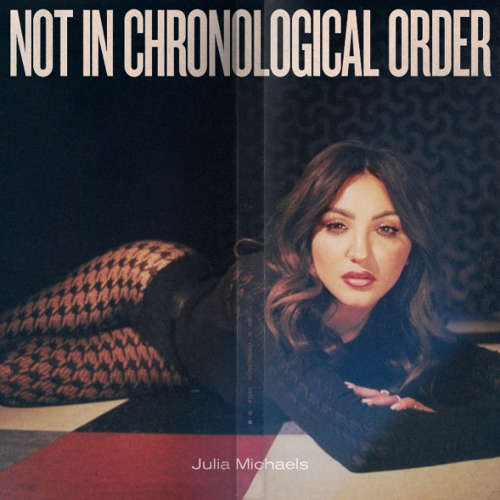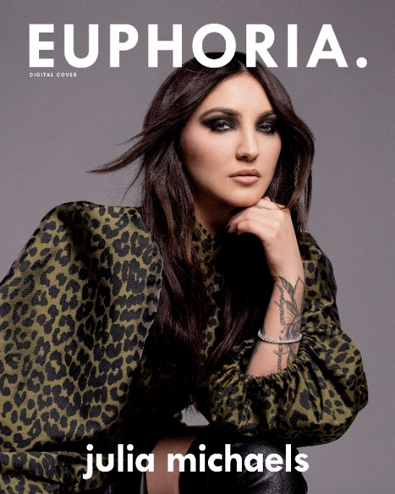

Watch the video for Julia Michaels’ new single “ALL YOUR EXES” HERE
Download Press Materials HERE
Download social assets HERE

Today, Grammy® Award-nominated multiplatinum singer and songwriter JULIA MICHAELS reveals the title and track listing to her long-awaited debut album, Not In Chronological Order, which arrives April 30th. To accompany the announce, she shared a new song from the album, “Love Is Weird,” with the launch of the album pre-order via Polydor Records.

Listen to “Love Is Weird”—HERE.
Pre-order Not In Chronological Order — HERE

In support of the release, JULIA spoke with Zane Lowe on Apple Music 1 Radio’s New Music Daily Show.

Offering another glimpse into what fans can expect from the upcoming album, “Love Is Weird,” weaves together airy production and soft acoustic guitar, while she delicately likens relationships to “Playing Operation trying to put me back together,” before candidly admitting, “Love is weird. Don’t know how I wound up here…It shows up and disappears.” This honest and hypnotic melody highlights her uncanny ability to tune into raw emotion and unfiltered lyricism, with her signature vocal tone and delivery.

The new song sets the stage for the release of her anxiously awaited full-length debut album, Not In Chronological Order, out on April 30, 2021. Presenting a full 360-degree perspective on the critically acclaimed songstress, it examines every facet of her life emotionally and spiritually in a 10-song body of work that finds Julia piecing together the chapters of her life in one place work – pre-order Not In Chronological Order HERE.

“When I was looking at the tracklisting, it literally was not in chronological order of the events that it took place in my life,” she says. “The way that I saw the tracklisting in my head, a lot of the heartbreak came in the middle, and finding new love came at the end. That's the arc of this album: I'm not bitter about love anymore. I know what functional love is like and being in love and being hesitant about that love because it feels so perfect.”

JULIA’S current single “All Your Exes” arrived to critical acclaim upon its release. Co-written with Grammy nominated singer and songwriter JP Saxe, “All Your Exes,” Entertainment Weekly hailed it “a deliciously wicked delight,” with The New York Times praising it as “harsh, funny, sad and relatably petty.” FLOOD Magazine called it “a prime example of a vulnerable pop-punk banger,” while Billboard noted “Michaels has a tendency to throttle her listeners with her pen -- and on the muscular, virtuosic “All Your Exes,” she makes sure that your attention is focused entirely on her seething jealousy.” Meanwhile, V Magazine summarized, “There’s something to ditching fairytale notions of love that Julia Michaels fully gets as she returns to the front of the stage once again.”

JULIA currently features on the cover of Euphoria Magazine where she talks more about the album HERE.

Watch the video for the new single “ALL YOUR EXES” HERE

Get ready to experience Julia Michaels Not In Chronological Order…

Not In Chronological Order Tracklist:
- All Your Exes
- Love Is Weird
- Pessimist
- Little Did I Know
- Orange Magic
- Lie Like This
- Wrap Around
- History
- Undertone
- That’s The Kind Of Woman

ABOUT JULIA MICHAELS
Over the past few years, no songwriter has had more of an impact on reshaping pop music than Grammy nominated and multi-platinum selling artist Julia Michaels, whose razor-sharp perspective on love, loss, and the wide spectrum of the human experience has deservedly catapulted her to the forefront of her industry. Lauded for her work on hit singles by artists like Justin Bieber, Selena Gomez, Niall Horan, Dua Lipa, Janelle Monáe, Shawn Mendes, P!NK, Ed Sheeran, Britney Spears, Gwen Stefani, Hailee Steinfeld, The Chicks, Keith Urban, Jessie Ware, and more, Julia has spent the last decade honing her craft and delivering fans some of the most evocative music of a generation.

In 2017, Julia embarked on a solo career separate from her work synthesizing the stories of the stars around her with “Issues,” her 5x-platinum selling debut single. A year later, her peers recognized her stunning work with Grammy nominations for “Best New Artist” and “Song of the Year.” Committing to her solo work, Julia released a series of critically acclaimed EPs, including 2017’s fan-favorite Nervous System and 2019’s critically acclaimed Inner Monologue Part 1 and Inner Monologue Part 2. She also embarked on The Inner Monologue Tour, which marked her first-ever headline tour throughout the U.S. following an enviable run touring the world with an incredible array of artists including Maroon 5, Keith Urban, Shawn Mendes, Niall Horan, and P!NK.

In 2020, she received her third Grammy nomination, and second in the prestigious “Song Of The Year” category, for her collaboration with JP Saxe on “If The World Was Ending,” in addition to earning her second #1 as a songwriter on the Billboard Hot 100 for Selena Gomez’ “Lose You To Love Me.”

SOCIALS: OFFICIAL // FACEBOOK // TWITTER // INSTAGRAM

For more information and press enquiries please contact

Jenny Entwistle
Jenny@chuffmedia.com

