IMAGINE DRAGONS DEBUT NEW SINGLE “WRECKED”
LISTEN HERE

ANNOUNCE FIFTH STUDIO ALBUM MERCURY - ACT 1
SET FOR RELEASE SEPTEMBER 3, 2021

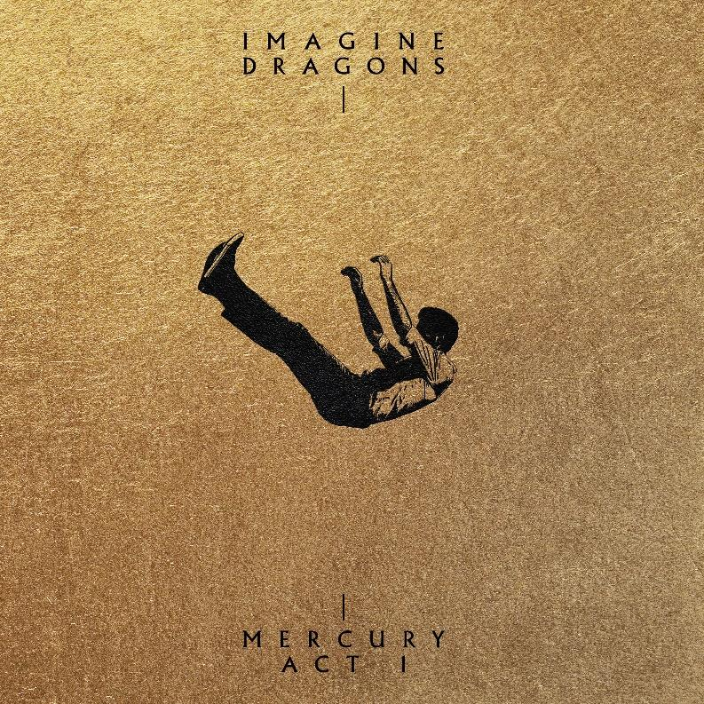
DOWNLOAD MERCURY: ACT 1” COVER ART HERE
DOWNLOAD IMAGINE DRAGONS PRESS PHOTO HERE

July 2, 2021 - GRAMMY®-winning, multi-Platinum band Imagine Dragons unveil their new single “Wrecked,” released today via KIDinaKORNER/Interscope – listen HERE. Additionally, the band announced the arrival of their forthcoming fifth studio album, Mercury - Act 1, set for release on September 3, 2021. Imagine Dragons teamed up with esteemed producer Rick Rubin to create Mercury - Act 1, a candid album that abandons metaphorically charged lyrics and instead embraces emotional extremities, holding nothing back. The title draws inspiration from the word “mercurial.” Mercury - Act 1 is available for preorder now HERE. The pre-order launch includes multiple album configurations including CD, deluxe CD “book”, CD box set, multiple vinyl configurations, cassette, exclusive CD and vinyl with alt cover and poster for Target (US) and merch items unique to the album cover art and album package.

“Wrecked” was written by lead vocalist Dan Reynolds, Wayne Sermon, Ben McKee & Daniel Platzman and produced by Imagine Dragons. “Wrecked” was mixed in Spatial Audio and is accompanied by a new lyric video – watch HERE.

The song is a powerful and raw outpouring about grief, loss, and moving forward. Reynolds started writing the song shortly after losing his sister-in-law, Alisha Durtschi Reynolds, to cancer.
“She was the brightest light. A beacon of joy and strength for everyone she met. Her sudden passing has shaken me in ways that I still am unable to express. I was with her and my brother when she passed, and it was the first time in my life that I had witnessed death in this way. It sealed into my mind the fragility of life and finality of this all. I’ve watched my brother face something that no one should have to. But I’ve also seen his faith bring him hope in a future with her. I can only hope for the same,” Reynolds says. “This song was my way of dealing with it all, as music has always been my refuge. No longer being a man of fervent faith, I can only hope that she hears it somewhere in a place where she is healed and no longer in pain. This song is my wish for an eternity with those that I love.”
The emotional intimacy of “Wrecked” continues to provide a glimpse into what fans can expect from Mercury - Act 1, the band’s first new music since their 2018 album Origins. Billboard revered that the recent releases of “Follow You” and “Cutthroat” marked the band’s return “with soaring ambition intact.” On launch day, both singles will be available in Spatial Audio.
“Follow You,” released March 12, reached No. 1 on both Mediabase’s Alternative Radio chart and Billboard’s Alternative Airplay chart. It marked the band’s quickest ascent to the top of the Billboard chart, surpassing the seven-week climb for “Natural” in 2018 and eight-week climb for “Believer” in 2017. “Follow You” is a love song written by vocalist Dan Reynolds upon re-marrying his wife after the couple had separated. “I wanted [the song] to represent a love that is realistic. One where love isn’t perfect, but it endures,” Reynolds said. The single’s accompanying music video, featuring Rob McElhenney & Kaitlin Olson of It’s Always Sunny In Philadelphia, offered a cheeky visual companion piece to fans and caught the attention of press. The video has amassed over 30 million views to date – watch HERE.
“Cutthroat” was released in conjunction with “Follow You” and “invites head-banging in line with its jittery, pseudo-industrial stomp,” Billboard wrote after its release. The gritty, cinematic video for “Cutthroat” stars Olivia Munn growing increasingly agitated at the DMV and visually depicts the song’s frenetic energy – watch HERE.
About Imagine Dragons
With 40 million albums and 50 million songs sold globally, as well as 60 billion combined streams, Imagine Dragons were the best-selling rock band of the 2010s, even as they were busy reinventing the genre. Billboard’s Top 3 rock songs of the decade belonged to the band – “Believer,” “Thunder” and “Radioactive.” Formed in 2009, Imagine Dragons developed a grassroots following with a series of independently released EPs before making their major label debut on KIDinaKORNER/Interscope with the 2012 EP Continued Silence. Night Visions, their 2012 full-length debut, entered the Billboard 200 at No. 2 and the lead-off track “Radioactive” topped Billboard’s Hot Rock Songs chart, won a GRAMMY for Best Rock Performance, and achieved RIAA Diamond status. 2015’s Smoke + Mirrors debuted at No. 1 on the Billboard 200. EVOLVE, which followed in 2017, earned a GRAMMY nomination for Best Pop Vocal Album and unleashed three No. 1 Alternative radio hits: “Believer,” the GRAMMY-nominated “Thunder” and “Whatever It Takes.” All three songs were also top 5 hits at Top 40 radio, with “Thunder” rising to the No. 1 spot. The band’s fourth album, ORIGINS, debuted atop Billboard’s Alternative Albums and Top Rock Albums charts and lead single "Natural" spent nine weeks at No. 1 at alternative radio and set the current record for all-time “most spins in a week” at the format.

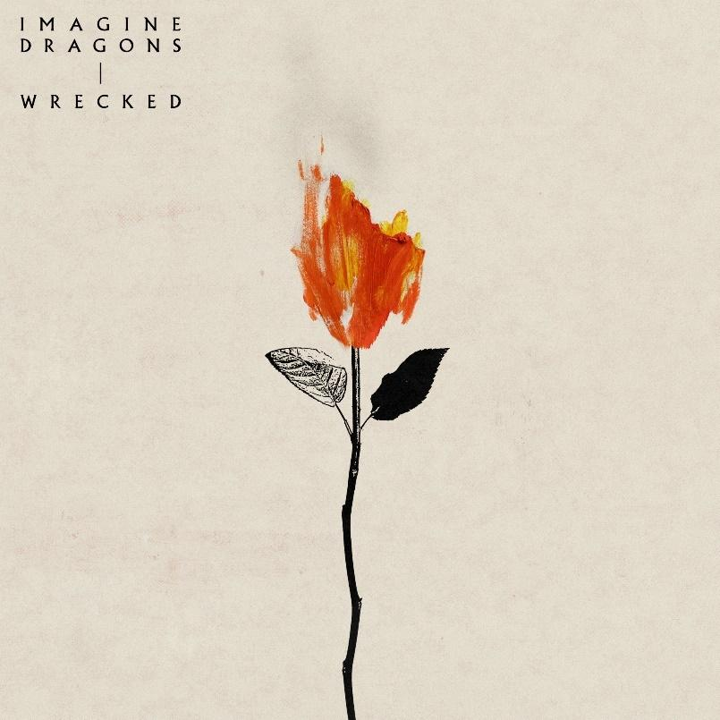
DOWNLOAD “WRECKED” COVER ART HERE

Imagine Dragons Mercury – Act 1 eAlbum Pre-Order
Retail: https://ImagineDragons.lnk.to/Mercury
Amazon Unlimited: https://ImagineDragons.lnk.to/Mercury/amazonmusic
Apple Music: https://ImagineDragons.lnk.to/Mercury/applemusic
iTunes: https://ImagineDragons.lnk.to/Mercury/itunes
Spotify: https://ImagineDragons.lnk.to/Mercury/spotify

For more information and press enquiries please contact
Jenny Entwistle
Jenny@chuffmedia.com

