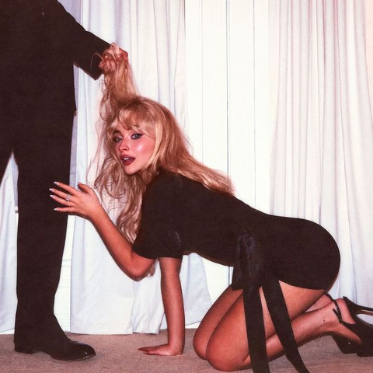

**TWO-TIME GRAMMY® AWARD WINNING GLOBAL SUPERSTAR SABRINA CARPENTER ANNOUNCES NEW ALBUM**

***MAN’S BEST FRIEND* COMING AUGUST 29th**

**LEAD SINGLE ‘MANCHILD’ OUT NOW, BST HYDE PARK HEADLINE SHOWS JULY 5th & 6th**

**PRE-ORDER** [**HERE**](https://sabrinacarpenter.lnk.to/MansBestFriend)

**WATCH THE VIDEO FOR ‘MANCHILD’** [**HERE**](https://www.youtube.com/watch?v=aSugSGCC12I)

**LISTEN** [**HERE**](https://sabrinacarpenter.lnk.to/Manchild)**PHOTO/ARTWORK** [**HERE**](https://umusic.box.com/s/67ork1vmplumrtayrdvsz2d1r34r8je6)

Today, two-time GRAMMY® Award-winning record-breaking global superstar Sabrina Carpenter announces her new album, *Man’s Best Friend,* out August 29th.  Pre-order [here](https://sabrinacarpenter.lnk.to/MansBestFriend).

The album’s lead single, ‘Manchild’, which was written by Sabrina and her frequent collaborators Jack Antonoff and Amy Allen, was released last week to rave reviews and quickly ascended to number 1 on both the Spotify US and Spotify Global charts. The critically acclaimed music video quickly amassed more than 15 million views.

*Man’s Best Friend* is Sabrina’s seventh studio album and follows her monumental album, *Short n’ Sweet*. Released last August, *Short n’ Sweet* topped the charts worldwide and had one of the biggest global debuts of 2024. All three singles off the album, ‘Espresso’ (2.2 billion), ‘Please Please Please’ (1.4 billion), and ‘Taste’ (1 billion) entered the coveted Billions Club on Spotify. *Short n’ Sweet* sold 10 million albums globally.

*Short n’ Sweet* garnered Sabrina six GRAMMY® nods as a first-time GRAMMY® nominee and won two awards for her GRAMMY® debut. Sabrina took home the “Best Pop Vocal Album” award for *Short n’ Sweet* along with “Best Pop Solo Performance” for the album’s lead single, “Espresso.” Following the GRAMMYs, Sabrina released *Short n’ Sweet (Deluxe),* which featured five additional songs, including a duet with global icon Dolly Parton on ‘Please Please Please’ and ‘Busy Woman’, which Sabrina debuted live on her sold-out headlining arena tour.

Internationally, Sabrina shattered records by becoming the first female artist to hold the top three spots on the UK Singles Chart simultaneously with ‘Taste’, ‘Please Please Please’, and ‘Espresso’. She also set a new benchmark for most weeks at #1 in a single year by a female artist on the UK chart—totaling 21 weeks—and became the first international artist to receive the BRITs’ Global Success award.

This autumn, Sabrina will embark on the second sold-out North American leg of her highly praised Short n’ Sweet Tour. The tour kicks off on October 23rd in Pittsburgh and will stop at major arenas in New York, Nashville, Toronto, and Los Angeles. Sabrina will perform five nights at Madison Square Garden in New York and six nights at Crypto.com Arena in Los Angeles, where the tour will conclude on November 23rd. This second leg follows the massive success of the previous 33-date sold-out North American tour last November, as well as the sold-out European leg, which saw additional shows added in four cities due to overwhelming demand. She appeared on SNL earlier this year for their 50th anniversary special, where she sang ‘Homeward Bound’ with Paul Simon and starred in a remake of the fan favorite ‘Domingo’ sketch. Sabrina made her SNL debut as the musical guest for the season finale last May. She recently graced the cover of Vogue US for the first time - see the cover/read the feature [here](https://www.vogue.com/article/sabrina-carpenter-march-cover-2025-interview).

**ABOUT SABRINA CARPENTER**:

Two-time GRAMMY® award winner, Sabrina Carpenter, has enchanted an audience of millions as a singer, songwriter, actress, and style icon. With her music, she has delivered one anthem after another on stage and in the studio, earning multiple gold and multi-platinum certifications, and performing to sold-out crowds worldwide.  On-screen, she has generated mega-fandom through starring roles on television and film. She is signed to Island Records, where she debuted her acclaimed Gold-certified fifth studio album, *emails i can’t send*, which appeared on many “Best Of 2022” lists, including Rolling Stone and Billboard. The album features her hit single ‘Feather,’ which went #1 at Top 40 Radio, earning Sabrina her first #1. Her sold-out emails i can't send tour took her to North America, Europe, Asia and Brazil, and she served as direct support for Taylor Swift in Latin America, Australia, and Singapore on the Eras Tour. In April, Sabrina made her Coachella debut and was one of the most talked-about artists of the festival. Ahead of her Coachella debut, she released her single ‘Espresso,’ which quickly climbed the charts. Upon release, ***Pitchfork*** declared ‘Espresso’ as "in pole position to be this year’s song of the summer,” and ***The New York Times*** heralded the single as the song ready to “propel her to the next level”. Since its release, ‘Espresso’ has gone on to reach #1 on the UK & Australian singles charts, Top 5 in the US, and #1 on Spotify globally, where it reached over 200M streams within its first month. Her second single, ‘Please Please Please,’ was released in June and shot straight up to the top of the charts. The single hit #1 on Spotify’s Global and US charts, #1 on Apple Music, and debuted at #2  on the Billboard Hot 100 before claiming the #1 spot a week later and went #1 at US Pop Radio. Sabrina made her *Saturday Night Live* debut in May on the season finale where she performed ‘Espresso’ and ‘Feather/Nonsense’. In August, she released her highly anticipated sixth studio album, *Short n’ Sweet*. The album was instantly met with an outpouring of critical acclaim from the likes of the *New York Times, Rolling Stone, Pitchfork, Variety*, and many more. The album debuted at #1 on the Billboard 200, making it the 3rd biggest first week debut in the US in 2024, and became only the second album that year to spend its first three weeks atop the list. *Short n' Sweet* also topped the charts around the world, reaching #1 in UK, Canada, Australia, Spain, and France. The album earned Sabrina an impressive six GRAMMY® nominations as a first-time nominee. *Short n’ Sweet* took home the GRAMMY® Award for Best Pop Vocal Album and Sabrina also won the “Best Pop Solo Performance” GRAMMY® Award for the album’s lead single “Espresso.” She made her debut at the 67th GRAMMY® Awards with a captivating performance of “Espresso/Please Please Please.” Last Fall, Sabrina wrapped the 33 date North American leg of her monumental sold-out *Short n’ Sweet Tour* and recently wrapped the sold-out European leg. Later this year, Sabrina will return for a second North America leg that includes six shows at  Crypto.com Arena in Los Angeles and five shows at Madison Square Garden in New York.

**For more information and press enquiries please contact**

**Jenny Entwistle**

[**Jenny@chuffmedia.com**](mailto:Jenny@chuffmedia.com)