SAM FENDER ANNOUNCES “LIVE FROM FINSBURY PARK” ALBUM RELEASE

THE HUGE SUMMER LONDON SHOW WAS CAPTURED LIVE AND FINDS A DECEMBER RELEASE ON DOUBLE VINYL

FENDER TO HEADLINE NEWCASTLE’S ST. JAMES’ PARK ON 9TH JUNE 2023. TICKETS GO ON SALE FROM FRIDAY

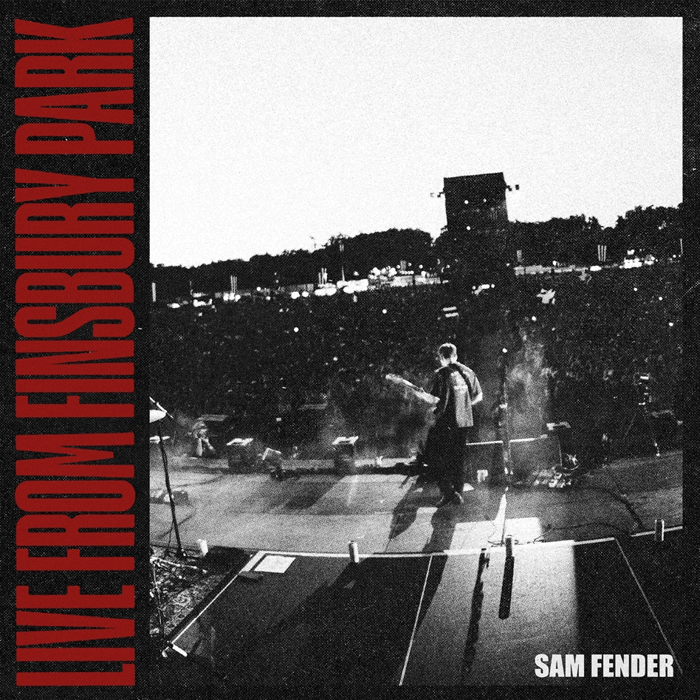

Sam Fender is very pleased to share details of a new live album for release in December, “Live From Finsbury Park”. The album captures Sam’s scintillating sell-out performance in front of 45,000 fans earlier this Summer in London. As Sam’s biggest headline show to date, and straight off the back of his show-stealing performance at Glastonbury Festival, the Finsbury Park show paid testament to an incredible twelve months for an artist whose rise has been meteoric.

The album will be released as a standalone double coloured vinyl on 9th December through Polydor Records. It will also then feature as a “Live Deluxe Edition” of Seventeen Going Under on double CD and include B-sides and the “Live From Finsbury Park” recordings.

Fans can pre-order the Finsbury Park vinyl or Live Deluxe Edition of Seventeen Going Under on CD HERE

Watch a live video of Sam performing Getting Started live from Finsbury Park In July

News of “Live From Finsbury Park” follows swiftly from the announcement last week that Sam will headline his first stadium show next year at Newcastle’s St. James’ Park on 9th June 2023. Tickets for the huge hometown show go on general sale from Friday at 10am via www.samfender.com/live – with Sam set to play to in excess of 55,000 fans.

It’s been a huge 2022 so far for the North Shields hero, picking up a slew of BRIT, NME, and Ivor Novello Awards, and a first nomination for the prestigious Mercury Prize this week, for his second album, the critically acclaimed number 1 album, Seventeen Going Under. Ahead of a series of shows alongside Florence & The Machine in the US, and his first Australian shows since 2019, Sam triumphantly caps another incredible twelve months.

Sam Fender Live 2022:

12th September – Capital One Arena, Washington DC (w/ Florence & The Machine)
14th September – TD Garden, Boston (w/ Florence & The Machine)
16th September – Madison Square Garden, New York (w/ Florence & The Machine)
18th September – Life Is Beautiful Festival, Las Vegas
22nd September – Wonder Ballroom, Portland SOLD OUT
24th September – The Showbox, Seattle SOLD OUT
25th September – The Commodore Ballroom, Vancouver SOLD OUT
18th November – Palace Foreshore, Melbourne SOLD OUT
22nd November – Enmore Theatre, Sydney SOLD OUT
22nd November – Harvest Rock Festival, Adelaide
24th November – Fortitude Music Hall, Brisbane SOLD OUT
26th November – Hordern Pavilion, Sydney *New Date*

2023:

9th June – St. James’ Park, Newcastle *New Date*

For more information & enquiries please contact jenny@chuffmedia.com

