ART SCHOOL GIRLFRIEND ANNOUNCES THIRD STUDIO ALBUM ‘LEAN IN’ DUE MARCH 11th VIA FICTION RECORDS | PRE-ORDER HERE

SHARES NEW TRACK ‘THE PEAKS’ | LISTEN HERE

ANNOUNCES UK HEADLINE TOUR | BUY TICKETS HERE

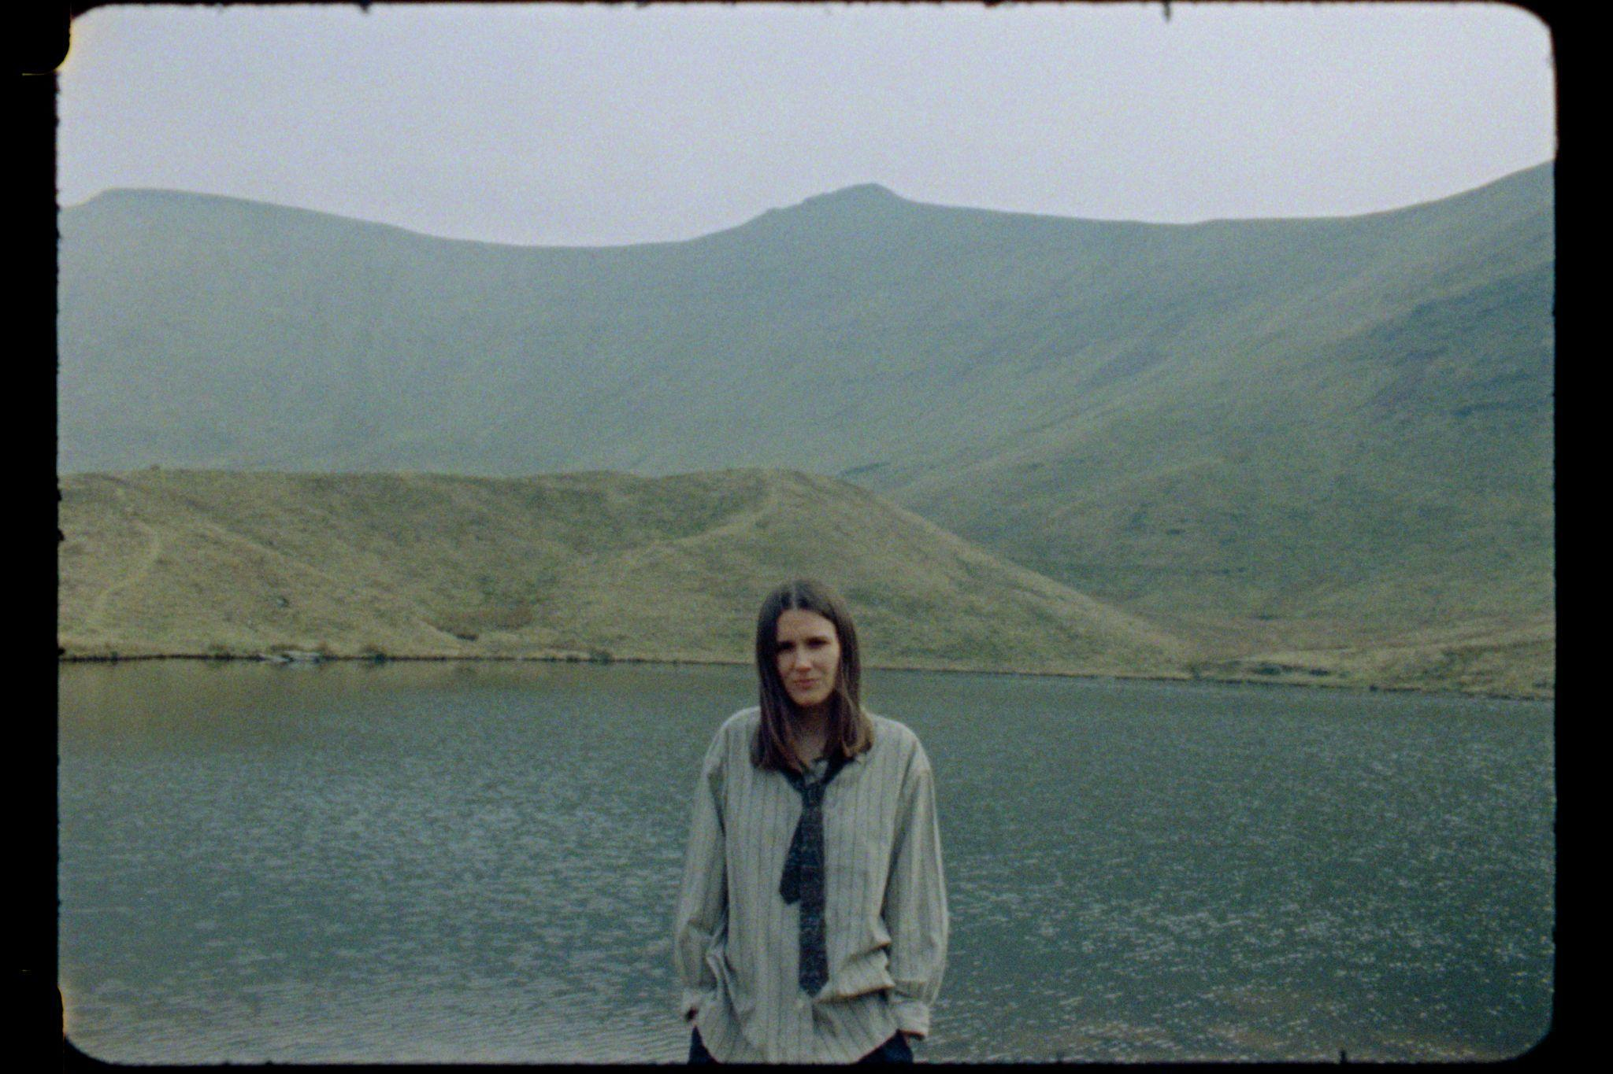
Photo credit: Zak Watson (@zak_watson) [download here]

Today, London-based, Wrexham-raised artist and producer Art School Girlfriend announces her third studio album Lean In, due March 11th via Fiction Records. She also shares new track ‘The Peaks’, and announces a 2026 run of headline dates.

Armed with the freedom and space to experiment, Lean In was self-produced in her own East London studio and sees Art School Girlfriend set to move from cult bedroom artist to one of the UK’s most vital artist/producers operating at the moment, tackling alternative rock, electronic pop & experimental ambient sounds in her most cohesive work to date.

Last month, Art School Girlfriend shared L.Y.A.T.T., a shoegaze and techno-tinged meditation on love that received strong support across BBC Radio 1, Radio 6 Music Spotify & Apple Music. In contrast, The Peaks brims with restless energy. The first spitting, galloping bars of the glitch-laden beat sound like the very sonic manifestation of zoning in and psyching up with a kind of crystalline gutpunch. The track acts as a microcosm for her upcoming album, a statement of intent. The electronic-organic hybridity, the gorgeous melodic twists that mirror rugged landscapes bent by natural forces, the unparalleled production born from time, space and expertise, the lyrics exploring the tension of, in Mackey’s words, ‘desperately wanting to stay alive for the people you love’; the darkness, the light and the galloping, singular beats: they’re all there.

Speaking further on the track, Mackey adds: “During the making of this album, there was a period of time when everything around me felt fragile — the things worth living for came into focus with a kind of hyperreal clarity. It’s a beautiful but health anxiety-inducing thing to realise: how lucky we are to be here. The lyrics are desperate and widescreen: “I want to give you the peaks, don’t slip, hold me.” The production and arrangement are designed to overwhelm, with peaks and troughs, offering moments of deep calm amidst the waves of relentless beats and stuttering synths.”

Lean In arrives at a time where her audience has grown exponentially, partly due to her diverse involvement across the music scene at large – contributions to the work of Daniel Avery, Lane 8, Jasper Tygner and Ghostpoet; being chosen by Bonobo to DJ at his Outliers series at Drumsheds; touring the US with both The Japanese House and Marika Hackman; a notable DJ set for HOR; producing and engineering for up-and-coming post-rock band Pencil; the tastemaker curation of her 5-years-in-the-running monthly radio show on Foundation FM.

Mackey speaks of making Lean In whilst feeling ‘a lot of things in parallel: grief, joy, love, anxiety, hopelessness, hopefulness, the effects of age, capitalism, technology’. Riding these parallelisms beyond binary collapse was both a key theme and a key to ASG’s process for the album. This is music made to listen to on headphones, while turning you outward to what’s important in the world — loved ones, natural spaces, and connection. It’s music that makes you lose your shit dancing — but in the middle of the night, when you can’t sleep for anxiety. ‘The album is very existential. Over the last few years I’ve experienced for the first time what people call “Big Life Shit.” Everything in life had been distilled down to its purest essence, and it terrified me to see it so purely because it just felt so incredibly precious and fragile. It’s the price you pay for having lots of amazing things to care about.’

Self-producing, writing and recording Lean In, Mackey invites the listener to quite literally lean into the world she has built around her. With every detail intentional, this new record is less of a honing of her trademark sound of emotional blend of electronic sounds and shoegaze - and more of an expansion of it. At the top of next year, she will perform these new tracks for the first time on a UK headline tour, with tickets available to subscribers of her mailing list from Friday 21st Nov, sign up here for first access. Tickets go on general sale from Fri 28th Nov.

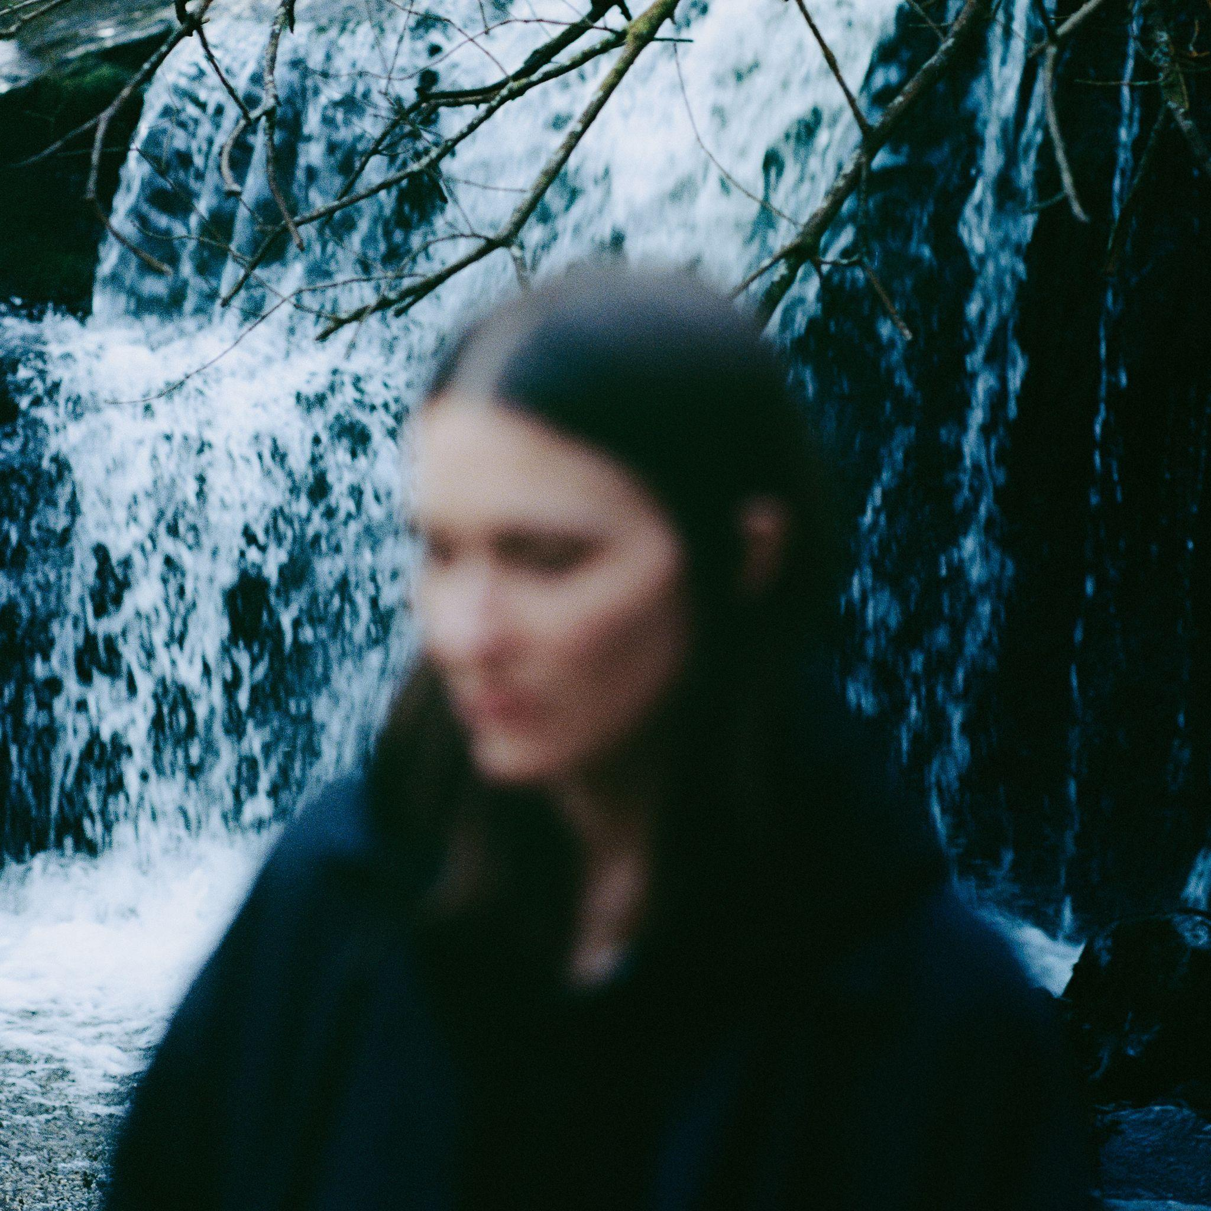
Lean In Artwork [download here]

Lean In Tracklist:

- Doing Laps
- L.Y.A.T.T.
- The Field
- Down The Line
- Almost Transparent
- Save Something
- The Peaks
- Hope More, Hopeless
- Lines
- Framer

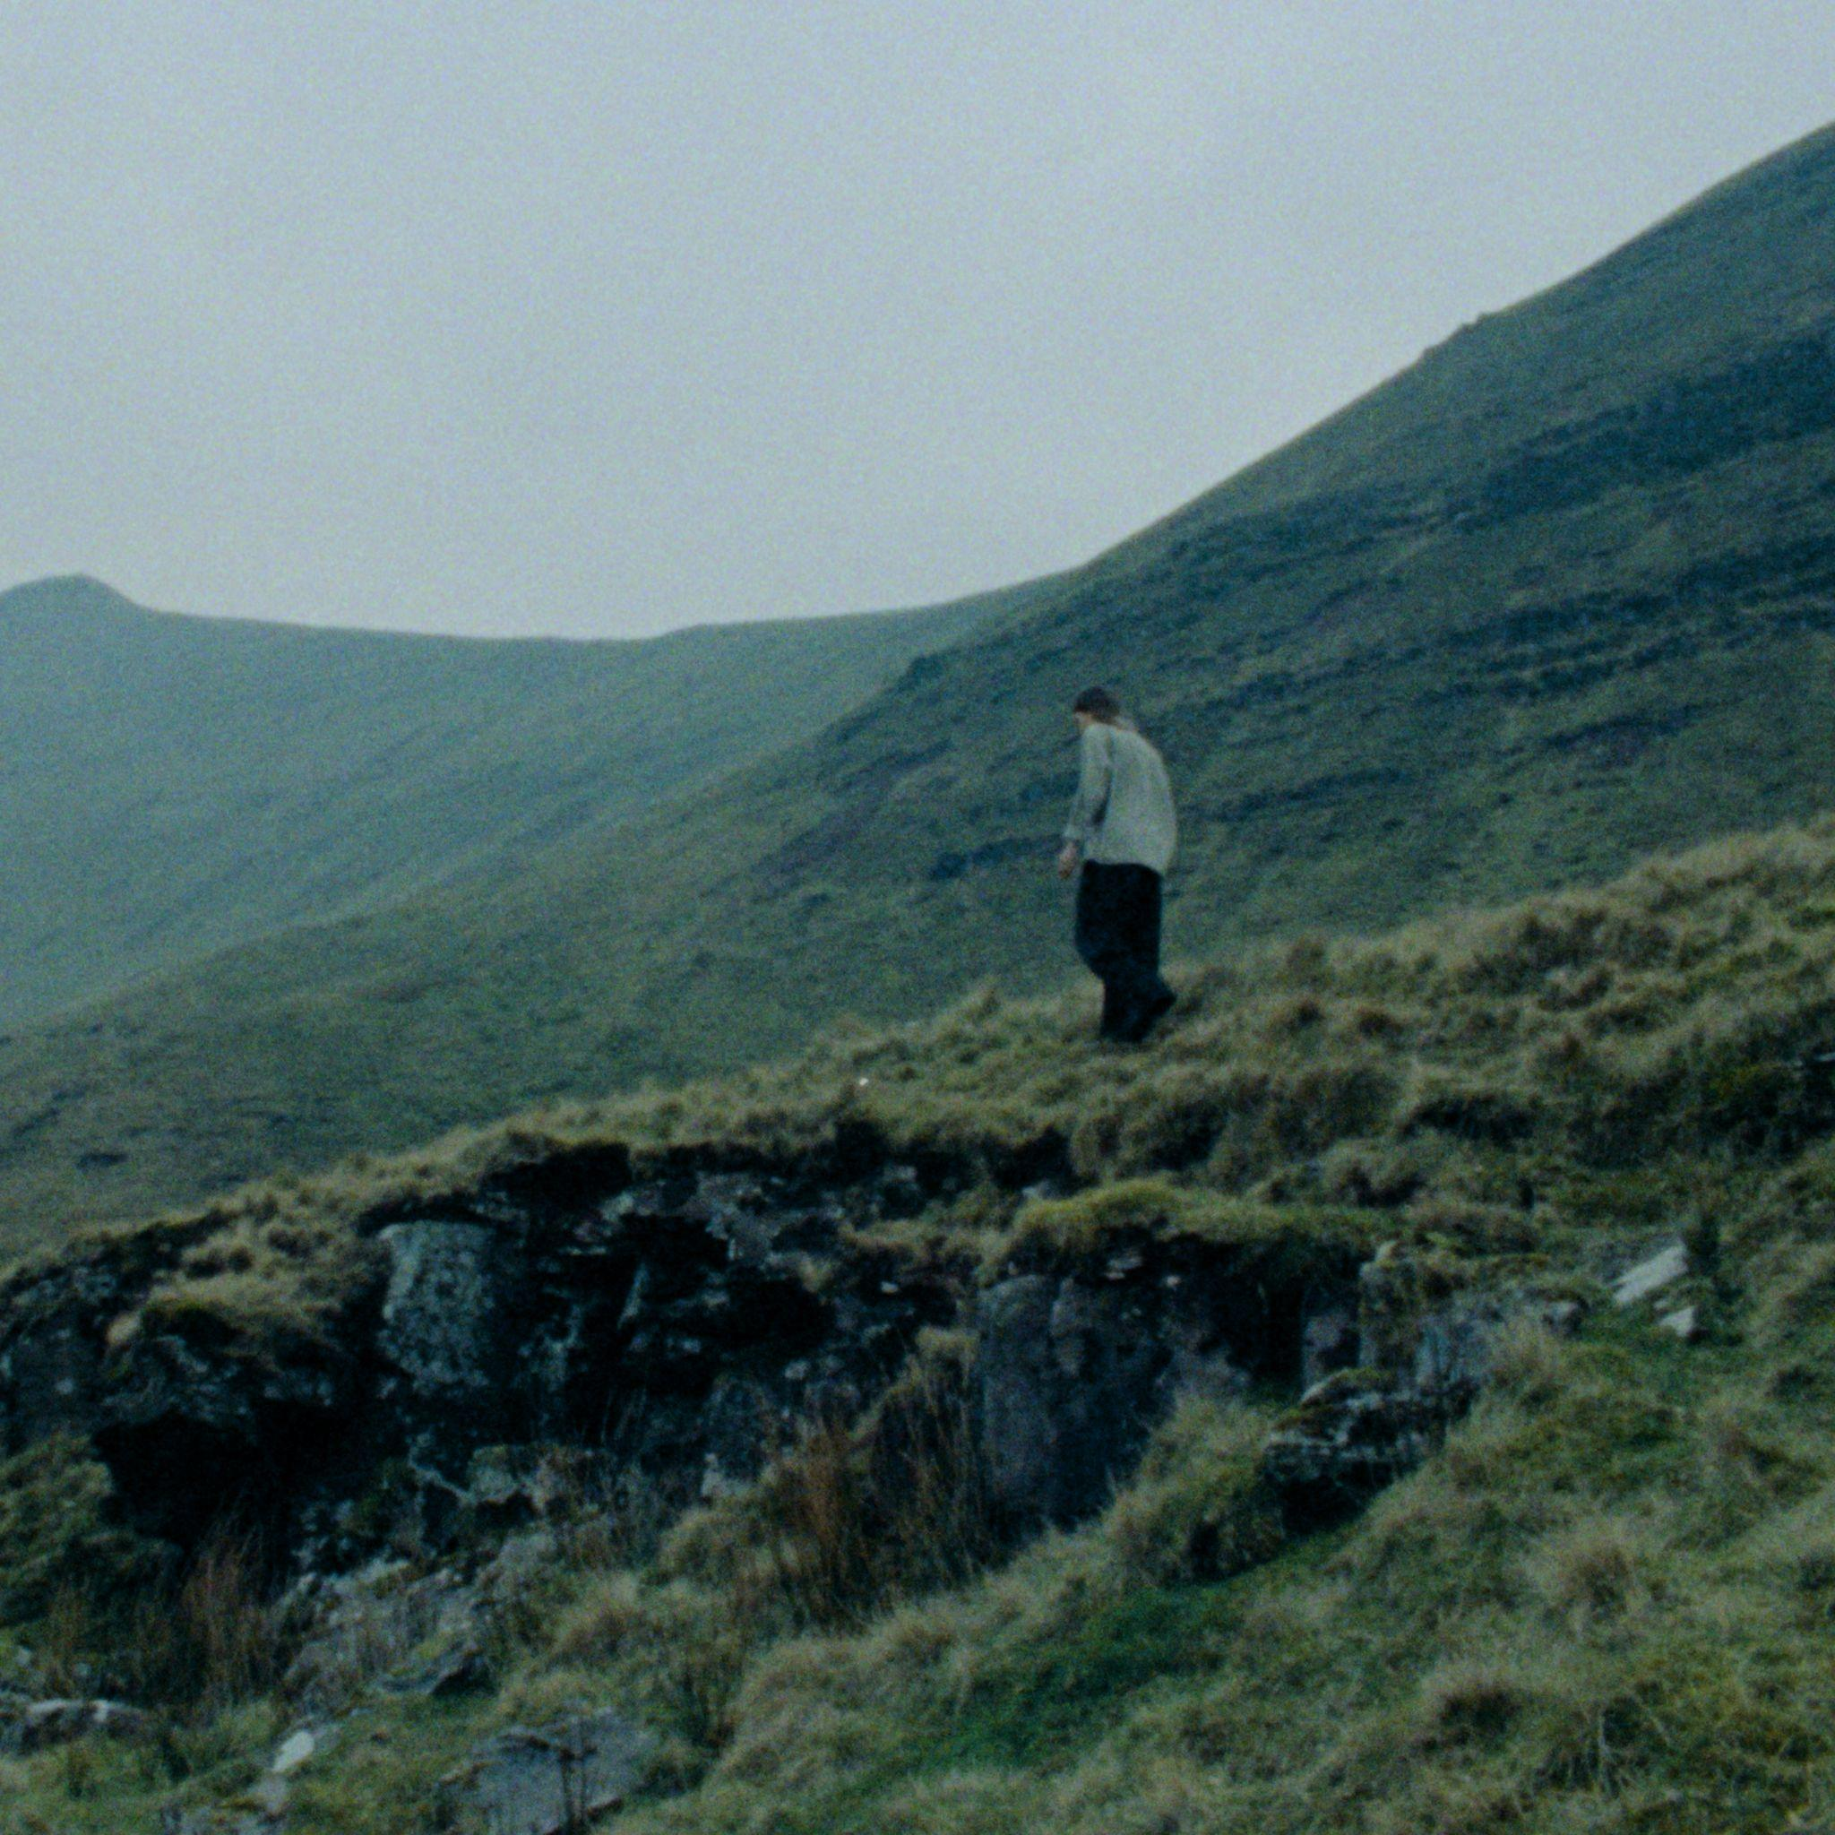
‘The Peaks’ Artwork [download here]



Art School Girlfriend 2026 Live Dates:

April 7th - Dust, Brighton
April 8th - Colour Factory, London
April 9th - Strange Brew, Bristol
April 10th - Clwb Ifor Bach, Cardiff
April 15th - Brudenell, Leeds
April 16th - Gorilla, Manchester

Follow Art School Girlfriend
Instagram / Spotify / Apple Music

For more information contact

Warren Higgins
warren@chuffmedia.com

