TO UNVEIL NEW ALBUM LOOM ON JUNE 28th - PRE-ORDER HERE
NEW SINGLE “EYES CLOSED” AVAILABLE NOW HERE
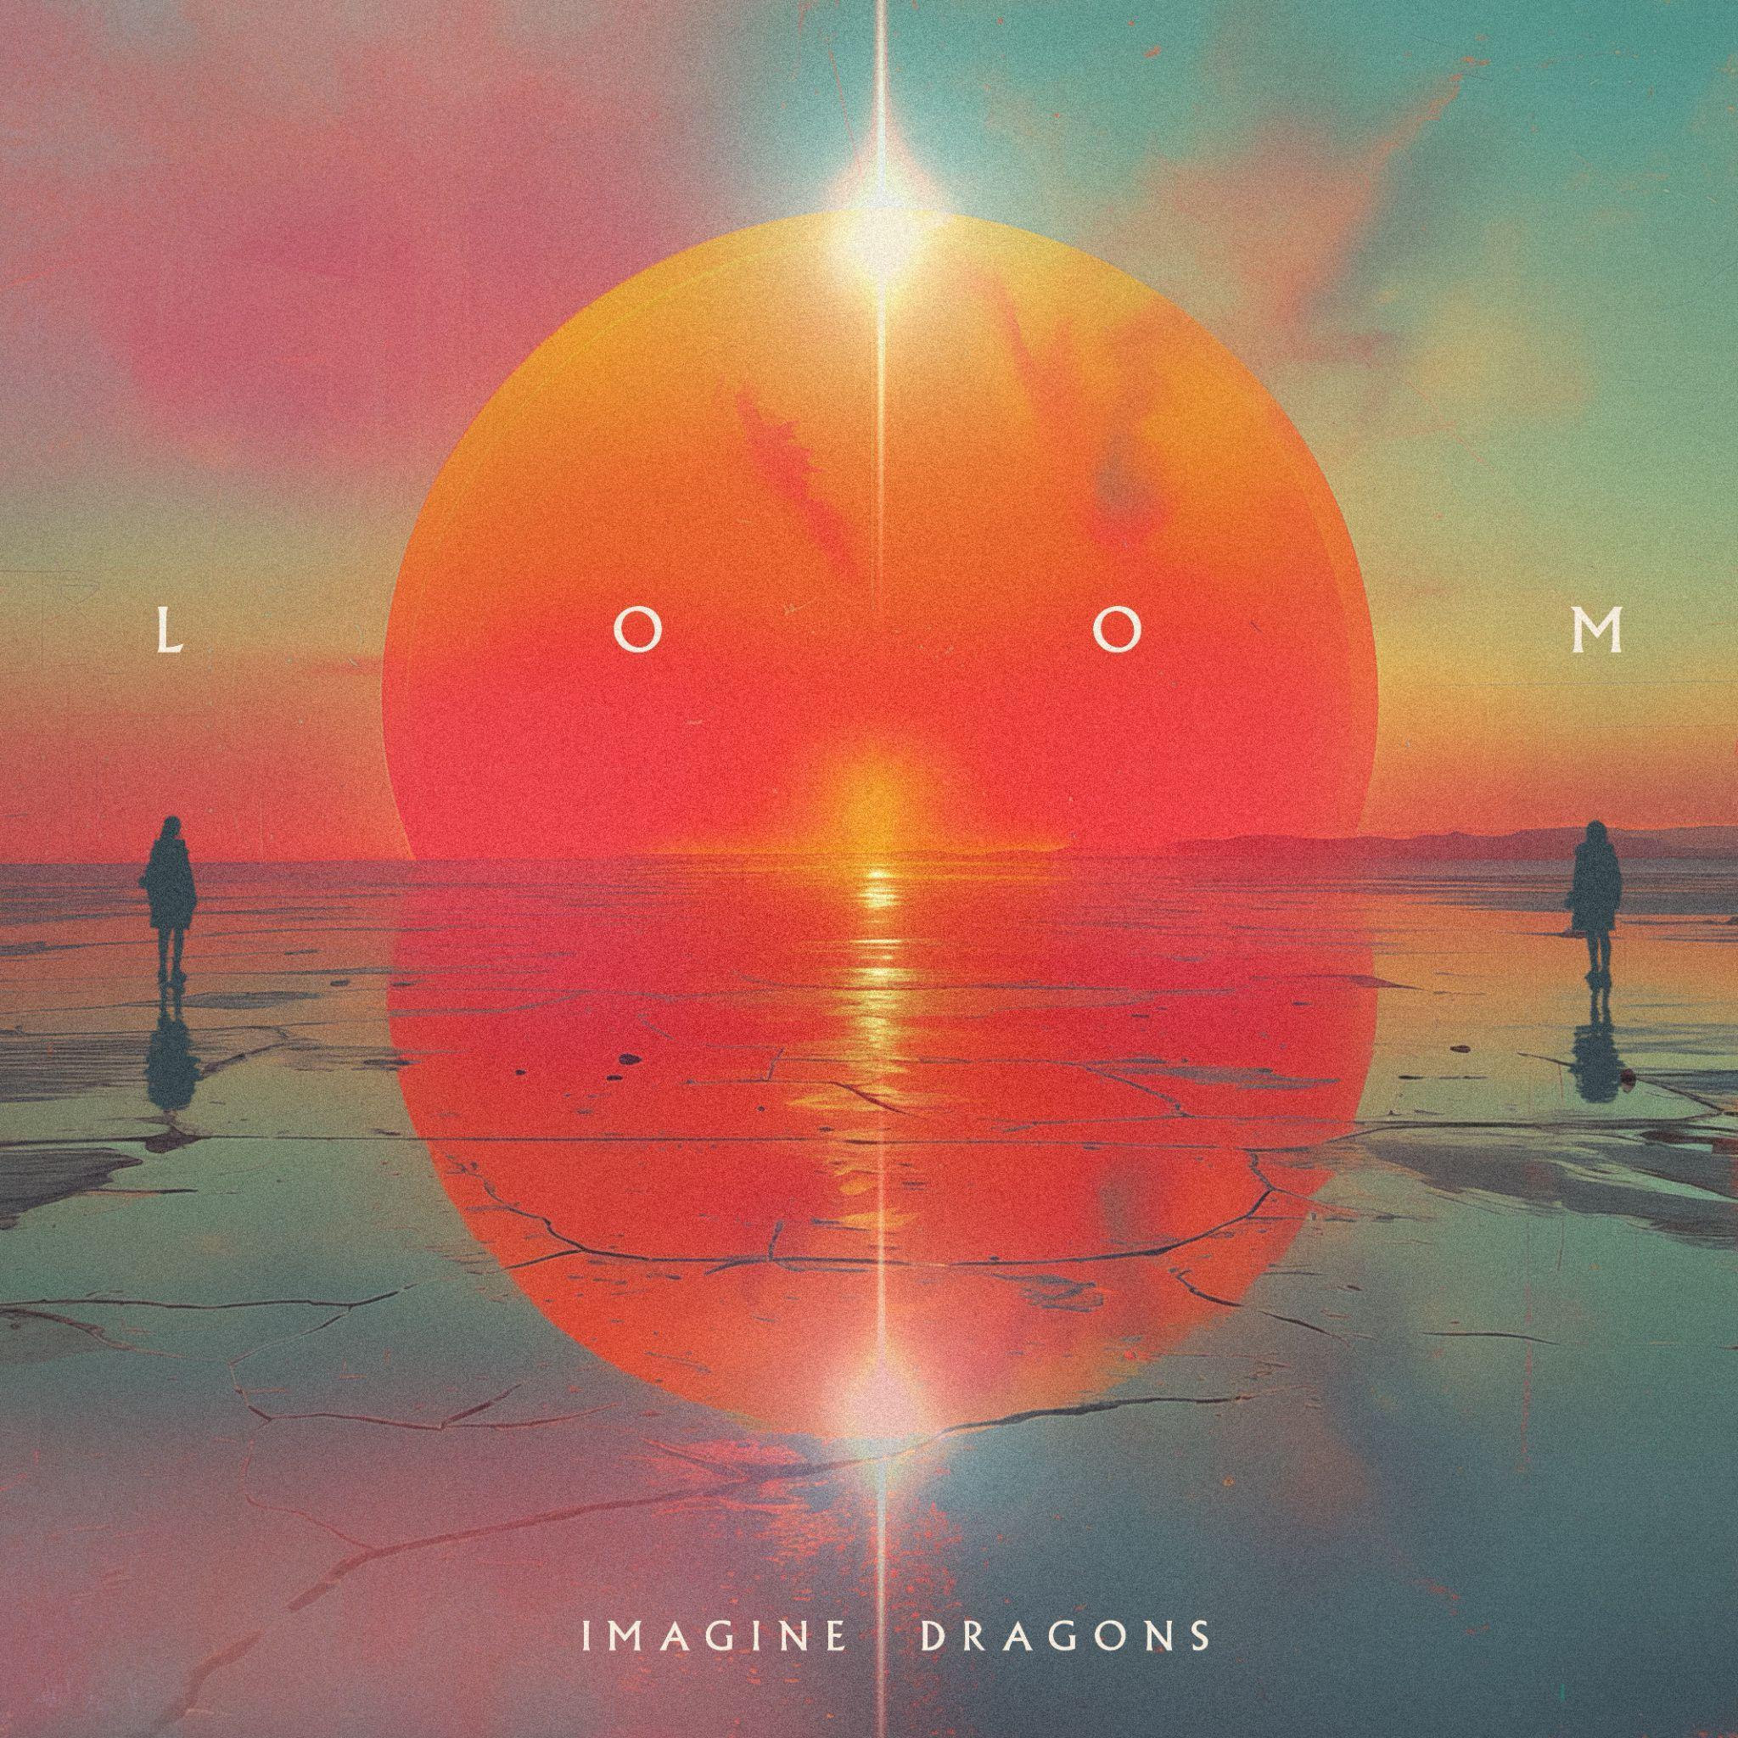
DOWNLOAD ASSETS HERE

Entering a fearlessly bold era, Imagine Dragons will unveil their anxiously awaited sixth full-length album, LOOM (KIDinaKORNER/Interscope), on 28th June 2024.
Pre-order/Pre-save the album HERE.
Imagine Dragons’ sixth studio album LOOM represents the pinnacle of their artistic journey of self-discovery and marks the best body of work they've ever made. LOOM, produced entirely by Imagine Dragons and their longtime collaborators Mattman and Robin, finds the perfect balance between the classic sounds that have made them superstars and the freshness that brought them joy in the studio. Featuring 9 brand new tracks including the hit single “Eyes Closed”, LOOM signifies new beginnings on the horizon – the excitement for a new day, moments yet to come.

Last year, the members of Imagine Dragons found themselves with a rare and well-deserved break from the road—perhaps their longest in many years. So, they made the most of it by devoting that time to family and friends. Catalyzed by this respite with a refreshed perspective, the band rallied together in the studio and mined the same well of inspiration that fed their most beloved material. The musicians reflected on the past in order to catapult into a future where stylistic boundaries have disappeared entirely and anything is possible creatively. This journey has brought them to their most dynamic and definitive body of work to date, LOOM.

To herald LOOM, the band recently shared their soaring new anthem entitled “Eyes Closed.” Check out the video HERE. The track illuminates their penchant for boundary-breaking. Stretching the limits of the soundscape almost to the breaking point, they harness a burst of energy with a rafter-reaching refrain primed to soar.

It's the year of the Dragons…

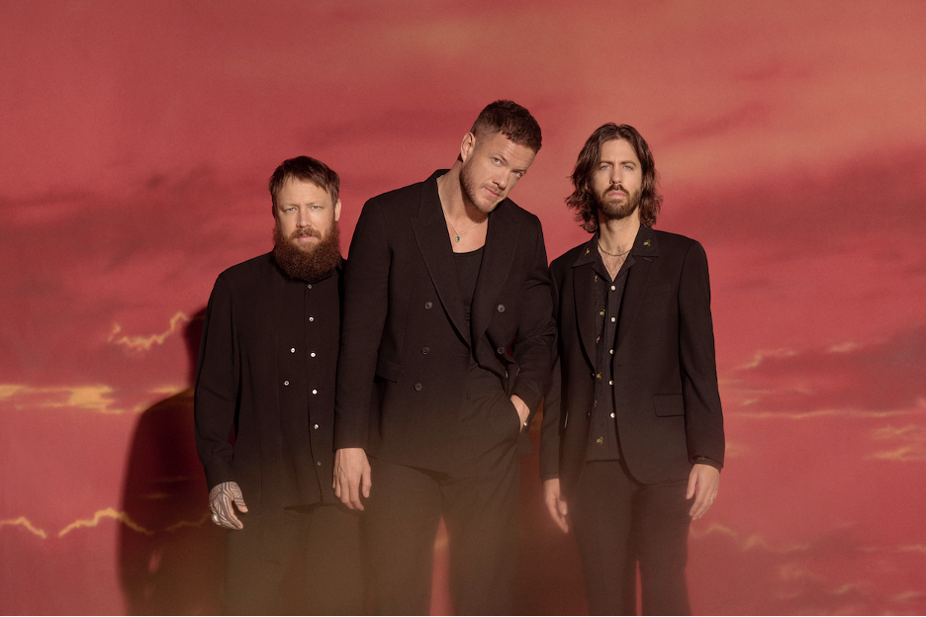
Photo Credit: Eric Ray Davidson
Download image HERE
ABOUT IMAGINE DRAGONS:
Imagine Dragons continue to redefine rock in the 21st century. Filling stadiums, crafting cloud-rattling anthems, and breaking records at every turn, diamond-certified GRAMMY® Award-winning Las Vegas quartet Imagine Dragons occupy rarified air as one of the biggest rock bands in the world. Tallying cumulative sales of 74 million album equivalents, 65 million digital songs, and over 160 billion streams, they stand out as “the only band in history to earn four RIAA Diamond singles,” namely “Radioactive” (16x-platinum), “Believer” (13x-platinum), “Thunder” (12x-platinum) and “Demons” (11x-platinum). Since emerging in 2009, they’ve scored five consecutive Top 10 debuts on the Billboard Top 200 with Night Visions [2012] (7x-platinum) (KIDinaKORNER/Interscope), Smoke+Mirrors [2015] (platinum) (KIDinaKORNER/Interscope), Evolve [2017] (triple-platinum) (KIDinaKORNER/Interscope), Origins [2018] (platinum)(KIDinaKORNER/Interscope), and Mercury – Act 1 [2021]( KIDinaKORNER/Interscope). With the release of Mercury – Act 2 (KIDinaKORNER/Interscope) in 2022, they completed their first double-album opus produced by the legendary Rick Rubin. The hit single “Bones,” featured on Mercury Act 2, went to number one at Alternative Radio and remains in the Global Top 50 on Spotify. The band’s hit collaboration with East Atlanta-based rapper J.I.D, “Enemy,” has racked up billions of global streams and landed at #6 on the IFPI Global Singles Chart for 2022. Dominating radio, they remain one of only four bands to ever achieve consecutive Top 5 singles at Alternative radio, and the only band to repeat this feat. Most recently, Imagine Dragons made history on Spotify, as “Bad Liar” became their 10th song to surpass 1 billion streams. The band now holds the crown for the group with most billion-plus streamed songs, becoming the first in the platform’s history to have ten songs reach this milestone. Meanwhile, Imagine Dragons’ music videos for hits “Thunder” and “Believer” have garnered an astounding 2 billion YouTube views, while videos for “Radioactive” and “Demons” have surpassed over 1 billion views. They’ve collaborated with everyone from Kendrick Lamar, Lil Wayne, and Wiz Khalifa to Avicii and film composer Hans Zimmer. Giving back, they’ve raised millions for various causes, including their pediatric cancer charity the Tyler Robinson Foundation, and frontman Dan Reynolds' LOVELOUD Foundation and festival in support of LGBTQ+ youth. In 2022, Ukrainian president Volodymyr Zelensky named them ambassadors for UNITED 24, which benefits humanitarian aid in Ukraine. Imagine Dragons earned an impressive four nominations for the 2022 American Music Awards including “Favorite Pop Duo or Group,” “Favorite Rock Artist,” “Favorite Rock Album” and “Favorite Rock Song.” The band was also nominated for “Group of 2022” for the 2022 People’s Choice Awards. Most recently, they received an MTV VMA nomination for “Video For Good” for their acclaimed “Crushed” music video.

For more information and press enquiries please contact

Jenny Entwistle
Jenny@chuffmedia.com

