Jacob Alon Announces Debut Album Details + Shares New Single

“In Limerence” Released 30th May 2025
Listen To Don’t Fall Asleep <Streaming Now>

+ New UK Live Dates

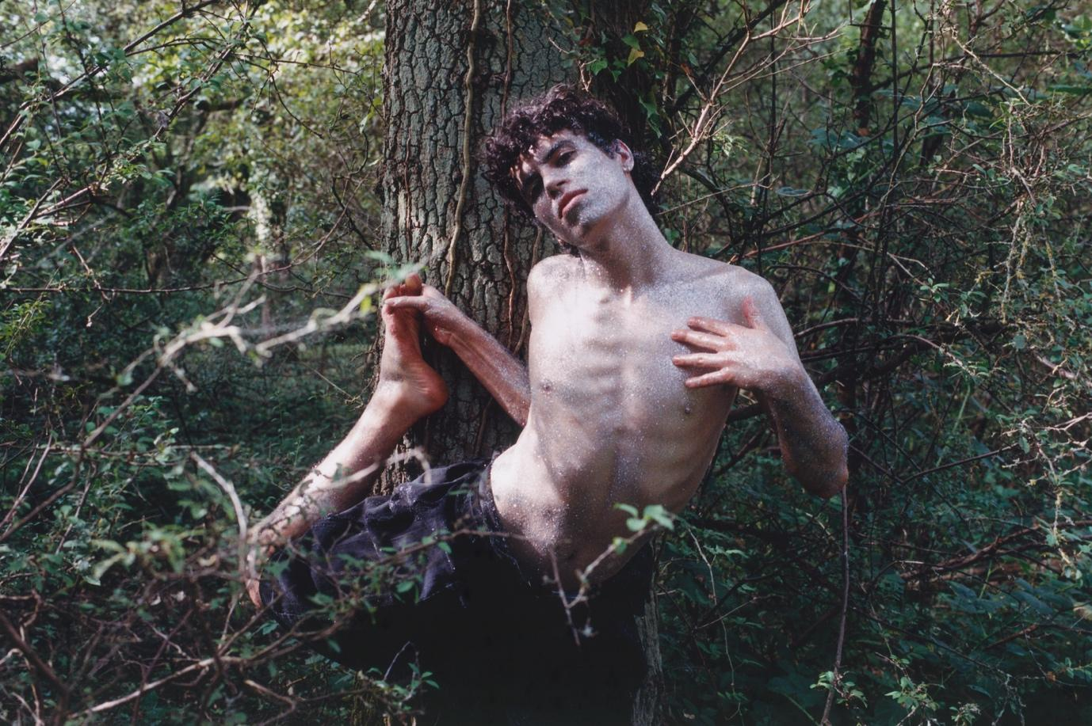
Credit: Jules Moskovtchenko

“One of the most remarkable voices of their generation” - The Independent
“With just voice, guitar and poetic words culled from experience, Alon has breathed new life into the singer-songwriter genre” – The Times
“Jacob performs with a reverence that feels genuinely spiritual” – DIY Magazine
“quietly stunning” – Wonderland
“An artist of profound honesty, there’s a magic to everything Jacob Alon touches” – Clash Magazine
“Jacob Alon’s music conjures an intrinsic sense of hope” – Billboard
“a distinctive new voice” – Rolling Stone UK

Jacob Alon is very pleased to announce details of their debut album, In Limerence. The record is released on 30th May via Island / EMI.

The album was recorded in London and produced by Dan Carey. It features all of Jacob’s singles released to date: Fairy In A Bottle, Confession, and Liquid Gold 25. A new single is shared to coincide with the album’s announcement, and it is streaming now. Listen to Don’t Fall Asleep HERE.
Scotland’s Jacob Alon is resetting the button on British contemporary folk music. They certainly possess all the touchpoints; that lilting, otherworldly vocal, colourful story-telling, and fingerpicking patterns traced along their acoustic guitar’s fretboard, but whilst Jacob displays all the classic folksy attributes, they fidget on a different plain entirely. Sure, the voice is ghostly, but often evokes that of a tortured angel; the darkest of lyricists laced with jet black humour. Bleakly beautiful bittersweet symphonies. Scotland’s young Makar in waiting, and In Limerence their opening chapter.

Jacob on new single, Don’t Fall Asleep: “This song, to me, floats across the stormy surface of the sea of dreams, gasping against its choppy tide, resisting the soft pull below into an endless deep.

It’s centred around the story of a cousin of mine who tragically drowned in a freak accident before I was born.

I never knew him personally, but I’ve always had an idea painted in my mind of what he’d be like through the memories & stories of my family members. Because of this, I’ve always had a kind of fictional relationship to him.

So, this song takes place in the liminal space between worlds, from his fictional perspective.

He would leave behind a son he didn’t know about - tracing circles of life and death. A gift of life born on the other side of that delicate & fragile balance between two worlds. Of loss & gain. And the love & pain which bridges both.

It’s also about the moments in my life where living & loving has felt more like an active choice & promise to go on, than a faithful given. Like treading water. Like thinking about breathing. It’s about choosing to keep believing in the real world and not giving in to the seductive world of dreams - to that shy death.

In a strange bout of synchronicity, just as I was writing this song, I received a message from my cousin’s brother - who told me the story of how he and my cousin used to pick a record each night to fall asleep to - I found this to be a wildly meaningful coincidence. This brother is also one of the only other musicians in my family and he shared an ambient album* he had made dedicated to his late brother that was intended to be listened to whilst falling asleep.”

*The ambient record, Altar 25 | Vol 1 Awake Until Dreaming by the artist KULLUS, is here: https://prismglitchmusic.com/home

Jacob takes these songs out on the road for the rest of the year, firstly in support of Olly Alexander in rooms across the UK and Europe, and then three headline shows of their own in London, Manchester and Glasgow. Tickets for these headline shows in May and June go on sale from Friday 21st March – See Jacob’s socials for pre-sale information - Instagram / TikTok

Tracklisting:
Glimmer / Of Amber / Don’t Fall Asleep / I Couldn’t Feed Her / Confession / Elijah / Liquid Gold 25 / August Moon / Home Tapes / Zathura / Fairy In A Bottle / Sertraline

Jacob Alon Live:
24th May - Bristol @ Dot to Dot Festival
25th May - Nottingham @ Dot to Dot Festival
27th May - London @ EartH Theatre *New Date*
4th June – Manchester @ Band on the Wall *New Date*
5th June – Glasgow @ Art School *New Date*
26th July – Yorkshire @ Deer Shed Festival
30th August – Val de Bagnes, Switzerland @ Palp Festival

About Jacob Alon…

Growing up in Fife and raised by a young single mother, Alon was surrounded by winding woods beyond the sprawling housing estates, which lacked glamour but instilled in them a determination to make their own fun.

Growing up without much music in their household (“my family’s idea of musical brilliance was whoever was on The X Factor”), Alon then taught themselves guitar and singing on YouTube as a teenager after finding a dusty nylon-string guitar in a cupboard at their grandmother’s house. “I never really liked rules and I didn’t take well to the dogmatic and creatively devoid process of classical musical education,” they say. “It was quite empowering, being able to take it into my own hands.”

It was Alon’s friends at school that introduced them to Nick Drake, David Bowie, and more, and they had finally found their tribe. At school, they formed the bands The Pleaser Tweezers and TRAMADOL NATION and primarily made songs to make their friends laugh and take power away from some of the more toxic characters at their school. Though songwriting wasn’t taken that seriously at the time, “music became a tool with which to reclaim a bit of power over my life,” Alon says.

After feeling a lack of support and encouragement towards music from their family, Alon instead enrolled in first medical school, and then to study theoretical physics. “I thought I wanted to save the world somehow, to help people ,” Alon says. “But I think I really just wanted love and respect from my family. When I finally got it, I fell into a deep depression. That’s when I realised I can’t keep living to please other people.” Despite this newfound obsession with music, Alon never considered a career in it and was actively discouraged from it. “I remember a family member telling me, as a child, I’d be a poor fool to ever become a musician. And it stuck with me.”

It was while living alone in lockdown, and after dropping out of university for the second time (“I realised I was living someone else’s dream”), they picked up the guitar again – inspired by the bewitching playing of Nick Drake and Big Thief’s Adrianne Lenker – and “found the thing that brings me this all-consuming curiosity”. Through the discovery of open tunings, they played the guitar almost as if discovering it again for the first time. They might have gotten into music through a “desire to be exceptional and to get love where I didn’t feel it from the inside out,” but an eventual deeper love and safety in the format came from making choices for themselves and not anyone or anything else.

After COVID, Alon tried to move to London to start a music career, but all-too-common run-ins with shady landlords and declining mental health took the artist back up north, where they took out a bank loan and decided to live in a van and travel around Europe, before returning home to work in a series of queer nightclubs, vowing to never pay another penny to a landlord. They also became a regular at Edinburgh’s lauded folk clubs, becoming a core part of a scene that they initially saw as “aloof and impenetrable” but grew to feel truly at home in. At these nights, musicians would play anything from old Gaelic Walking songs and forgotten Scottish folk tunes to Leonard Cohen and Britney Spears. “I was looking for approval again, but in a good way this time,” they smile.

Getting songs ready to perform at the Wednesday sessions at the Captain’s Bar brought a new intensity and pace to their songwriting, as well as excavating feelings about their life and ostracisation from their family. “Suddenly, I was able to translate deep, deep things within me and pour them onto a page – and I knew that I could trust this small group of misfits - young and old - to receive them first.”

In this time, Alon also found what they describe as their “chosen family” within the local queer scene, who encouraged them to flourish. “We hold each other up and I owe so much to them,” Alon says of their community. Alon’s queerness is also embedded in every song they make, as in their entire life, and is an integral part of them as an artist.

At the time they were doing the rounds at the folk clubs, Alon was working in a small coffee shop and playing the archetypal hopeful artist, gigging any time and place people would have them and praying for a big break.

Though their first songs have flickers of Lenker, Nick Drake, Rufus Wainwright and other titans of modern-day songwriting, Alon also feels like a limitless artist. While their raw power shines through clearest with just a voice and guitar, they have the personality and panache of a pop star and has flirted with the idea of a future turn towards electronic music. In whatever sonic guise, their commitment to devastatingly honest and frank lyricism, and to pulling humour and warmth out of despair, makes them a truly special new voice.

Throughout all of the twists and turns of their childhood and young adulthood, the love they didn’t receive and then learned to give themselves, music has remained the freest and most effective way for Alon to make sense of the world. In finally sharing that wisdom and beauty with others, they make the deeply personal universal and reaffirm the unrivalled power of the form.

In Limerence Artwork.
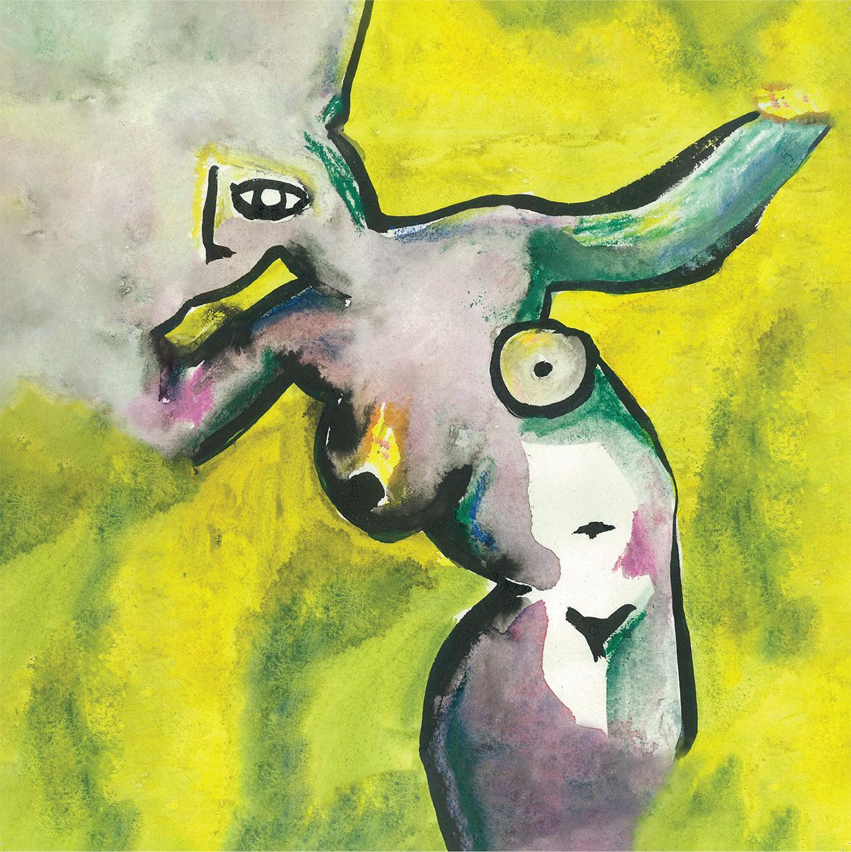

For more on info contact warren@chuffmedia.com 07762 130510

