“JUST IN CASE” & “I’M A LITTLE CRAZY”
OFF I’M THE PROBLEM OUT NOW

WALLEN’S FOURTH STUDIO ALBUM SET FOR MAY 16

Pre-Save HERE

I’m The Problem On Vinyl & CD Will Be Available For Purchase On MorganWallen.com & At Target; Pre-order On Target.com

“​​All his album’s smashes are bestsellers” – Forbes

Wallen Returns as Musical Guest on NBC’s Saturday Night Live Next Saturday, March 29

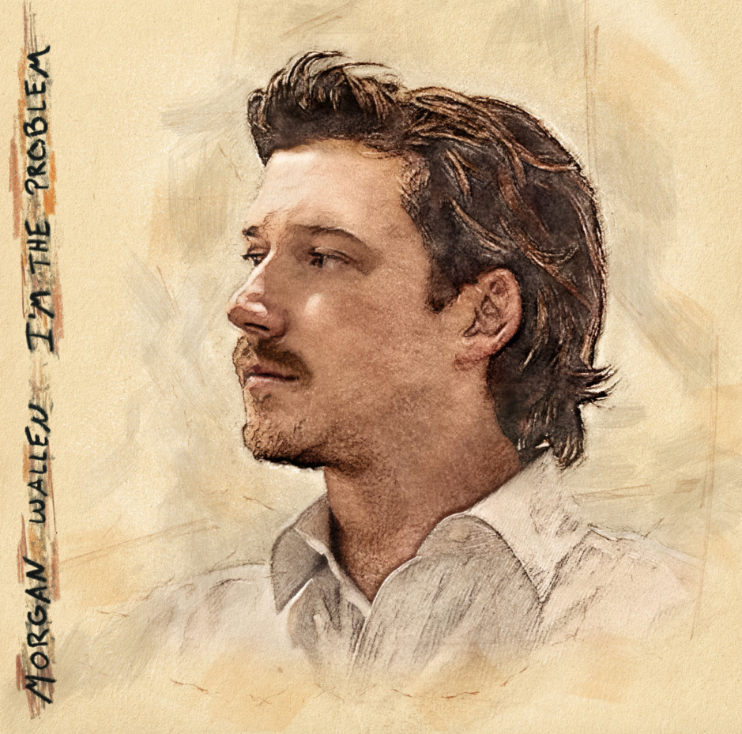
Morgan Wallen I’m The Problem cover art. | Label: Big Loud / Mercury | Release Date: May 16, 2025 | Download HERE

NASHVILLE, Tenn. – On the heels of announcing the May 16 release date for his upcoming album, I’m The Problem, Morgan Wallen is offering fans two new songs off the project, “Just In Case” and “I’m A Little Crazy;” the latter of which is the 37-song tracklist’s closing number. Listen to “I’m A Little Crazy” HERE and “Just In Case” HERE.

While “I’m A Little Crazy” is a quiet, self-reflective song that looks inward while examining the world outside, “Just In Case” offers a side that’s equal parts self-assured and vulnerable, as Wallen balances moving on from a past love, while never fully letting go. Each song encapsulates what this next chapter will usher in for Wallen as he digs deeper; providing a glimpse into his life that feels more intimate, more grounded, and closer to his core.

“Just In Case” was written by Wallen, John Byron, Jacob Kasher Hindlin, Ryan Vojtesak, Josh Thompson, Blake Pendergrass and Alex Bak; and “I’m A Little Crazy,” was written by Michael Hardy, Smith Ahnquist, Hunter Phelps and Jameson Rodgers. Both songs were produced by Joey Moi, with Charlie Handsome joining as co-producer for “Just In Case.”

The release of “Just In Case” and “I’m A Little Crazy” rocketed I’m The Problem to the top of Apple’s country album chart this morning, with just six of 37 songs released, as “Just In Case” simultaneously tops the iTunes chart. The instant chart takeover left Forbes observing “all the excitement around his new tunes means all his album’s smashes are bestsellers once more.”

With I’m The Problem combining Wallen’s country, cross and dirt-rock influences, the release will appropriately coincide with his inaugural, all-genre Sand In My Boots Festival in Gulf Shores, Alabama May 16-18. Pre-save I’m The Problem HERE.

I’m The Problem on vinyl & CD will be available for purchase on MorganWallen.com and at Target. Additionally, exclusive I’m The Problem collector’s edition vinyl featuring an opaque brown vinyl with a hunting ID and CD with a fishing ID will be available only at Target. Pre-order on Target.com now.

Wallen will perform songs off the upcoming album on NBC’s Saturday Night Live next Saturday, March 29 when he returns as a musical guest.

The upcoming project sparked Wallen’s 2025 I’m The Problem Tour. Kicking off June 20 at NRG Stadium in Houston, Texas, Wallen’s 20-show run will include stops in Seattle, Washington; Foxborough, Massachusetts; Toronto, Ontario and more. With a second stop recently added in Madison, Wisconsin, Wallen’s appearances will mark the first time an artist has played two consecutive nights at Camp Randall Stadium.

A rotating lineup of guests including Brooks & Dunn, Miranda Lambert, Thomas Rhett and Koe Wetzel join in direct support with Gavin Adcock, Corey Kent, Ella Langley and Anne Wilson as first-of-three across select dates. Coupled with Wallen’s Sand In My Boots Festival, these 21 shows are the only place to see the superstar in 2025.

About Morgan Wallen:
Morgan Wallen sets the pace in, and beyond, country music – with Billboard calling him “the biggest country star in the world” and The New York Times doubling down, declaring he’s “one of the biggest stars in pop, period.” With 17 No. 1 singles at Country radio, 19 Billboard Music Awards to-date, more than 170 weeks spent atop Billboard’s Top Country Albums chart (the most in country music history), the highest selling country tour under his belt and more, Wallen has propelled country music to a global level in less than five years. As Las Vegas Review Journal puts it: “Wallen’s appeal is remarkable as it is fueled by his ability to connect to a crowd.”

With Dangerous: The Double Album, Wallen solidified his place as country music’s “dominant superstar,” with the project recently being named Billboard’s No. 1 Album of the 21st Century. One Thing At A Time’s groundbreaking success saw Wallen’s crossover appeal reach a global scale, as he topped the Australian ARIA charts for the first time, along with a host of other accolades. With two No. 1’s already hailing from his forthcoming album release I’m The Problem, due May 16 via Big Loud / Mercury, Wallen digs even deeper, uncovering a side that’s both more vulnerable and more resolute than ever before.

As Wallen prepares a refreshed setlist for his 20-stadium-show I’m the Problem Tour, kicking off on June 20 in Houston, Texas, he’s also highlighting some of his favorite artists by bringing the personally-curated, multi-genre Sand In My Boots Music Festival to Gulf Shores, Alabama, this May, which sold out in less than two hours.

Wallen continues to donate a portion of every ticket sold to his Morgan Wallen Foundation — which supports youth music and athletic programs and gives communities access to essentials in times of crisis. More at MorganWallen.com.

###

For more information and press enquiries for MORGAN WALLEN please contact

Jenny Entwistle
Jenny@chuffmedia.com

