‘IDOLS’
YUNGBLUD ANNOUNCES
FIRST PART OF DOUBLE ALBUM
“A love letter to life; in all it’s f*cking madness.”
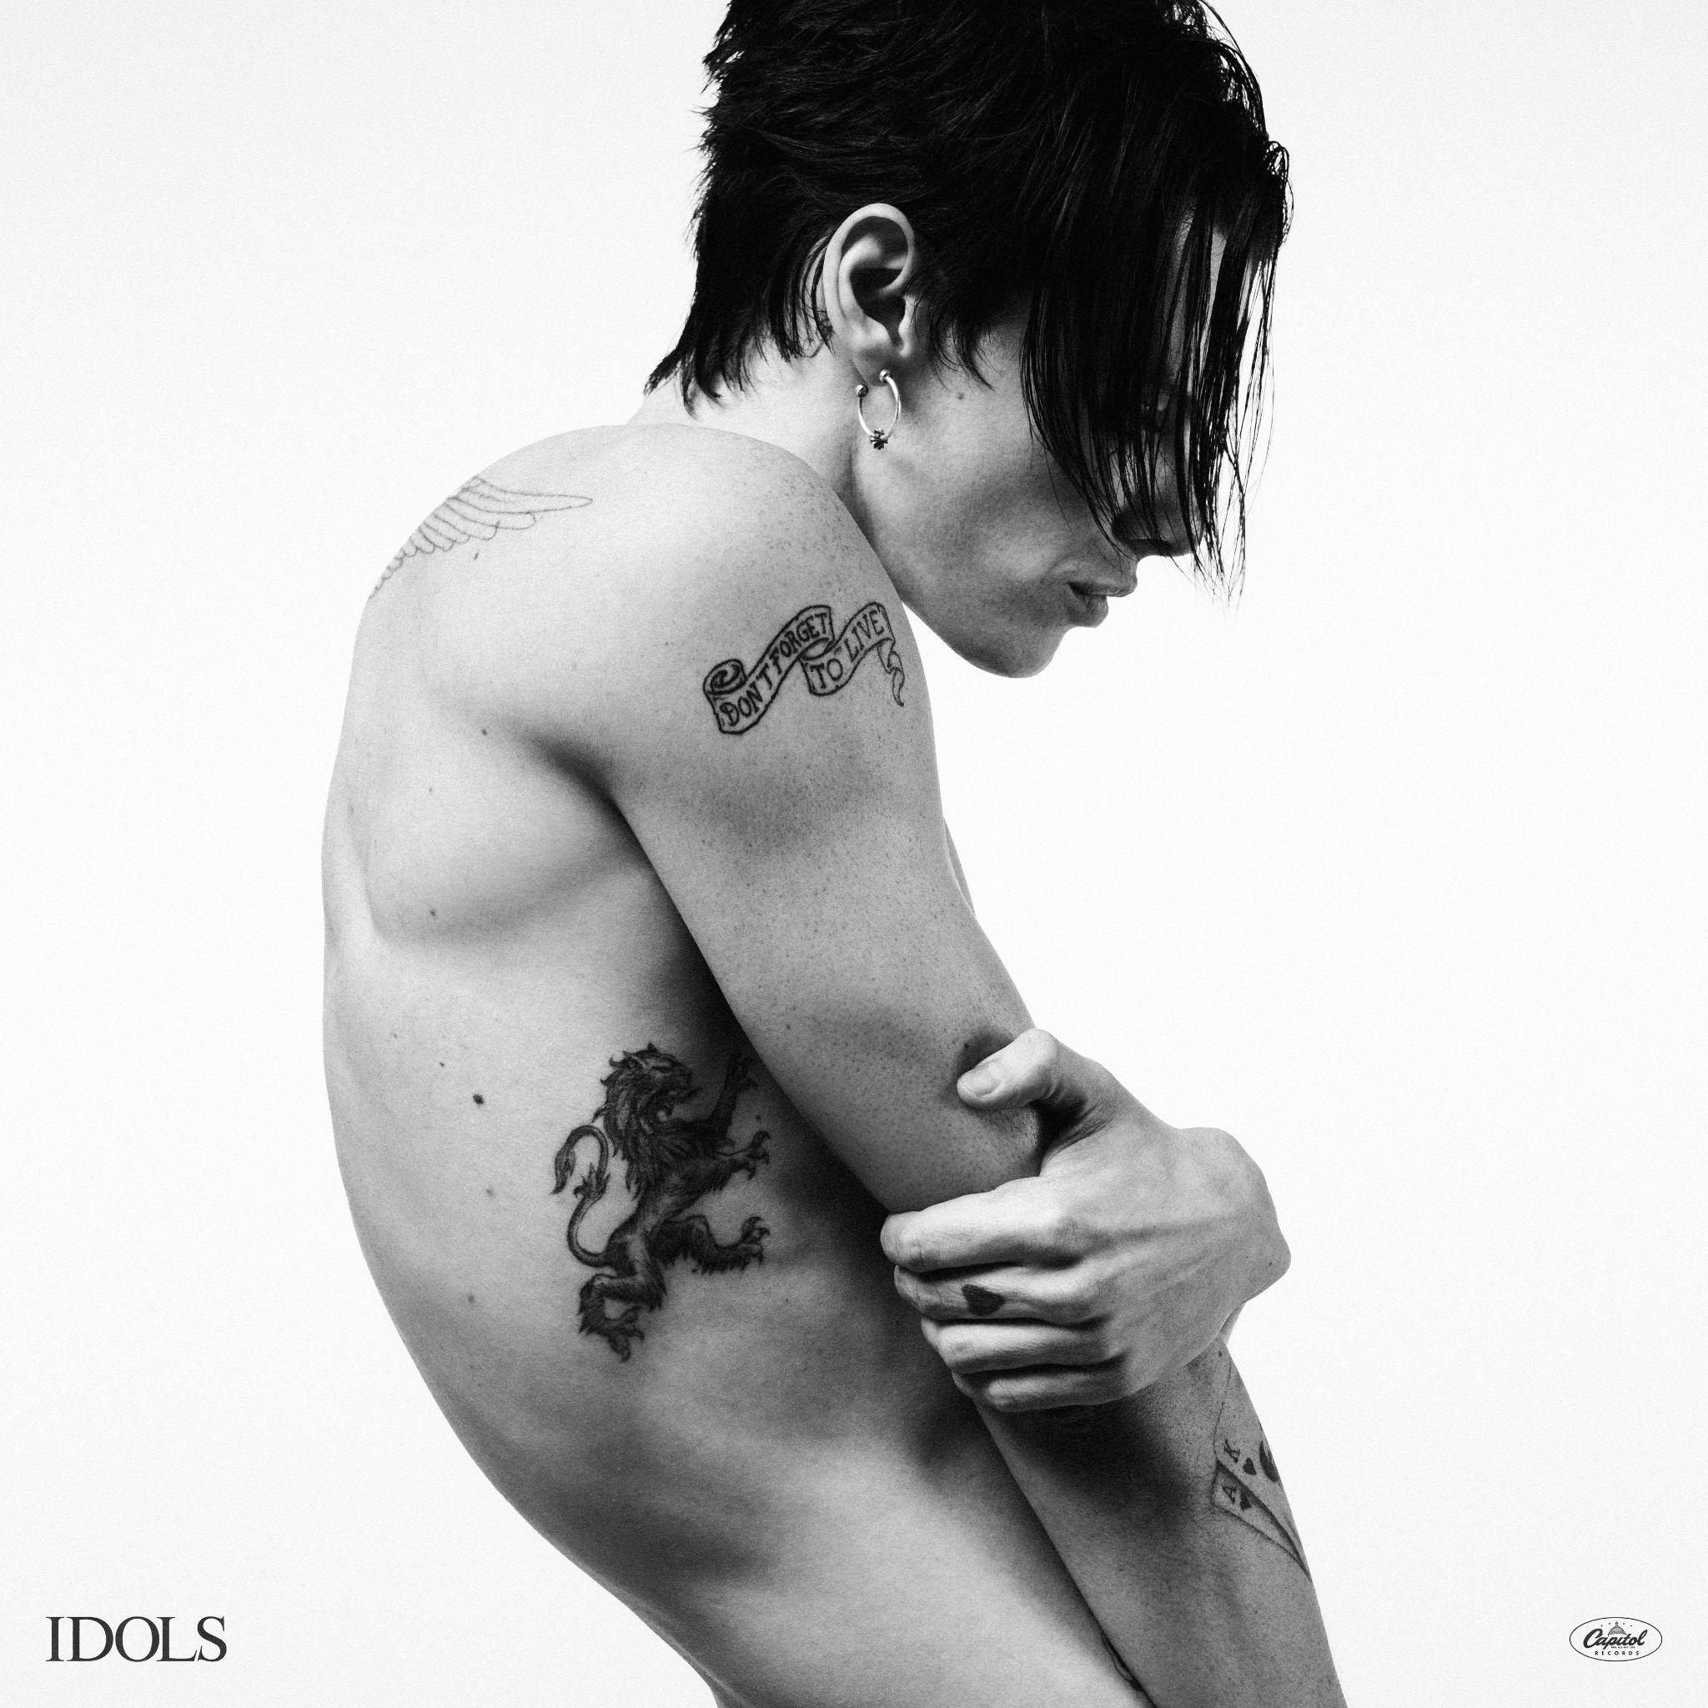
ALBUM OUT ON 20TH JUNE 2025
PRE-ORDER ‘IDOLS’

The fourth studio album by the 27-year-old creative force Yungblud was announced today.
Yungblud, whose last two albums went to number one in the UK and broke into the Billboard Hot 100, and whose back catalogue has accumulated an astonishing 6 billion streams globally, took to social media to reveal that his forthcoming body of work, ‘Idols’ will be released on 20th June 2025.
The 12-track offering, recorded in Leeds, is Yungblud’s most ambitious yet. The decision to produce the album just a few miles from where he grew up was made to minimise distractions during the process. Yungblud said “I wanted to make a project that didn’t focus on singles or anything else except feeling and world-building… A project with no limitations.” ‘Idols’ makes up the first part of a double album, with the release date of part two yet to be announced.
The artist was joined in the process by producer Matti Schwartz, Bob Bradley on additional production, and guitarist Adam Warrington. ‘Idols’ will be available across a number of formats, including four varieties of special edition vinyl.
On ‘Idols’, Yungblud explores the theme of hero-worship; how we look to others for validation, often putting others’ lives on a pedestal at the expense of the richness of our own experiences. Yungblud says, “We turn to others for an identity before turning to ourselves. Self-belief, self-reclamation, self-evolution and change. As we grow up, we lose our belief in magic and mystery. We begin to rationalise everything; our cage walls build up.”
He added, “We compare ourselves to 15 different people before we’ve even had our breakfast”.
Yungblud describes the album as, “A love letter to self-reclamation… to rock music… [and] to life; in all it’s f*cking madness.”
News of the album follows the release of a bold new single, 'Lovesick Lullaby', which came out on Friday 25th April alongside a stylish music video shot by Charlie Sarsfield (see HERE). To celebrate, Yungblud spent the evening behind the bar at the iconic Hawley Arms in London, serving drinks to a packed crowd. 'Lovesick Lullaby' marks Yungblud’s second single since his return in March with the nine-minute, six-second epic 'Hello Heaven, Hello,' which debuted as Jack Saunders’ Hottest Record on BBC Radio 1.
The Independent said of ‘Hello Heaven, Hello’, "...beneath all the bombast is a newfound maturity in songwriting and production."
Speaking about ‘Lovesick Lullaby’, BBC News’ Mark Savage said, “Combining Liam Gallagher's sneer with Beach Boys' harmonies, it's uniquely Yungblud.”
The Telegraph referred to the artist as “The pop star bringing real rock music back from the dead.”
The London Standard said, “... he’s a genuine Gen Z rock phenomenon.”

At his surprise Scala gig last month, the artist treated fans to unreleased tracks from the album. Introducing ‘Zombie’, he revealed, “This song was written initially about my grandmother going through serious injury and trauma. It’s about the feeling of deterioration and ugliness - shutting the world and the people we love out, out of the fear of becoming a burden or an embarrassment.”
News of the new album follows Yungblud’s appearance on The Jonathan Ross Show in March, where he joined guests on the sofa to discuss the forthcoming album as well as the return of his own-curated festival Bludfest, set for its second year. Speaking about his motivation behind the festival and its affordable price point, Yungblud explained, “It needed to represent a new idea and a new generation. Gigs at the minute are extortionately expensive”.
‘Idols’, the album by Yungblud is out on 20th June via Locomotion/Island Records.

ALBUM FORMATS:
VINYL
* Each vinyl offer includes a 4-page lyric booklet and 1 of 6 collectible double-sided photo lithos – unique to each vinyl variant – designed to form a cross-shaped image when the set is completed.
- Black Vinyl (Standard)
- Yungblud Store Exclusive: Signed “Distant Smoke” Marble Vinyl
Includes signed album artwork print
- Indie Exclusive: Signed “Supermoon” Silver Vinyl
Features alternate cover and includes signed album artwork print
- Amazon Exclusive: “Wishing Well” Magenta Vinyl
- Spotify Exclusive: “Hell And Back” Two-Color Vinyl
CDs
- Standard CD
- Signed CD
Available via Yungblud Store and indie retailers
- Amazon Exclusive CD
Features alternate cover

‘Idols’ full tracklisting:
- Hello Heaven, Hello
- Idols Pt I
- Lovesick Lullaby
- Zombie
- The Greatest Parade
- Change
- Monday Murder
- Ghosts
- Fire
- War
- Idols Pt II
- Supermoon

About Yungblud:
Yungblud is fast becoming one of the key musical voices of his generation, blending influences from Rock, Punk and Pop to monumental effect. His arena-filling performances around the world have cemented his place as one Britain’s most electrifying musical exports. He has received several accolades, including the MTV EMA for Best Alternative (2021) and the O2 Silver Clef Award for Best Live Act (2022). Known for his electrifying stage presence and boundary-pushing lyrics, Yungblud continues to challenge conventions while inspiring fans worldwide with messages of authenticity and acceptance. This year, Yungblud debuted own curated festival Bludfest and released his first book, the instant No1 Sunday Times Best Seller, ‘You Need to Exist: A Book to Love and Destroy’ on Penguin Books.
https://www.yungbludofficial.com/

Follow YUNGBLUD:
Instagram/ TikTok/ X / Youtube/ Facebook

For more information and press enquiries please contact

Jenny Entwistle
Jenny@chuffmedia.com

