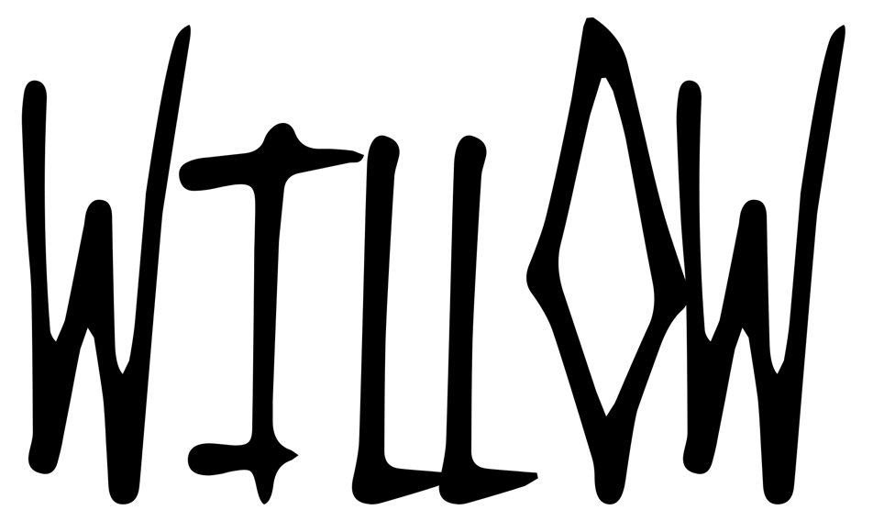

ANNOUNCES NEW ALBUM
lately I feel EVERYTHING
OUT JULY 16TH
NEW SONG ‘LIPSTICK’ AVAILABLE NOW
LISTEN HERE

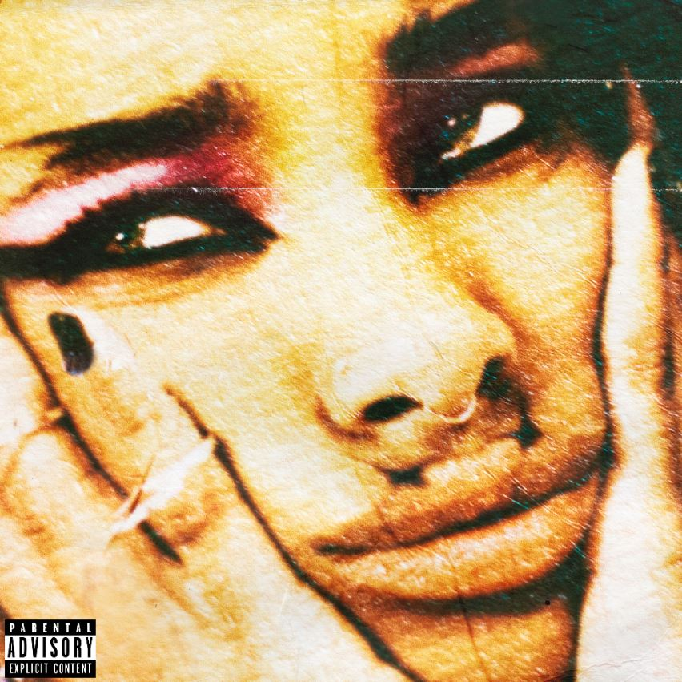

Today, WILLOW announces her new album, lately I feel EVERYTHING out July 16th on
MSFTSMusic/Roc Nation via Polydor in the UK. The album is available for pre-order / pre-save today and features Travis Barker, Avril Lavigne and more.
WILLOW has also released another song from the forthcoming record – ‘Lipstick’. “I just wanted to let loose with this album. I wanted to have fun and be young and not be so existential and worrying all the time,” says WILLOW. ‘Lipstick’ follows the release of the explosive first single ‘t r a n s p a r e n t s o u l feat. Travis Barker’.
At only 20 years old, WILLOW has spent half her life in the music industry. With lately I feel
EVERYTHING, a decade of growth both in the industry and as a young woman come to a head. Her new single and LP is a love letter to that constant evolution.
She began working on the album in 2020, during the pandemic. With all the extra time on her hands at home, she began recording demos that she would later re-record when she felt like she could safely enter a studio. It was a new process for her, born out of caution, but it helped her capture the rawness of her new sound. On the forthcoming record, WILLOW channels the pop-punk and emo heroes she adored as a teenager, like Avril Lavigne, My Chemical Romance and Paramore. “I thought this was a really dope outlet for a new energy I wanted to bring to my music,” she says.
‘t r a n s p a r e n t s o u l feat. Travis Barker’ was originally unveiled via Beats1’s Zane Lowe as a New Music Daily and has since garnered both critical praise and commercial success. WILLOW recently performed the single on The Tonight Show With Jimmy Fallon. Watch here.
PRAISE FOR
‘t r a n s p a r e n t s o u l feat. Travis Barker’
"Willow is back, and she’s stepping on necks on the way...Shredding on the guitar, she radiates power." - New York Magazine
"Willow Smith goes full pop-punk... the song draws from the music of Paramore, Fall Out Boy, and Barker’s own band Blink-182, with hard-hitting percussion and pop-punk power chords on guitar." - Rolling Stone
“Thank God for Willow, tracking her metamorphosis from precocious neo-soul explorer to out-and-out alt, kid. ‘t r a n s p a r e n t s o u l’ is bratty in the best way, pushing the genre towards more diverse expression” – The Guardian Guide
"Willow Smith is ready to rock your world...fully embraces the alt-rock and pop-punk sound. Complete with her own guitar playing and a head-banging chorus" - Harper’s Bazaar
“She is the moment...Over roiling guitars and Barker’s thunderous drums...belts in her best pop-punk voice about seeing right through the haters in her life. It’s super catchy. In its accompanying video, she channels the nostalgic fish-eye performance vids of pop-punk’s golden era with her own chic twists...No doubt the pop-punk heroes of her youth, Hayley Williams, Gerard Way, and Patrick Stump, would be proud." – NYLON
"A guitar-heavy track that sees the rap star take a significant sonic shift and swap intricate lyrical flows for thrash-y pop-punk powerchords...Wielding an Ernie Ball Music Man St. Vincent signature, Smith serves up a series of sweet melodic slides and oversized open-string chordal hooks over a moody bass guitar line, all of which are driven along by Barker’s high-octane drum part." - Guitar World
“Smith’s song doesn’t so much make the case for Black women in pop-punk as much as it
serves as a reminder that we’ve always been here. It’s a pop-punk banger for the ages.” – Jezebel

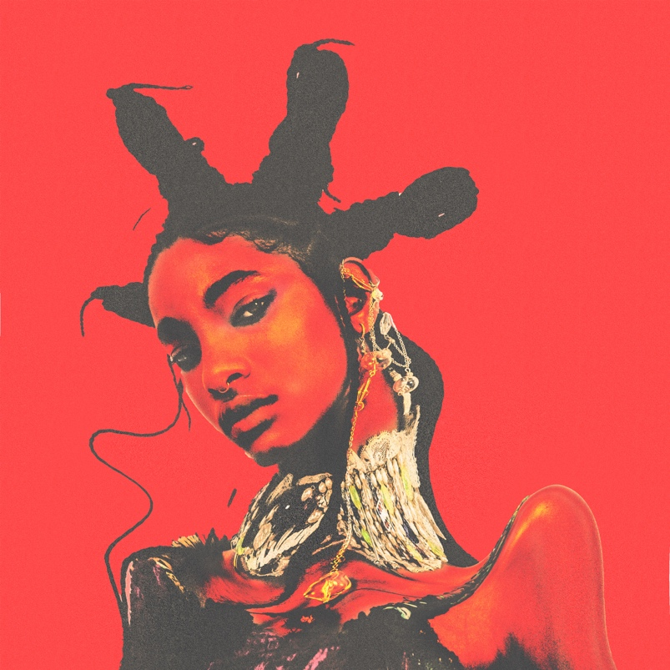
Photo Credit: Dana Trippe
FOLLOW WILLOW ON
SPOTIFY | INSTAGRAM | TWITTER | FACEBOOK
YOUTUBE | APPLE MUSIC | WEBSITE
For more information contact William Luff or David Sullivan at Wilful Publicity
william.luff@wilfulpublicity.co.uk / david.sullivan@wilfulpublicity.co.uk

More about WILLOW and ‘t r a n s p a r e n t s o u l feat. Travis Barker’:
Though she considers her writing process “very solitary” and “insular,” she has found a fruitful musical partnership in Tyler Cole, who she first worked with on 2019’s WILLOW. She describes the relationship she has with Cole as a great “synergy,” which has unlocked something deeper in her music as she progresses in her career.
One major influence for the record comes from a deeply personal place: her own mother Jada Pinkett Smith. These days, the two co-host the Facebook Watch talk show Red Table Talk with her grandmother Adrienne Banield-Norris. But prior to that, Pinkett had a rocker past that she fulfilled alongside her acting career. Pinkett formed the nu metal band Wicked Wisdom when her daughter was an infant. “I was always so inspired by the power of her voice,” WILLOW says. Wicked Wisdom was at their most active during her most formative years. The group has released two albums, opened for Britney Spears on her Onyx Hotel Tour in 2004 and a year later appeared at Ozzfest. While she admired her mom’s musical route, WILLOW was sceptical of her own ability to channel that rock side. “I never felt like I could sing that kind of music
because I was always trained to sing R&B and pop.”
Letting go of that insecurity proved to be a breakthrough when she realised how influential R&B and pop vocalists are on her pop-punk heroes like Hayley Williams, Gerard Way and Patrick Stump. She used the soulful range of her own vocal chops to add a fresh flare to the mosh-ready records she wrote for this release and learned how to stop looking at that training as a disadvantage. “I realised that it’s not my voice that can’t sing this kind of music. I was afraid to sing this kind of music because I wasn’t sure what people would think.”
‘t r a n s p a r e n t s o u l feat. Travis Barker’ teed off the album rollout, showcasing her own spin on emo and punk. It feels both nostalgic and modern, with a catchy hook and snappy melody that makes the song move like lightning. The lyrics were inspired by a quote from a “beautiful swami” she knows personally: “It is said that a saintly person is so pure that he or she acts like a spotless mirror. When we come in the presence of such mirror-like soul, we can see both the beauty and ugliness of our inner life.” She sees the single as a testimony to her desire to be the highest version of herself, something that she connects well with the angsty, pining feeling of the genres she explores. The songwriter rarely makes videos, but she felt so inspired by ‘t r a n s p a r e n t s o u l feat. Travis Barker’ that she decided to pursue one for it. She hopes the visual opens up new meanings for the listeners.
WILLOW’s own guitar playing factors into the project as well, which is something she was also inspired to do because of her mom’s band. She’s been playing the instrument since she was around 14, and it was part of a conscious effort to prove herself as a musician and songwriter, one that could have total involvement in more than the lyrics. “I personally feel it’s just really important to play an instrument if you’re going to have a career in music,” she adds. “Songwriting is 15 million times easier when you can actually write the songs.”
WILLOW compares her fifth LP to her last one, aptly titled The Anxiety. To her, this album showcases an artist who has made it to the other side of that anxiety and is a testament to everything she’s learned. Through the process specifically, she learned how to let go and show herself more compassion. More importantly, it helped her channel the playful inner child she felt she had lost for some time. “It was very cathartic for me,” she explains. “I want to live more like that."

For more information and press enquiries please contact

Jenny Entwistle
Jenny@chuffmedia.com

