YUNGBLUD

EXPANDS THE ‘IDOLS’ ERA WITH ‘IDOLS II’ FEATURING SIX NEW TRACKS

OUT DIGITALLY ON FEBRUARY 20TH 2026
SINGLE ‘SUBURBAN REQUIEM’ REVEALED WINS GRAMMY AWARD FOR
‘BEST ROCK PERFORMANCE’ AT 68TH ANNUAL AWARDS

YUNGBLUD: “Part 1 was a journey that helped me reclaim my identity from the darkest position I’ve ever been in my life. Part 2 is about realising that I am alive, that I am real, that this journey that I’ve been on didn’t kill me.”

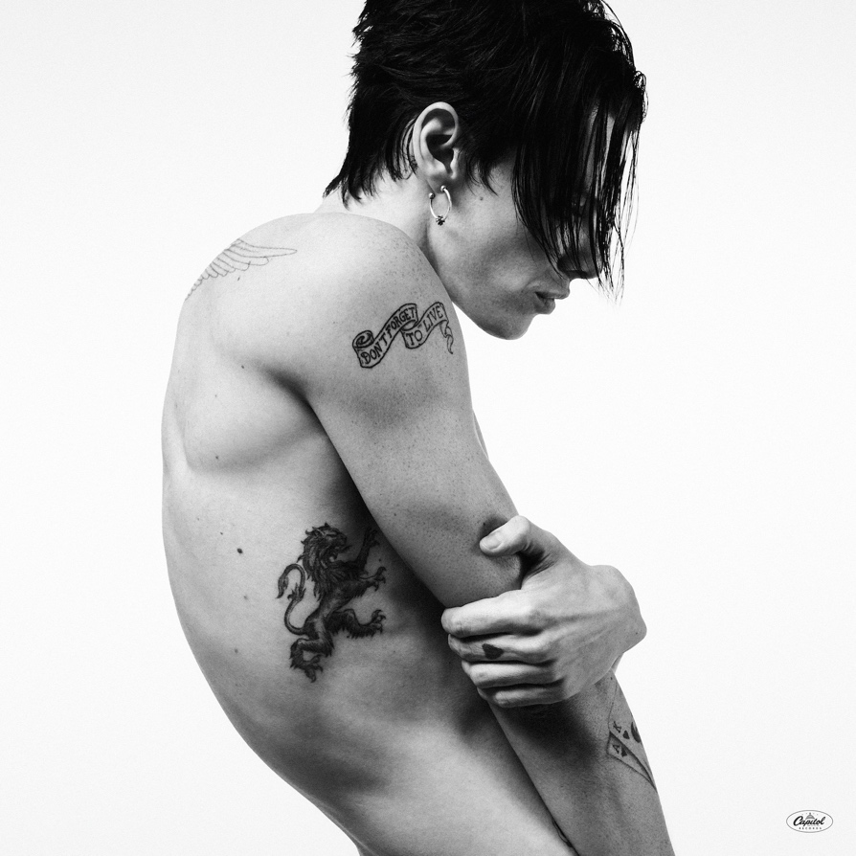

Britain’s biggest Rock star and Grammy Award-winner, Yungblud, has officially announced the long-awaited second instalment of his formidable concept album, Idols. The album is set for digital release on 20th February 2026 via Island Records/Locomotion and features six new songs alongside the Yungblud and The Smashing Pumpkins version of the Grammy Award-nominated track, ‘Zombie’.
Following the immense success of the album’s predecessor, the 28-year-old has also revealed the title of the record’s lead single, ‘Suburban Requiem’.
Speaking on the evolution of the project, Yungblud shared:

“This is it. The second chapter of the Idols story. Part 1 was a journey that helped me reclaim my identity from the darkest position I’ve ever been in my life. Part 2 is about realising that I am alive, that I am real, that this journey that I’ve been on didn’t kill me. It’s about realising that you can feel invincible when you actually feel yourself. It’s about comprehending that my heart is beating and that my lungs are filling up with air.”

Alongside the album’s digital release, available for pre-order and releasing later this year, the physical collection includes a Yungblud store-exclusive ‘Idols (Complete)’ 180g 2LP audiophile vinyl and CD, both featuring all 19 tracks from ‘Idols’ and ‘Idols II’, as well as a silver transparent ‘Idols II’ vinyl with new cover artwork.

A Landmark Era for British Rock

The album’s forebear, Idols, arrived in June 2025, securing Yungblud’s third consecutive UK Number One album. It received critical acclaim from across the press:
- Kerrang!: “It’s Yungblud like you’ve never heard him before.”
- The Telegraph: “A record that spans big, soaring melodies, angsty pop-rock ballads and even the gutsy theatrics of Queen”
- Daily Star: “His voice sounds refreshingly raw and emotional.”

This announcement follows a historic run for the Yorkshire-born artist. In November 2025, Yungblud secured his fourth UK Number One album, and his second of the year, with One More Time, a collaboration with Aerosmith. The release marked Aerosmith’s first-ever UK Number One album.

Grammy History and 2026 UK Tour

Earlier this month, Yungblud’s global impact was recognised at the 68th Annual Grammy Awards in Los Angeles where he was awarded ‘Best Rock Performance’ for his stunning rendition of ‘Changes’ at Villa Park for Black Sabbath’s Back to the Beginning concert, alongside Nuno Bettencourt, Frank Bello, Adam Wakeman and II.

With three nominations (Best Rock Performance, Best Rock Song, and Best Rock Album) he has become the first British artist in history to earn three nominations in the rock categories in a single year.
Fans won't have to wait long to hear the new material live. In April, Yungblud begins his
sold-out UK arena tour, culminating in a massive headline show at The O2 Arena, London on 24 April 2026.

IDOLS TRACKLIST:
- I Need You
- Postman
- Zombie (Yungblud, The Smashing Pumpkins)
- Time
- War Part II
- Blueberry Hill
- Suburban Requiem

ABOUT YUNGBLUD
Yungblud is the definitive musical voice of his generation, seamlessly blending Rock and Punk to monumental effect. With over 8 billion streams and 3 million albums sold, his arena-filling performances have cemented his status as one of the UK's most electrifying exports.
A multi-instrumentalist born in Yorkshire, Yungblud has achieved four UK No. 1 albums to date: Weird! (2020), Yungblud (2022), Idols (2025), and One More Time (2025). His accolades include MTV EMAs, an O2 Silver Clef Award, and a Sunday Times Best Seller for his debut book, You Need to Exist. Following the release of the feature-length documentary YUNGBLUD: Are You Ready, Boy?, he continues to lead a global movement of authenticity and acceptance.
FOLLOW YUNGBLUD: WEBSITE | INSTAGRAM | TIKTOK | YOUTUBE | X | FACEBOOK

For more information and press enquiries for YUNGBLUD please contact

Jenny Entwistle
Jenny@chuffmedia.com

