CYNTHIA ERIVO TO RELEASE MUCH-AWAITED NEW ALBUM I FORGIVE YOU ON JUNE 6

ALBUM PRE-SAVE LIVE NOW HERE

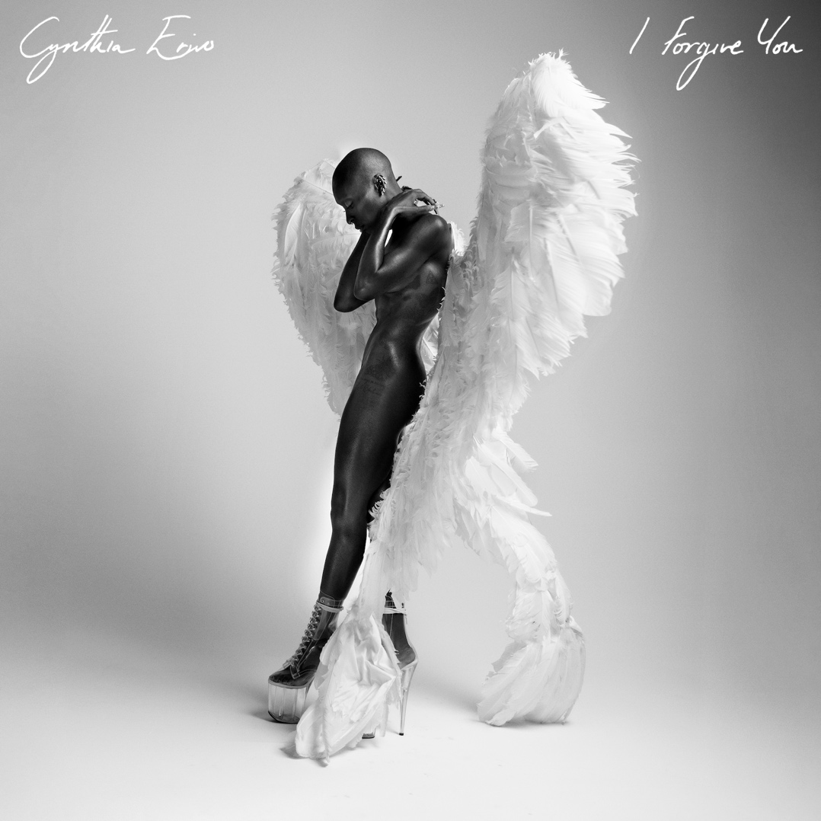

Press Assets HERE

NEW SINGLE “WORST OF ME” DROPS TOMORROW

Embarking on a bold creative chapter, GRAMMY®, Tony®, and EMMY® Award winner and three-time Academy® Award nominee Cynthia Erivo will unveil her much-awaited new full-length solo album, I Forgive You, on June 6 via Verve Records/Republic Records. Album pre-save is live now HERE.

She sets the stage for its arrival by sharing new single “Worst Of Me” tonight at Midnight 12AM ET/9PM PT/5am UK tomorrow

Cynthia has carefully curated this body of work, cowriting each song and showcasing the range of her expansive, entrancing, and enigmatic vocals. Holding nothing back and opening up more than ever before, she traces a personal, poetic, and poignant journey through romance, heartbreak, love, forgiveness, rebirth, and new beginnings.

She initially teased this chapter with the release of “Replay.” Co-written by Cynthia and Justin Tranter (Selena Gomez, Chappell Roan, Lady Gaga), it has already gathered millions of streams. Listen HERE and watch the visualizer HERE. Inciting tastemaker applause, Billboard highlighted how it “delves into the emotional rollercoaster of being human,” while ELLE hailed it as “groundbreaking,” going on to proclaim, “The confessional single is transfixing.” ESSENCE named it among “Best New Music This Week,” predicting, “Cynthia Erivo looks to add her name to the Billboard charts with the new single ‘Replay’.” She broke down the song for Genius.

Earlier this year, she was nominated in the category of “Best Actress” at the 2025 Academy® Awards for her unanimously acclaimed portrayal of Elphaba in last year’s blockbuster Wicked. She also took the Oscars' stage for a showstopping performance.

Experience I Forgive You and more from Cynthia in 2025.

ABOUT CYNTHIA ERIVO:
Cynthia Erivo’s sophomore album I Forgive You marks a bold – and vulnerable – new chapter in the Grammy®, Emmy®, and Tony® Award-winning actress, singer, author as well as SAG, Golden Globe®, and 3x Academy Award® nominee’s artistry. The tenderhearted 20-track LP is a soft testimony of her life, a haunting plea to be witnessed with an open heart. The album is split into four parts: a breakup, something new, the deepening of a connection, and acceptance. Each part is divided by haunting interludes where Cynthia’s voice is the only instrument. Blending the sounds of pop, R&B, folk, Britpop, hip-hop, wailing, and gospel, I Forgive You leaps headfirst into the most vulnerable and impassioned moments of her life, a slow-baked reminder that we’re all just flesh and bone. The good and the bad, and everything in between, make up the stories of our lives, and Cynthia Erivo is a sight to behold.

FOLLOW CYNTHIA ERIVO:

WEBSITE | INSTAGRAM | YOUTUBE | TIKTOK | FACEBOOK

For more information and press enquiries for CYNTHIA ERIVO please contact

Jenny Entwistle
Jenny@chuffmedia.com

