LOYLE CARNER
ANNOUNCES NEW ALBUM
“hugo”
OUT OCTOBER 21 VIA EMI
PRE-ORDER / PRE-SAVE HERE
-
NEW SINGLE
“GEORGETOWN”
LISTEN HERE
WATCH THE VIDEO HERE

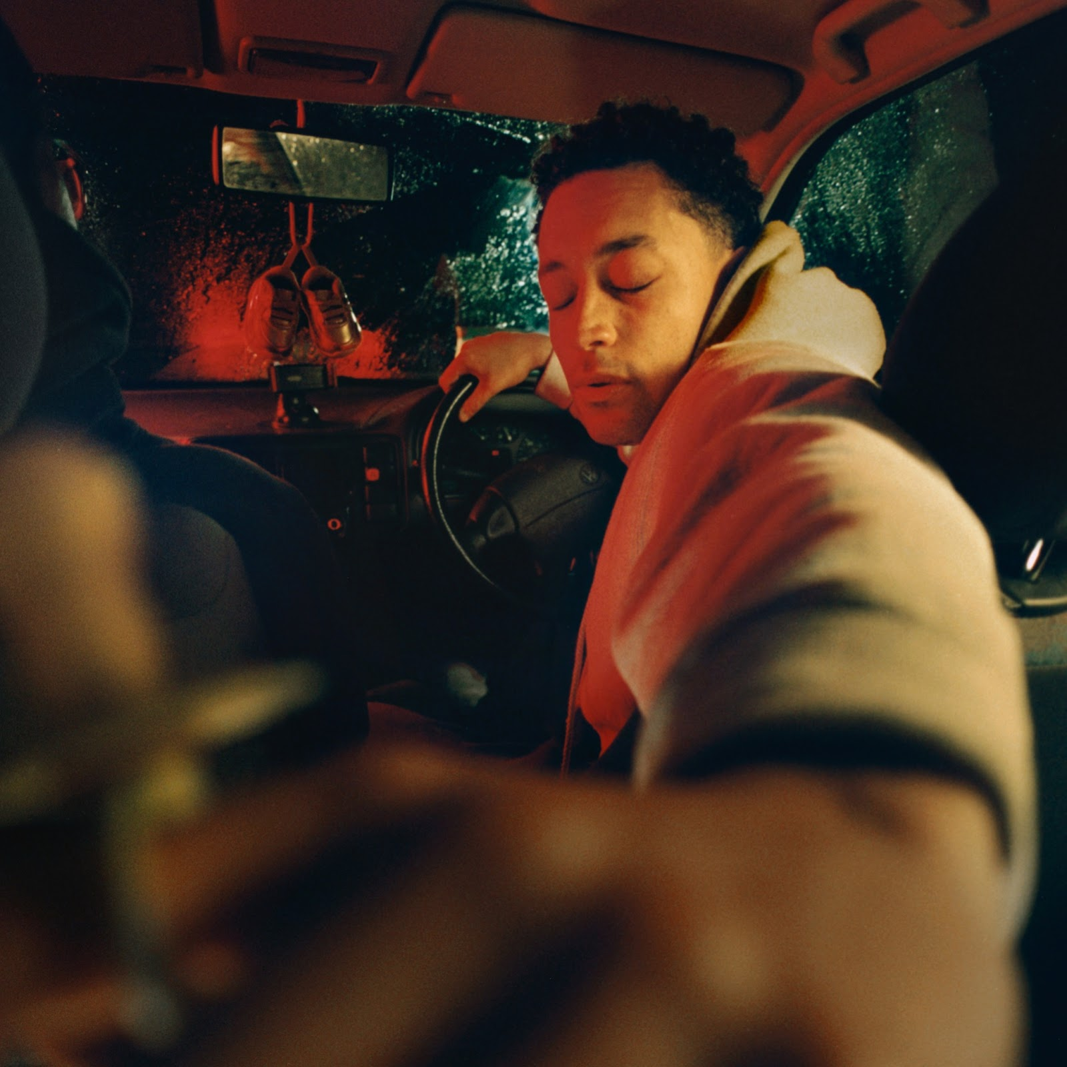

“hugo” album artwork

In hugo, there’s a central question that Loyle Carner keeps coming back to: “I’m young, Black, successful and have a platform - but where do I go next?”

The answer is explored in this epic scream of a third album. With urgent delivery and gloriously widescreen production, Carner confronts both the deeply personal (“You can’t hate the roots of a tree, and not hate the tree. So how can I hate my father without hating me?) and the highly political (“I told the black man he didn’t understand I reached the white man he wouldn’t take my hand”). Cinematic in scale and scope, hugo is both a rallying war cry for a generation forged in fire and a study of the personal internal conflict that drives the rest of the album - as a mixed-race Black man, as an artist, as a father and as a son.

With Mercury and Brits nominations, NME Awards and appearances in global brand campaigns (Nike, YSL, Timberland), Carner has undoubtedly had a meteoric rise to the top, culminating with his second album Not Waving, But Drowning charting at number 3 in the UK albums chart in 2019. However, hugo sees Carner taking a sharp detour from his previous work, putting it down to lockdown and the “hedonistic side of career being stripped away. There were no shows, no backstage, no festivals, no photoshoots”. By continuing to write in these tumultuous times with a renewed clarity and sense of artistic freedom, Carner reached deeper beneath the surface than he ever had before.

The result is his most cathartic and ambitious record yet, a coruscating journey into the heart of what it means to be alive in these tumultuous times, and one which looks set to neatly cement his position as one of the most potent and vital young talents around today. Working alongside renowned producer kwes. (Solange, Kelela, Nao), Carner leaves no stone unturned on this album, in both its sound and its stories. In a 10-track album that moves from gorgeous neo-soul moments to thundering hip hop, with immediate, infectious bangers and sampled interludes from non musicians (mixed-race Guyanese poet John Agard and youth activist and politician Athian Akec) Carner shifts seamlessly from micro to macro, confronting everything from strained relationships with family to the societal tears caused by class stratification.

It also lays bare bruises in his personal life that he has never revealed before – often in painful, deeply uncomfortable ways, focusing on Carner's experience of becoming a father in the context of growing up without contact with his biological father. With the song “Polyfilla”, against the backdrop of a warm melodic beat, Carner explores his desire to “break the chains in the cycle” of dysfunctional Black fatherhood, commenting on the narrative of fatherhood in the genre, and saying a key part of the process was realising that his father “grew up in a world where nobody showed him how to love or nurture”. The follow up track “A Lasting Place” is an exploration of the MC’s failure and inability to be perfect in this mission. The album closer is a powerful statement of love and forgiveness; with his signature lyrical dexterity, Carner declares his relentless commitment to his son and sees forgiving his father as a key part of this. The song closes with an emotional ending of Carner telling his dad “still I’m lucky yo that we talk”.

There’s a striking duality of hugo’s bold, multilayered tracks and its often starkly intimate and tender lyricism, and that dichotomy is deliberate - it is a message for young Black men, but really, anyone, who is listening. Cognizant of the immense pain and fear and confusion that we are faced with everyday, Carner has thrown down the gauntlet, defying us not to rise above the fray, wake up each day and be ambitious. Ambitious in building strong personal relationships. Ambitious in our pursuit of our goals. Ambitious in never refusing to back down against injustice. Rejecting the title of leader, Loyle Carner sees himself “as holding up a mirror”, and that clearly translates into the album's universal messages.

"hugo" TRACKLIST

1. Hate
2. Nobody Knows (Ladas Road)
3. Georgetown (feat. John Agard)
4. Speed Of Plight
5. Homerton (feat. JNR Williams & Olivia Dean)
6. Blood On My Nikes (feat. Wesley Joseph & Athian Akec)
7. Plastic
8. A Lasting Place
9. Pollyfilla
10. HGU

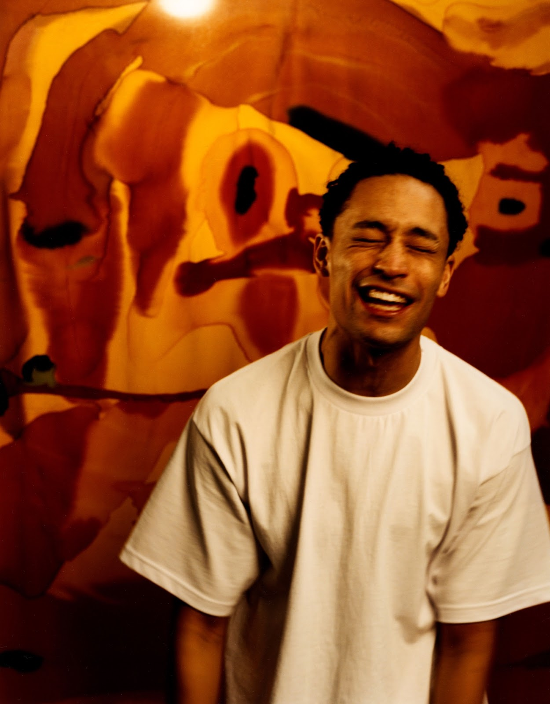
Photo credit: Jack Davison
Download high res here

Praise for “Hate”

“Loyle delivers nothing short of a masterpiece in the form of turbo-charged verses about his inner anxieties” - Wonderland

“Guilt, fear and indignation combine in this powerful new track from the south London artist” - The Observer

“This fervent and full-bodied single marks an exciting change of pace for the south London rapper previously known for his mellow beats” - The Times

“A tightly wound track that reflects the myriad thoughts, worries and irritations that seem to have been bubbling away beneath the surface” - Complex UK

“Brimming with fury and emotion, but backed against lush orchestration, it’s a deft juxtaposition that sets up his new chapter poignantly” - DIY Magazine

“An exciting, vital taste of what's to come” - Dork Magazine

“Loyle Carner channels fury, injustice and anxiety in typically poetic style on ‘Hate’” - Daily Star

“The latest track from the multi-talented south London songwriter is a vulnerable and fearful snapshot of being black and British” - i News

“Against a scuffed but sturdy breakbeat, Carner ponders the blinkered aspirations sold to black Britons, as well as his own conflicted feelings about race. A riveting screed” - The Guardian

Follow Loyle Carner
Instagram
Tik Tok
You Tube
Facebook

For more information please contact warren@chuffmedia.com

