BEN PLATT RELEASES TOUCHING NEW SINGLE "ANDREW" FROM HOTLY ANTICIPATED THIRD ALBUM HONEYMIND
EXECUTIVE PRODUCED BY DAVE COBB, HONEYMIND TO BE RELEASED MAY 31 VIA INTERSCOPE RECORDS

Listen To “Andrew” HERE
Watch The Video For "Andrew" HERE

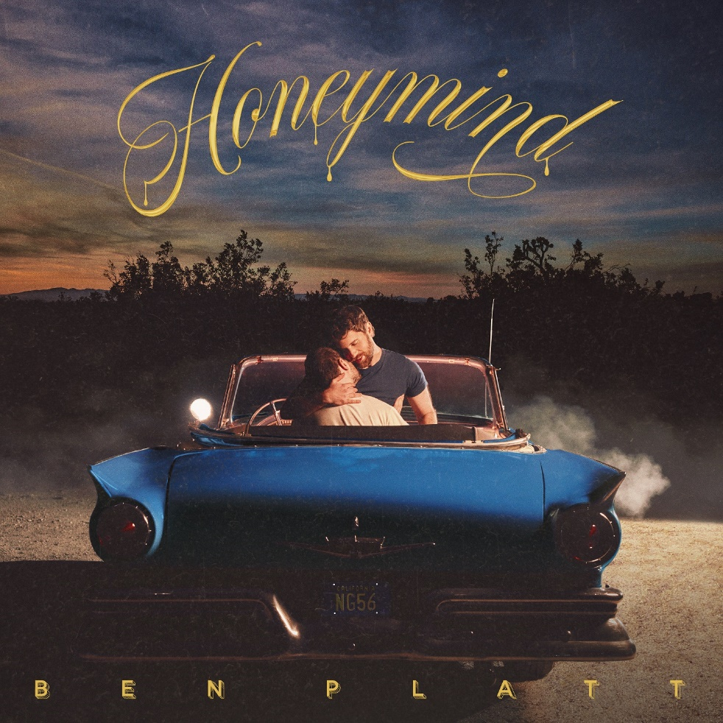

March 15, 2024 – Santa Monica, CA – Today, acclaimed singer, songwriter, and actor Ben Platt releases the tender new single "Andrew." Buoyed by raw emotion and a stripped-back approach, the folky track finds the multihyphenate delivering insightful lyrics and breathtaking vocals that effortlessly tug at the heartstrings. "Andrew" is the first taste of Platt's highly anticipated new album Honeymind, due May 31 via Interscope Records, and is accompanied by a stirring video. Listen to “Andrew” HERE and pre-order Honeymind HERE.
"His hair falls in cool, careless waves without trying, goes days without crying but still treats me kind," Platt croons over acoustic guitar plucking. "And it's not his fault all the sleep I've been losing, the way that I’m ruined — one look in his eyes and I’m gone, helplessly gone." Produced by hitmakers Dave Cobb and Alex Hope, it's a raw, vulnerable, and deeply romantic introduction to the platinum-selling artist's most introspective and unfiltered project to date.
The serene, minimalist approach of "Andrew" is reflected in the Sam Wrench (Taylor Swift: the Eras Tour, Billie Eilish: Live At The O2) directed music video. Watch the video for “Andrew” HERE.
Platt recently opened up about the creation of his new album, and how it got its name. "One day I ate some mushroom chocolate and went on a hike with the love of my life," he wrote. "I thought about how to describe to him that I was just so happy to be in love with him. That my love for him somehow softens things and slows it all down." After a moment of contemplation, he settled on "honeymind" as a suitable description for his state of bliss.
As it turns out, matters of the heart dominate the album. "I wrote about finding real love," Platt explains. "About being grateful for it and tending to it, and all of the work we have to do as individuals to find security in who we are, so that we're ready for that real love when it comes along." Although this is the first new album from Platt since 2021's Reverie, the prolific artist never slowed down. Last year, he starred on Broadway as Leo Frank in the revival of Parade, earning him his second Tony nomination, and in the film Theater Camp, which he also produced and co-wrote.
"Andrew" — and the forthcoming Honeymind — begins the latest chapter of a storied career jam-packed with hits and acclaimed performances in iconic properties such as Dear Evan Hanson, Pitch Perfect, and Parade.

###

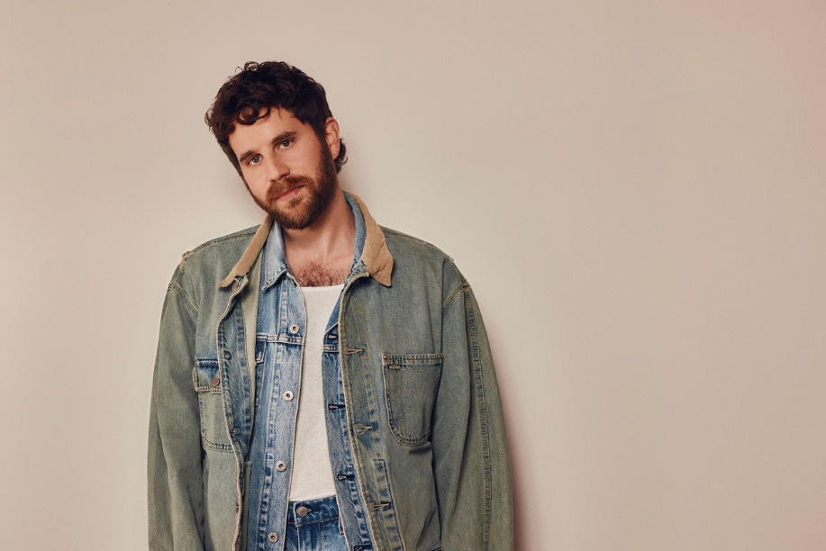
Photo credit: Vince Aung
Download hi res single art and press photos HERE.

About Ben Platt:
Tony, GRAMMY® and Emmy Award winner Ben Platt made his highly anticipated return to the New York Stage as Leo Frank in Parade at the City Center which transitioned to the Broadway stage. The riveting musical opened to rave reviews and led to Platt’s second Tony Award nomination. Most recently Ben starred in the film Theater Camp, which is co-written by Platt, Molly Gordon, Noah Galvin and Nick Lieberman inspired by their popular 2020 short film by the same name.

An accomplished recording artist, Platt has released two albums previously – 2019’s Sing To Me and 2021’s Reverie. He completed a hugely successful solo tour following the release of Reverie which saw him headlining sellout crowds at such important venues as The Hollywood Bowl, Madison Square Garden and others.

Platt won the Tony Award for Best Actor in a Musical for his groundbreaking performance as Evan in Dear Evan Hansen and later went on to reprise his role in the Universal film adaption alongside Julianne Moore and Amy Adams. Ben starred in the highly popular Netflix series by Ryan Murphy, The Politician where he served as the executive producer on the series – his performance in Season 1 earned him a Golden Globe nomination for Best Lead Actor in a Comedy Series and the show received a nomination for Best Comedy. Additionally, Platt began filming alongside Beanie Feldstein, Merrily We Roll Along which will be shot over a 20 year period, directed by Richard Linklater. Last fall, Platt was seen in the Amazon film, The People We Hate at The Wedding alongside Allison Janney and Kristen Bell. Other film and TV highlights include; Pitch Perfect 1 & 2, Ricky & the Flash, The Premise and a guest appearance on Will & Grace.

Ben Platt – “Andrew” – eSingle
Retail: http://BenPlatt.lnk.to/Andrew
Amazon Music: http://BenPlatt.lnk.to/Andrew/amazonmusic
Apple Music: http://BenPlatt.lnk.to/Andrew/applemusic
Deezer: http://BenPlatt.lnk.to/Andrew/deezer
iTunes: http://BenPlatt.lnk.to/Andrew/itunes
Pandora: http://BenPlatt.lnk.to/Andrew/pandora
SoundCloud: http://BenPlatt.lnk.to/Andrew/soundcloud
Spotify: http://BenPlatt.lnk.to/Andrew/spotify
Tidal: http://BenPlatt.lnk.to/Andrew/tidal
YouTube Music: http://BenPlatt.lnk.to/Andrew/youtubemusic
Official Music Video: http://BenPlatt.lnk.to/AndrewVideo

Ben Platt – “Honeymind” – Album Pre-Order
Retail: https://BenPlatt.lnk.to/Honeymind
Amazon Music Pre-Order: https://BenPlatt.lnk.to/Honeymind/amazonmusic
Apple Music Pre-Add: http://BenPlatt.lnk.to/Andrew/applemusic
Barnes & Noble: https://BenPlatt.lnk.to/Honeymind/barnesnoble
iTunes Pre-Order: https://BenPlatt.lnk.to/Honeymind/itunes
Spotify Pre-Save: https://BenPlatt.lnk.to/Honeymind/spotify
D2C Store: https://BenPlatt.lnk.to/OfficialStore

# # #

TikTok | Instagram | Spotify | Facebook

For more information and press enquiries please contact

Jenny Entwistle
Jenny@chuffmedia.com

