GRACIE ABRAMS PREMIERES NEW SINGLE & VIDEO
“Where Do We Go Now?”

ACCLAIMED singer-SONGWRITER TO RELEASE DEBUT ALBUM
Good Riddance ON february 24TH

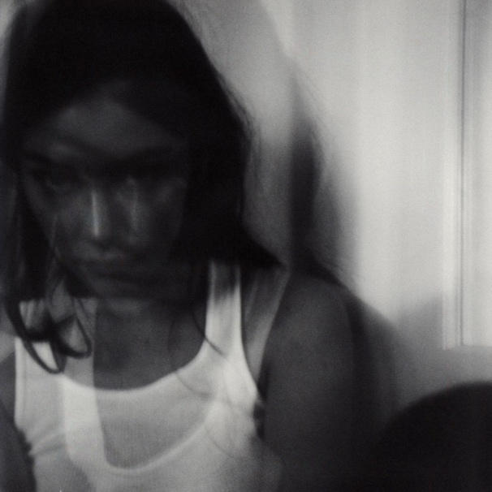

Today, acclaimed singer-songwriter Gracie Abrams shares her poignant and powerful new single “Where do we go now?” and its accompanying video. A gorgeously observed portrait of fading connection, “Where do we go now?” will appear on Abrams’s highly anticipated debut album Good Riddance. Produced by Aaron Dessner of The National, Good Riddance will be released February 24th via Polydor Records. Listen to “Where do we go now?” HERE, and watch the video HERE.

Produced by and co-written with her frequent collaborator Dessner, “Where do we go now?” finds Abrams documenting her emotional experience with more precision and impact than ever before. As she narrates the end of a fractured relationship and all the confusion, frustration, and longing that come with it, the 23-year-old artist achieves a new level of lyrical honesty and self-possession — an element fully reflected in her quietly captivating vocal work. Set against a sparse but hypnotic backdrop of elegantly sculpted beats, the result is a perfect introduction to the unfettered introspection that infuses all of Good Riddance. Good Riddance is available for pre-order now HERE.

Directed by Gia Coppola (Carly Rae Jepsen, Blood Orange), the video for “Where do we go now?” cycles through a series of stunningly composed shots capturing Abrams in various states of emotional unrest. With its delicate interplay of shadows and light, the visual shifts from stark black-and-white to softly saturated color as Abrams wholly embodies the track’s whirlwind of feelings, ultimately pulling the audience even deeper into her interior world.

“Where do we go now?” arrives as Abrams’s first new music since “Difficult,” an October release also produced by and co-written with Dessner. A shining example of the poetic realism at the heart of her songwriting, “Difficult” earned immediate praise from the likes of Rolling Stone, who hailed the track as “a candid look at the uncertainty that comes with growing up” and noted that “putting those feelings of anxiety about the unknown so eloquently is a skill that most of her peers are still refining.”

Abrams’s upcoming North American headlining tour The Good Riddance Tour kicks off on March 6th in Chicago. Along with performing in 14 cities across the U.S., Abrams will join Taylor Swift on select dates for her blockbuster Eras Tour. For more information, and to purchase tickets, visit www.gracieabrams.com/tour.

ABOUT GRACIE ABRAMS
Since making her debut with “Mean It” in October 2019, Gracie Abrams has emerged as one of the most compelling songwriters of her generation, earning the admiration of such likeminded artists as Lorde, Billie Eilish, and Olivia Rodrigo. A consummate songwriter who names Joni Mitchell as her most formative influence, she penned her first song at age eight, then went on to amass a devoted following on the strength of her emotionally intimate lyrics and DIY sensibilities. As her profile rose, Abrams was named an artist to watch by tastemaking outlets like Pigeons & Planes, Fader, and i-D, in addition to being crowned one of seven breakout female musicians by Vogue UK. With the arrival of her debut project minor in summer 2020, she received glowing reviews from the likes of NME, who praised her “painfully honest tales of heartbreak draped in delicate melodies that carry much more intrigue than the usual run-of-the-mill singer-songwriter.” Executive-produced by Blake Slatkin — and also made with leading producers like Joel Little and benny blanco — the seven-song effort features her beloved singles “21,” “I miss you, I’m sorry,” and “Long Sleeves.” In 2021, Abrams returned with This Is What It Feels Like, a 12-track project exploring such complex emotions as self-betrayal, insecurity, and failed attempts at connection. Soon after completing her sold-out North American headline tour for This Is What It Feels Like, she set to work on her debut album Good Riddance, due out on February 24.

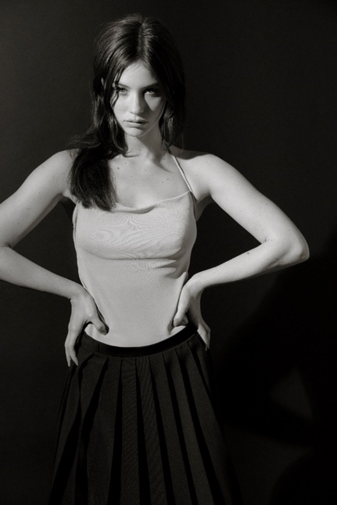
Photo by: Danielle Neu
Click HERE for hi res press photo

For more information on Gracie Abrams, visit:

instagram
twitter
youtube

For more information and press enquiries please contact

Jenny Entwistle
Jenny@chuffmedia.com

