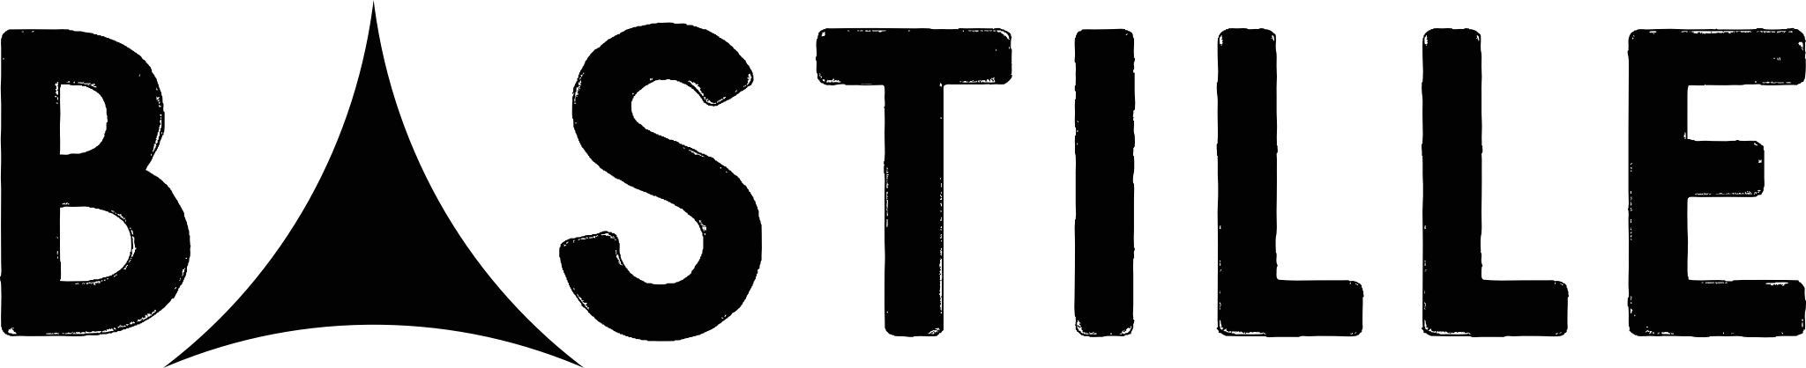

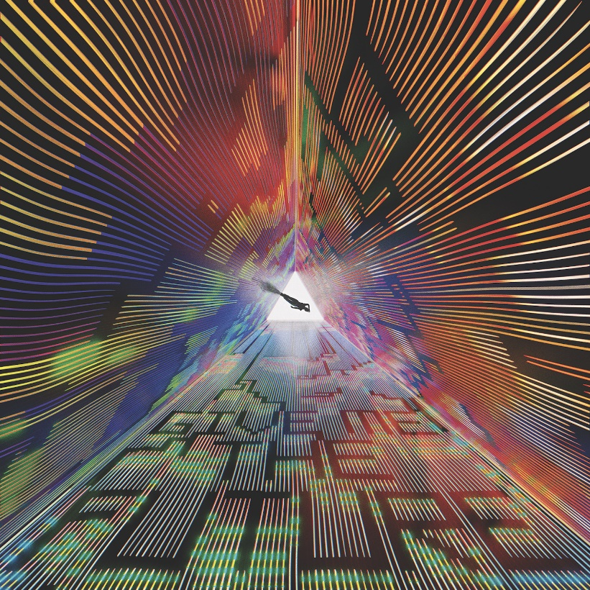

ANNOUNCE NEW ALBUM ‘GIVE ME THE FUTURE’ OUT FEBRUARY 4th 2022

NEW SINGLE ‘NO BAD DAYS’ OUT NOW

VIDEO CO-DIRECTED BY DAN SMITH

LISTEN HERE

WATCH HERE
PRE-ORDER GIVE ME THE FUTURE HERE
Give Me The Future, Bastille’s wildly ambitious and brilliantly bold new album is set for release on February 4th, 2022. To celebrate the announcement, the band releases their new single “No Bad Days,” accompanied by the official video co-directed by Dan Smith, today—listen HERE and watch HERE.
Give Me The Future is a tribute to humanity in a tech age and reflects on the strangeness of living through times that can feel like science fiction. Exploring both the opportunities of new technology and the dark side of lives lived online, it’s as playful and fun as it is thought-provoking, as dystopian as it is dancefloor-friendly, and as electronic as Bastille have ever been.
Eerily, songwriter Dan Smith came up with the idea pre-pandemic. The album was already underway and the band on hiatus from touring when the world shut down, forcing interaction solely through screens.
“Working on these songs in such an apocalyptic period, with everyone stuck at home, glued to screens, fed into the feeling that what is real and what is not has become pretty difficult to discern sometimes,” says Dan. “We’re in the age of deep fake, fake news and lying world leaders. But online, you can be anyone. What that does to our sense of self and to our relationships is huge and it’s fascinating.”
Give Me The Future takes us into a sci-fi wonderland free from restrictions – each song a different danceable dreamscape, a place where you can travel back and forward in time to be anyone, do anything and embrace a new wave of technology which enables us to get lost inside our imagination. The album is laced with references to the world of science fiction film and literature, video games and VR.

It’s a record that takes the idea of the limitless possibilities of the future and journeys everywhere from a joyride of escapism on the uplifting, Thelma & Louise – a tribute to the iconic feminist film on its 20th anniversary, to ‘80s New York with the artist Keith Haring on the bright and whistling Club 57, to a hospital bed in Australia for the devastating but hopeful new single, No Bad Days; Co-directed for the first time by Smith, the music video for the track is set in a futuristic laboratory and sees Dan playing a character using technology to try and resurrect a lost loved one. Nodding to the classic science fiction of “Metropolis”, “Ex Machina” and “The Matrix”, the video paints an emotional and intimate story. Watch HERE.
“It’s really satisfying to have finally directed, and I’m really proud of the little film we made. I grew up with film as my main obsession, so this was a bit of a dream. I learned a shitload and it was good to be challenged in a new way.”
You’ll hear disco basslines, orchestras of synths, guitars, futuristic gospel, spaceship sounds, euphoric strings, vocoders, talk boxes, a choir of roadies and host of beats. The title track, Give Me The Future tips its hat to Phil Collins and The Police, Shut Off The Lights is a sonic love letter to Paul Simon’s Graceland and Stay Awake nods to Daft Punk and Quincy Jones.
Having thrown himself into co-writing for other artists in recent years, for the first time ever on a Bastille album, the band inched open the door to collaborators. Although primarily produced by Dan Smith and long term production partner Mark Crew, the band also worked with a handful of writers and producers to expand the world. Distorted Light Beam was co-written and produced with Ryan Tedder (Adele, Paul McCartney, Taylor Swift) who also helped as a sounding board and executive producer for the album. Thelma + Louise, Stay Awake and Back To The Future were co-written with legendary songwriter Rami Yacoub (Britney Spears’ “…Baby One More Time”, Lady Gaga’s Chromatica Album). They also worked with British writers Jonny Coffer, Plested and Dan Priddy to bring the album to life.
You’ll also hear the voice of award-winning actor, musician, writer, creator, producer, director and activist Riz Ahmed on a spell-binding and evocative spoken word piece called Promises. Riz’s piece was a response the album and brings it’s overarching themes into sharp focus.

Over the course of their previous three albums, Bastille have cemented a reputation for building whole worlds around their releases, often doing so with innovative award-winning creativity. Give Me The Future is no different, this time accompanied by a fictional, but familiar tech giant called Future Inc, the creators of an invention called Futurescape - a device which allows users to live out their dreams virtually. It’s weaved through every element of the campaign and can be seen in the videos for all three singles - Distorted Light Beam, Thelma & Louise and No Bad Days (add link)

Sonically diverse and thematically adventurous, Bastille’s fourth album, Give Me The Future pushes the band into exciting new frontiers. The record serves as less of a judgement on modern life, more a reflection on where we are and perhaps where things could be, “I’m just observing the truly weird times we’re living in and having fun responding to it through these songs,” Dan says. “As the final track “Who Knows What the Future Holds… Don’t Matter If I Got You” says, this is happening, whether we like it or not. Finding happiness in the moment is surely the aim, whether it’s in the real or virtual world.”

Full tracklisting;
“GIVE ME THE FUTURE”

- Distorted Light Beam
- Thelma + Louise
- No Bad Days
- Brave New World (Interlude)
- Back To The Future
- Plug In…
- Promises (by Riz Ahmed)
- Shut Off The Lights
- Stay Awake?
- Give Me The Future
- Club 57
- Total Dissociation (Interlude)
- Future Holds (feat. BIM)

“You don’t predict the future, you imagine it.”
Future Inc.

ABOUT BASTILLE:
The four-piece has been experimenting and augmenting the Bastille sound since the release of their last album Doom Days in 2019, the conclusion of an unofficial trilogy. Last year, they released the Goosebumps EP, featuring Graham Coxon on “WHAT YOU GONNA DO???” and producer Kenny Beats on the title track, as they continued to pen songs that seek to understand and offer escape from the modern human condition. Doom Days received huge critical acclaim and charted in the Top 5 in both the U.K. and U.S., the only U.K. band to have achieved this chart landmark alongside The Beatles and Queen in 2019. The record found the band at their most lyrically provocative, most accomplished, and most vital and charts the course of one night in search of distraction from the surrounding apocalypse (sound familiar?). During the course of 2019, the four-piece continued to cement their reputation as one of the world’s most captivating live bands, having played an extensive two month-long sold-out U.S. and U.K. tour. At the beginning of 2020, Bastille received their sixth Brit nomination and their second nomination for British Group. In January 2021, Bastille was the subject of ReOrchestrated, a documentary film that provided a revelatory and bracingly honest new look into the band’s journey so far, framed through their ReOrchestrated shows and diving into themes of motivation, anxiety, and imposter syndrome. Over the summer, Bastille headlined both Latitude Festival and Standon Calling Festival, and played a further two sold-out shows at Hampton Court Palace Festival. With over 11 million records sold, 6 U.K. Top 40 singles, and 1.5 billion video views, Bastille continues to be one of the world’s most streamed bands.

BASTILLE: INSTAGRAM | TWITTER | WEBSITE

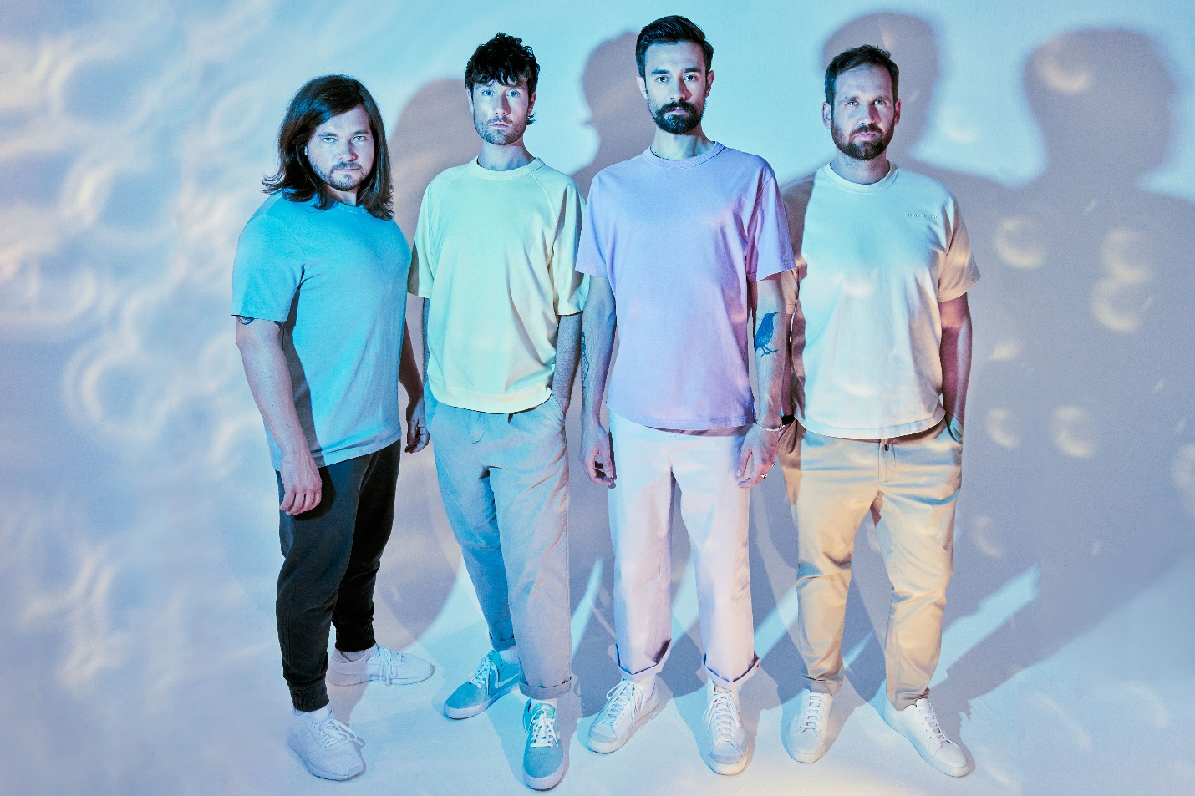

For more information and press enquiries please contact
Jenny Entwistle
Jenny@chuffmedia.com

