3X GRAMMY® AWARD SINGER/SONGWRITER
OLIVIA RODRIGO ANNOUNCES GUTS (SPILLED) – THE DELUXE EDITION OF NO. 1 ALBUM GUTS – OUT MARCH 22
ON GEFFEN RECORDS, PRE-SAVE HERE

NEW SINGLE “OBSESSED” IS ONE OF FIVE ADDITIONAL TRACKS INCLUDED

MASSIVE 75-DATE GUTS WORLD TOUR UNDERWAY

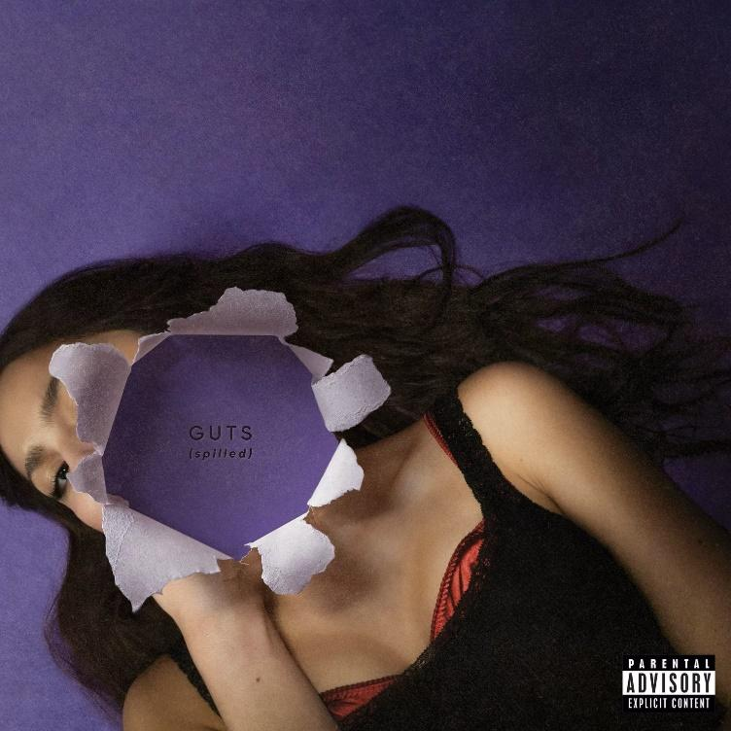

Download cover art HERE

GUTS (spilled), the deluxe edition of Olivia Rodrigo’s chart-topping sophomore album, will be released on March 22 via Geffen Records. Five additional songs will appear on the deluxe, including her new single “obsessed,” which has been performed nightly on the GUTS World Tour. Pre-Save GUTS (spilled) HERE.

Rodrigo wrote “obsessed” with Daniel Nigro, who produced GUTS as well as her debut album SOUR, and Annie Clark (who records as St. Vincent). The song originally appeared as a hidden track on the red D2C exclusive vinyl, standard black and additional retail variants of GUTS vinyl. The deluxe album also includes “girl i’ve always been,” “scared of my guitar” and “stranger” – hidden tracks from other color vinyl variants of GUTS. A brand-new song “so american,” recorded following the release of GUTS, appears on the deluxe as well.

Rodrigo, who is currently on her sold-out North American arena tour in support of GUTS, announced the deluxe tonight from the stage of her first of a two-night run at the United Center in Chicago. The New York Times observed, “The opening night of the pop star’s Guts World Tour had sparkle and abandon, but making her songs feel big didn’t require much besides the songs themselves.” The Los Angeles Times praised the “thrilling tour opener” while Rolling Stone noted, “Rodrigo cemented her position in pop culture as a generation-defining artist.” View the tour itinerary HERE.

Hailed as an “instant classic” by Rolling Stone, a “masterpiece” by the Los Angeles Times and “bitingly charismatic” by Pitchfork, GUTS topped the album charts in over 13 countries including the U.S., where it debuted at No. 1 on the Billboard 200, coinciding with lead single “vampire” returning to the top spot on the Billboard Hot 100 and Rodrigo’s No. 1 ranking on the Artist 100, thereby giving her a chart triple. GUTS’ 11 other tracks all appeared in the top 40 of the Hot 100, making Rodrigo the first artist to chart all songs from two career-opening albums in the Hot 100’s top 40. When critics reflected on the best albums of 2023, GUTS appeared on more than 30 lists, including The New York Times, Rolling Stone, NPR, Pitchfork and Billboard.

GUTS (spilled) tracklist:

1. all-american bitch
2. bad idea right?
3. vampire
4. lacy
5. ballad of a homeschooled girl
6. making the bed
7. logical
8. get him back!
9. love is embarrassing
10. the grudge
11. pretty isn’t pretty
12. teenage dream
13. obsessed
14. girl i’ve always been
15. scared of my guitar
16. stranger
17. so american

For more information and press enquiries please contact
Jenny Entwistle
Jenny@chuffmedia.com

