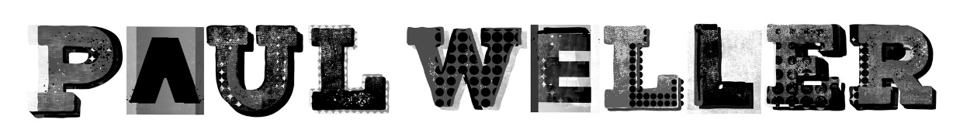

FAT POP (VOLUME 1)

Released May 14th on Polydor Records

We may be cursed to be in the midst a global pandemic, buffeted by all of its stresses and pain. But everyone knows that art provides succour, that music is the most reliable balm. And for many there is further significant comfort to be drawn from the knowledge that Paul Weller is in the midst of an unbelievably prolific purple patch. Paul Weller will not let us down when we need him most.

On May 14th, Paul Weller releases his 16th solo album since his self-titled debut in 1992, which comes in just under twelve months following June 2020’s magnificent, chart-topping On Sunset. It’s not hyperbole to state that this new album, titled Fat Pop (Volume 1), is among his most compelling collections. It’s an absolute scorcher.

During spring last year, after his tour dates were postponed, Paul Weller needed something else to focus on. With many ideas for new songs stored on his phone, Paul started to record them on his own with just vocals, piano and guitar which he’d send to his core band members (drummer Ben Gordelier, Steve Cradock on guitar and bassist Andy Crofts) to add their parts. Despite it being strange not being together, it kept the wheels rolling and sanity prevailing. The band reconvened at Weller’s Black Barn studio in Surrey when restrictions were lifted to finish the work with the shape of the album becoming clear to all.

Fat Pop (Volume 1) – Paul adding the “Volume 1” to keep options open for a second volume in the future - is a diverse selection of sounds. No one style dominates. There’s the synth-heavy, future-wave strut of Cosmic Fringes, the stately balladeering of Still Glides The Stream (co-written with Steve Cradock), the chunky percussive groove of Moving Canvas (a tribute to Iggy Pop no less), and the kind of dramatic immediate pop symphonies on Failed, True and Shades of Blue with which Paul Weller has hooked in generation after generation of devotee.

As ever, Fat Pop, sees a number of guests contributing including Lia Metcalfe, the young Liverpudlian singer with The Mysterines who combines her tremendous vocal as well as a song writing credit to True. Andy Fairweather Low adds his distinctive vocals to superfly strutting Testify and Paul’s daughter Leah co-wrote and features on the classic 3 minute pop kitchen sink drama Shades Of Blue which will be the first single taken from the album. Hannah Peel is back in the fray adding her classic string scores to Cobweb Connections and Still Glides The Stream.

Tracklisting:

COSMIC FRINGES
TRUE
FAT POP
SHADE OF BLUE
GLAD TIMES
COBWEB / CONNECTIONS
TESTIFY
THAT PLEASURE
FAILED
MOVING CANVAS
IN BETTER TIMES
STILL GLIDES THE STREAM

Fat Pop comes in several covetable formats all showcasing the stunning artwork:
Standard CD
Individual exclusive cassettes for Indie Record Stores and Paul’s artist store
Individual exclusive coloured vinyl for Amazon, Indie Record Stores and Paul’s artist store
Black Heavyweight vinyl
Exclusive picture disc vinyl

Deluxe Formats which include Fat Pop, Mid-Sömmer Musik (the live special from November last year) and bonus tracks:
3 CD Box Set
3 LP Box set – heavyweight black vinyl

For the latest news on tour dates see www.paulweller.com

For more info please contact Warren@chuffmedia.com on 07762 130510

