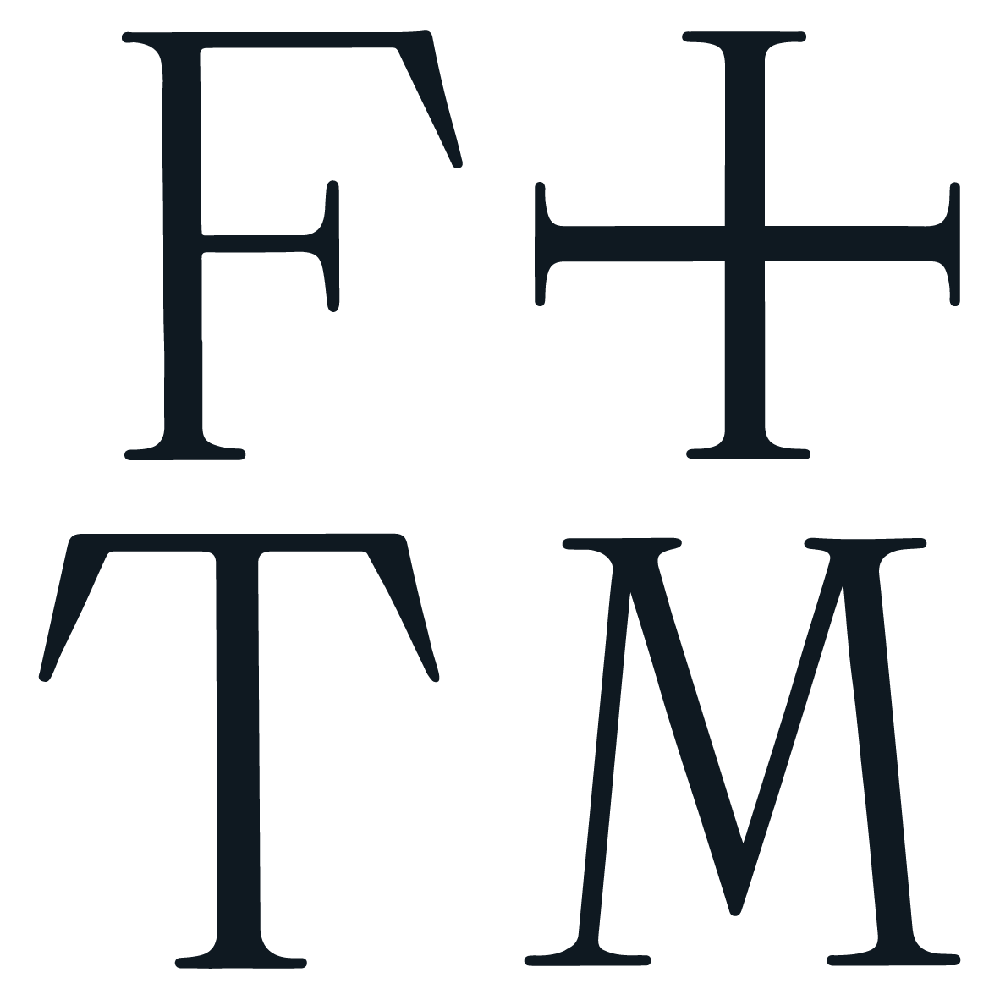
FLORENCE + THE MACHINE
ANNOUNCES NEW ALBUM EVERYBODY SCREAM FOR HALLOWEEN RELEASE
(Pre-order HERE)
TITLE TRACK OUT NOW
(Watch/Listen HERE)

(Press photo, credit Autumn de Wilde)
Today, Florence Welch, also known as Florence + the Machine, confirms her sixth studio album Everybody Scream is set for release on October 31. The album’s title track debuts today with an accompanying video directed by Autumn de Wilde, watch here and listen here. Preorder the album here.
Florence Welch wrote and produced the album over the past two years with a close-knit circle of collaborators including Mark Bowen of IDLES - who appears in the video for ‘Everybody Scream’ - Aaron Dessner and Mitski.
After needing lifesaving surgery on the Dance Fever Tour, Florence’s recovery took her down the path of spiritual mysticism, witchcraft and folk horror as she felt the limits of her body and explored what it means to be “healed”. The album treads through womanhood, partnership, aging and dying; exposing the murky in the mundane.
Across five albums - 2009’s Lungs, 2011’s Ceremonials, 2015’s How Big, How Blue, How Beautiful, 2018’s High As Hope and 2022’s Dance Fever - Florence has become one of the most monumental artists of a generation, with multiple US and UK #1 albums and countless awards. Known for her earth-shattering live show and singular, iconic voice, Florence has sold out shows and headlined festivals the entire world over. She has collaborated and shared stages with icons - The Rolling Stones, Lady Gaga and Taylor Swift among them - and published a book of lyrics, poetry and drawings, Useless Magic.

(Album cover, credit Autumn de Wilde)

Follow Florence HERE

For more information, please contact jenny@chuffmedia.com

