5 SECONDS OF SUMMER RETURN WITH NEW SINGLE “NOT OK” OUT NOW

ANNOUNCE SIGNING TO REPUBLIC RECORDS

GEARING UP FOR SIXTH FULL-LENGTH ALBUM, EVERYONE’S A STAR!, OUT NOVEMBER 14TH

LISTEN TO “NOT OK” HERE

PREORDER EVERYONE’S A STAR!

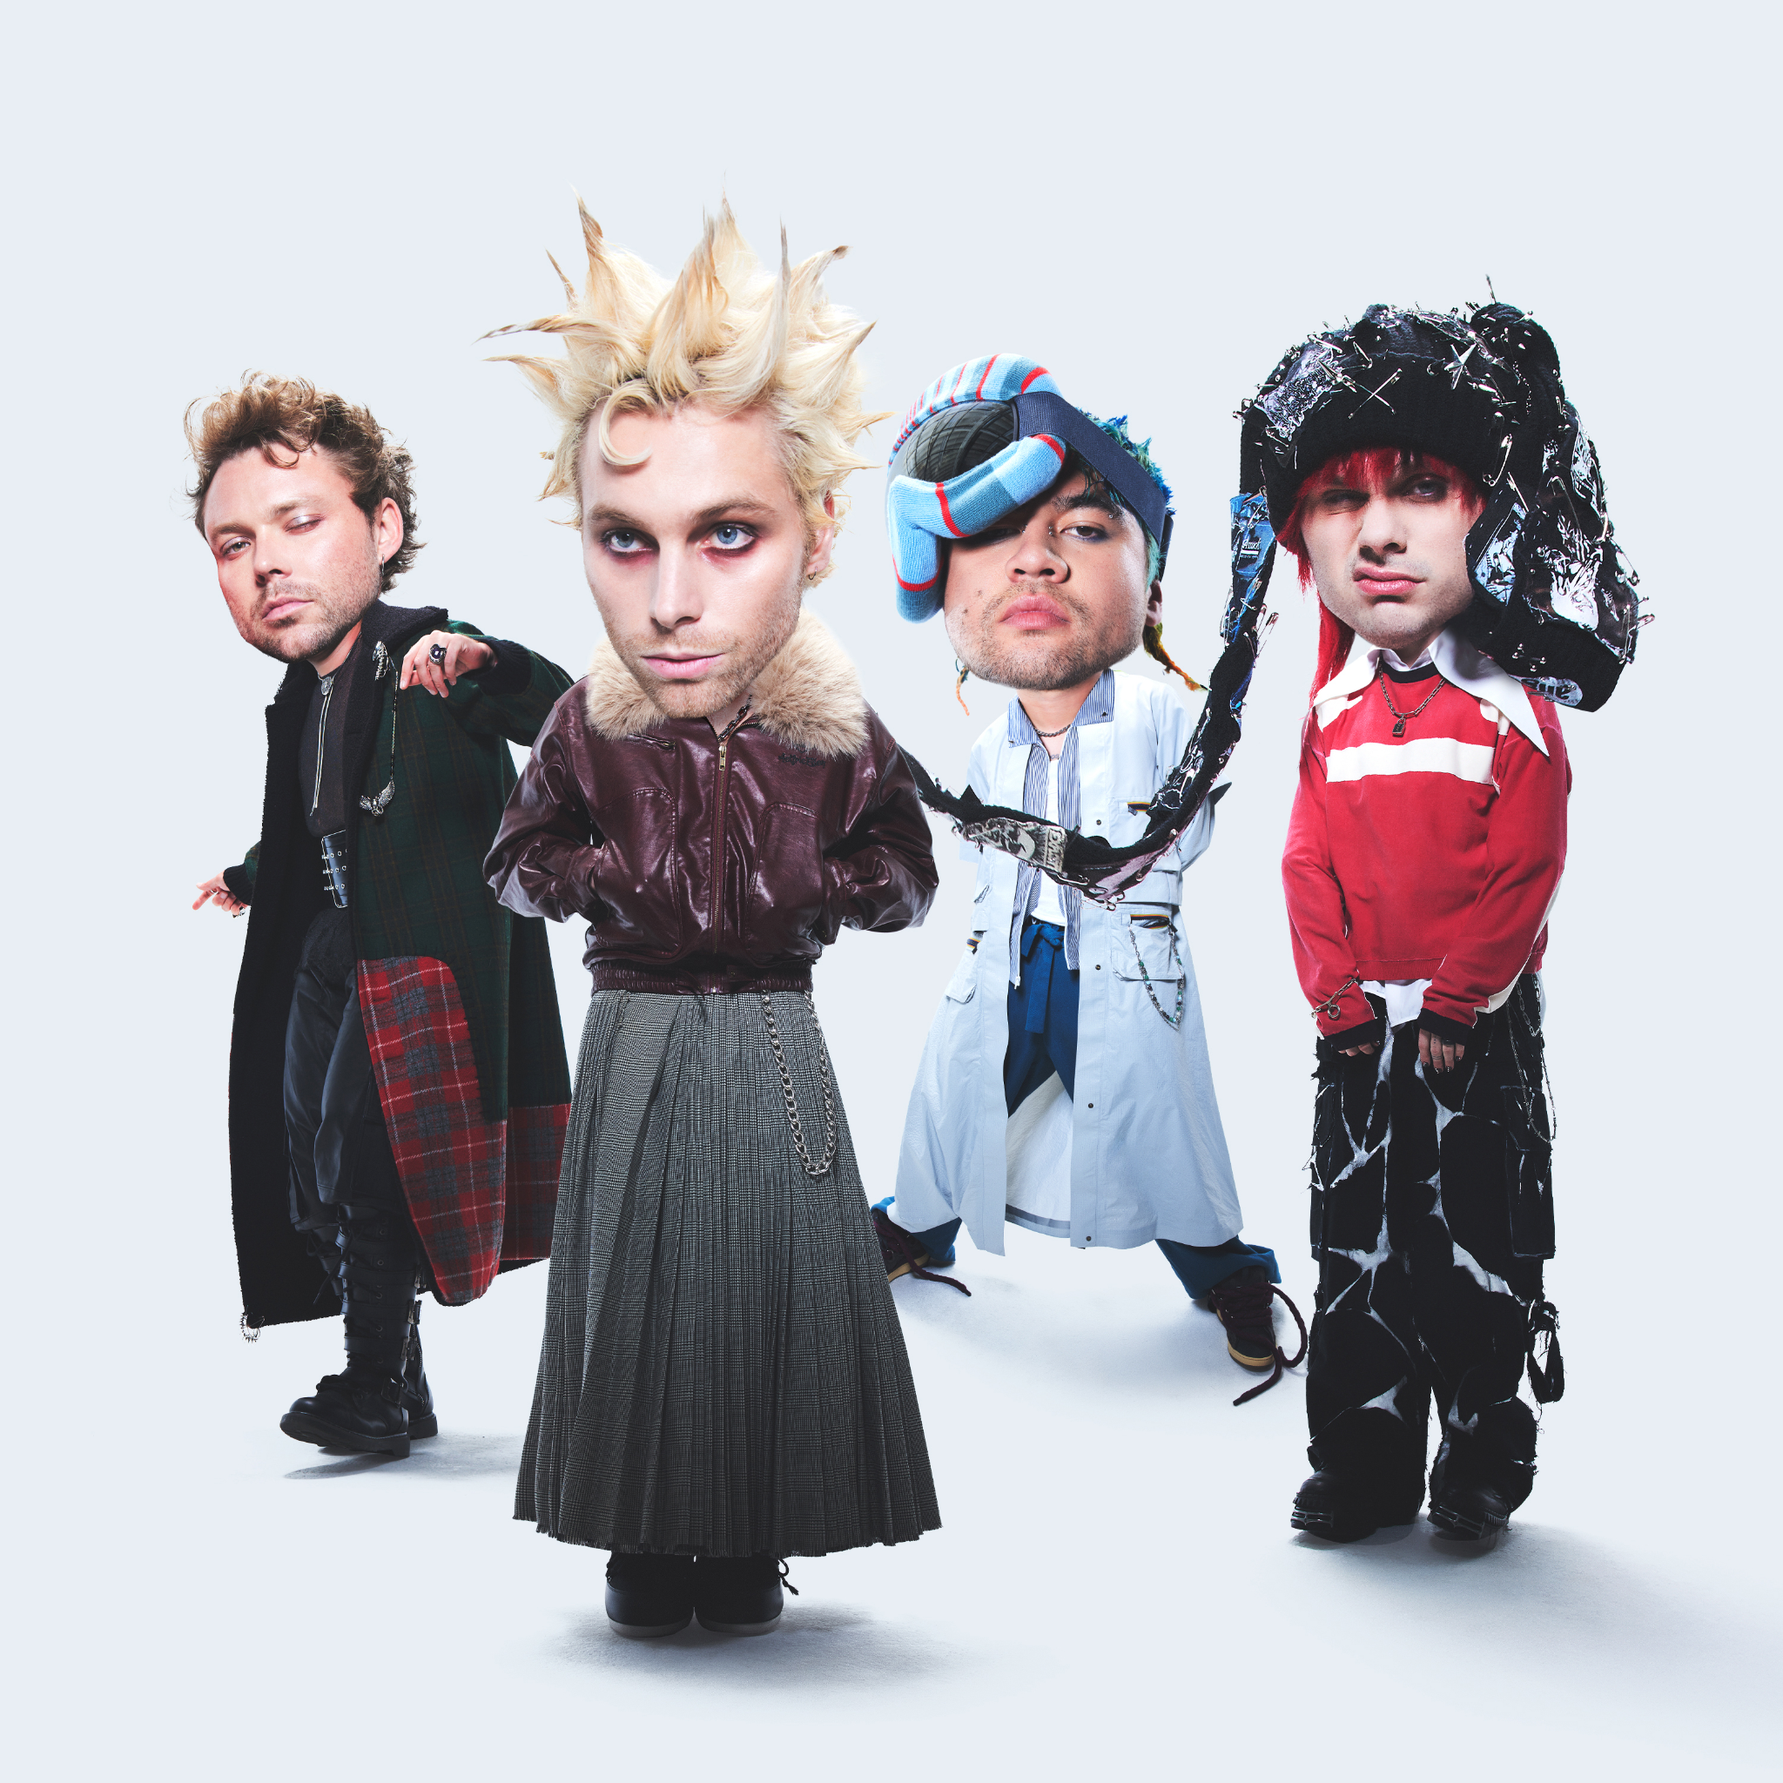

NEW YORK, NY (September 24th, 2025) — Today, history-making multiplatinum Australian alt-rock and future punk / pop band 5 Seconds of Summer return with their first new single in three years, “NOT OK” It not only marks their first release since 2022, but it also serves as the group’s debut under their newly minted deal with Republic Records.

Listen to “NOT OK” HERE

Preorder Everyone’s A Star!

Everyone’s A Star! Tracklist:
1. Everyone’s A Star!
2. NOT OK
3. Telephone Busy
4. Boyband
5. No. 1 Obsession
6. I’m Scared I’ll Never Sleep
7. istillfeelthesame
8. Ghost
9. Sick of Myself
10. Evolve
11. The Rocks
12. Jawbreaker



The quartet—Luke Hemmings [vocals, guitar], Michael Clifford [vocals, guitar], Calum Hood [vocals, bass], and Ashton Irwin [vocals, drums]—have boldly elevated their sound to another stratosphere with “NOT OK.” Nodding to everyone from The Prodigy to N.E.R.D., the track’s bright hyper-charged beat could just as easily ignite the dancefloor of an underground rave as it could shake festival grounds anywhere in the world. Across the song, anxious cymbals accent a buoyant bassline, and a hummable guitar solo rings out as Luke carries an emotionally complicated and undeniably catchy chorus, “Hey, I’m not okay! I like the darker side of me, that part of me comes out to play when I’m with you, bite the apple, baby.” It has all the makings of a live staple from the group as well.

Regarding “NOT OK,” Luke commented, “It has the older 5 Seconds of Summer energy, but it’s different—which is the whole M.O. of this chapter. Lyrically, it’s about letting out the darker side of yourself and embracing it. The song is also a nod to the band itself. We pull those sides out of each other.”

Most importantly, it heralds the arrival of the band’s sixth full-length album, Everyone’s A Star!, coming soon. The guys carefully assembled the record throughout 2024 and 2025, working in Los Angeles and Nashville with the likes of Jason Evigan [Maroon 5, Benson Boone, Papa Roach, Rüfüs Du Sol], Julian Bunetta & John Ryan (Sabrina Carpenter, Teddy Swims)

About the album, Luke added, “This band is made of four people who could all have their own solo albums where they do it all, sing it all, and write it all. Everyone’s A Star! embodies all of that. We were teenagers at the beginning of 5 Seconds of Summer. We were writing with more naivete, but we said what we were thinking. As time goes on, you tend to get a bit more cautious about what you say, but I think this record has more of our original sprit—but with 15 years of wisdom and a dash of reckless abandon.”

Back in 2022, 5 Seconds of Summer dropped their most recent album, 5SOS5. It notably bowed at #2 on the Billboard 200 and spawned the Billboard Hot 100 hit “Complete Mess.”

Get ready for a whole lot more from 5 Seconds of Summer very soon though.

Their biggest, boldest, and brightest era begins now. This is 5SOS 2.0 - Evolved.

ABOUT 5 SECONDS OF SUMMER
Formed in Sydney, Australia in 2011, 5 Seconds of Summer have grown from local high school friends into one of the biggest bands of the 21st century. Across fourteen years, the multi-platinum group has sold over 18 million albums, moved more than six million tickets worldwide, generated over 10 billion streams, and achieved three Billboard 200 #1 debuts, while winning multiple accolades at the ARIA Awards, MTV EMAs, MTV VMAs, and beyond. Known for their genre-defying collaborations and globe-spanning tours, the quartet - Luke Hemmings, Michael Clifford, Calum Hood, and Ashton Irwin - continue to reinvent what a modern band can be.
With the release of their highly anticipated sixth album Everyone’s A Star! - their first under Republic Records - 5 Seconds of Summer usher in their most ambitious era yet, led by the explosive single “NOT OK.”

For more information and press enquiries please contact
Jenny Entwistle
Jenny@chuffmedia.com

