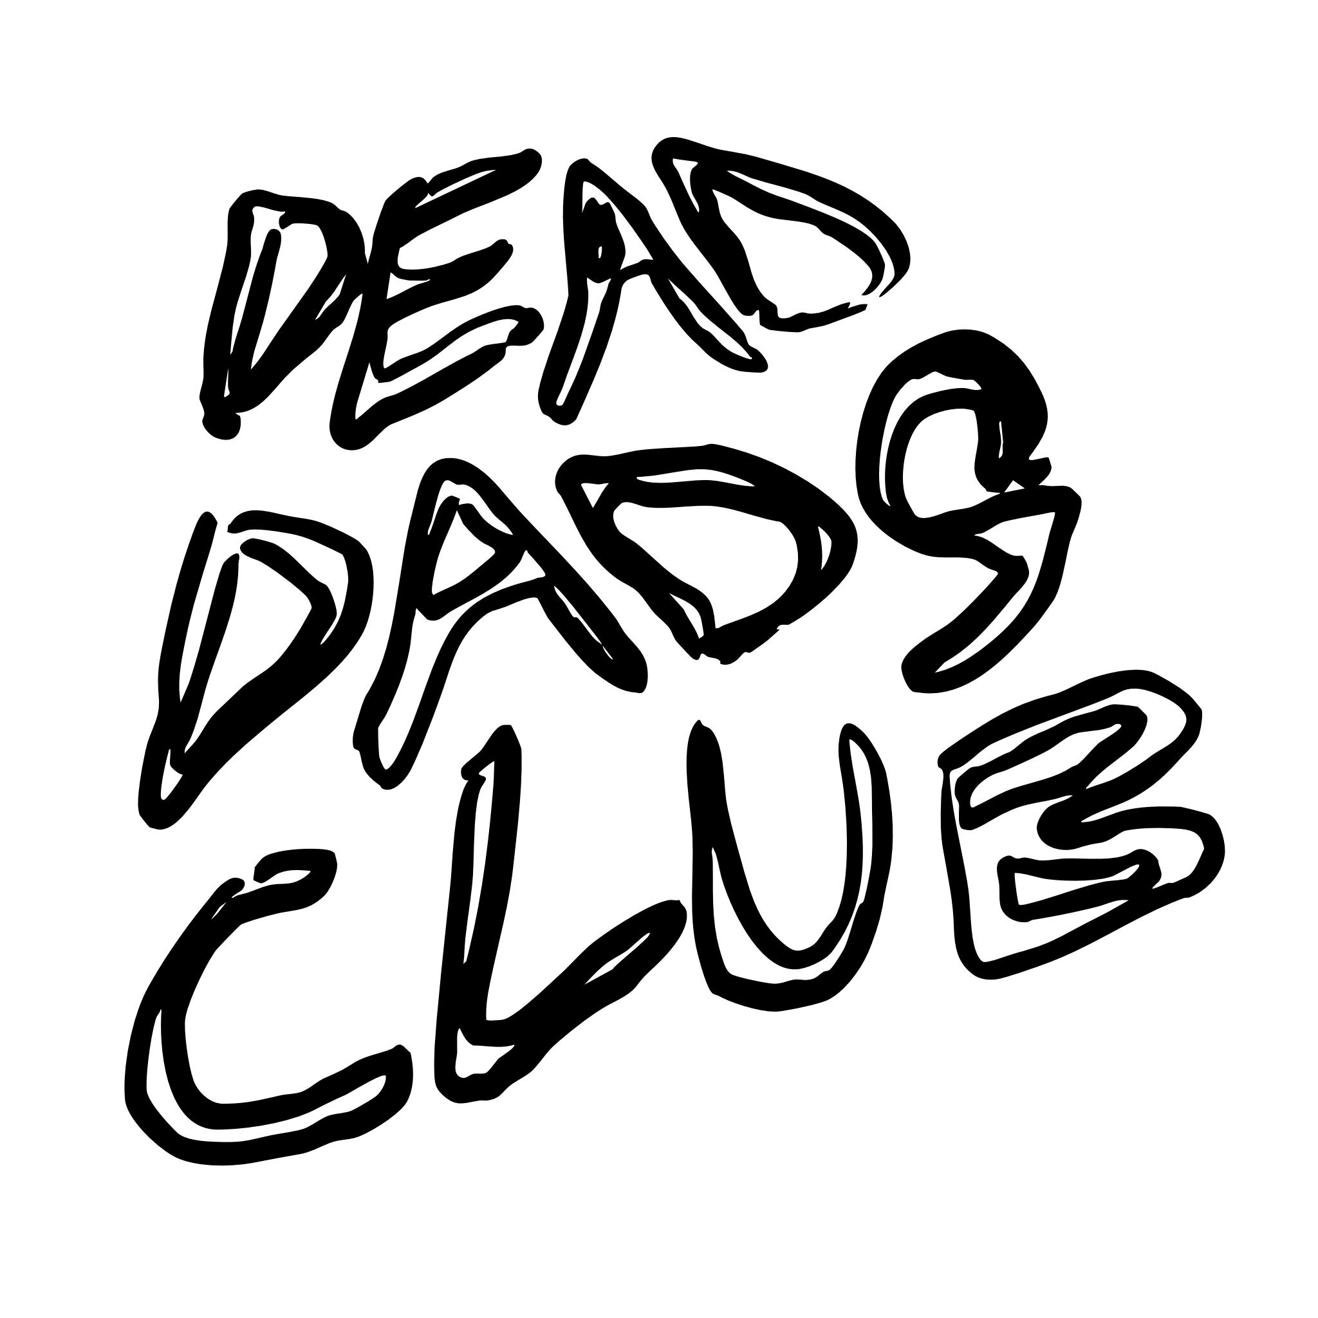

Share ‘That’s Life, the final single from their self-titled debut album - out via Fiction Records this Friday, 23rd January 2026.
Run of U.K. in-store dates kick-off on Friday
Listen to ‘That’s Life’ HERE.
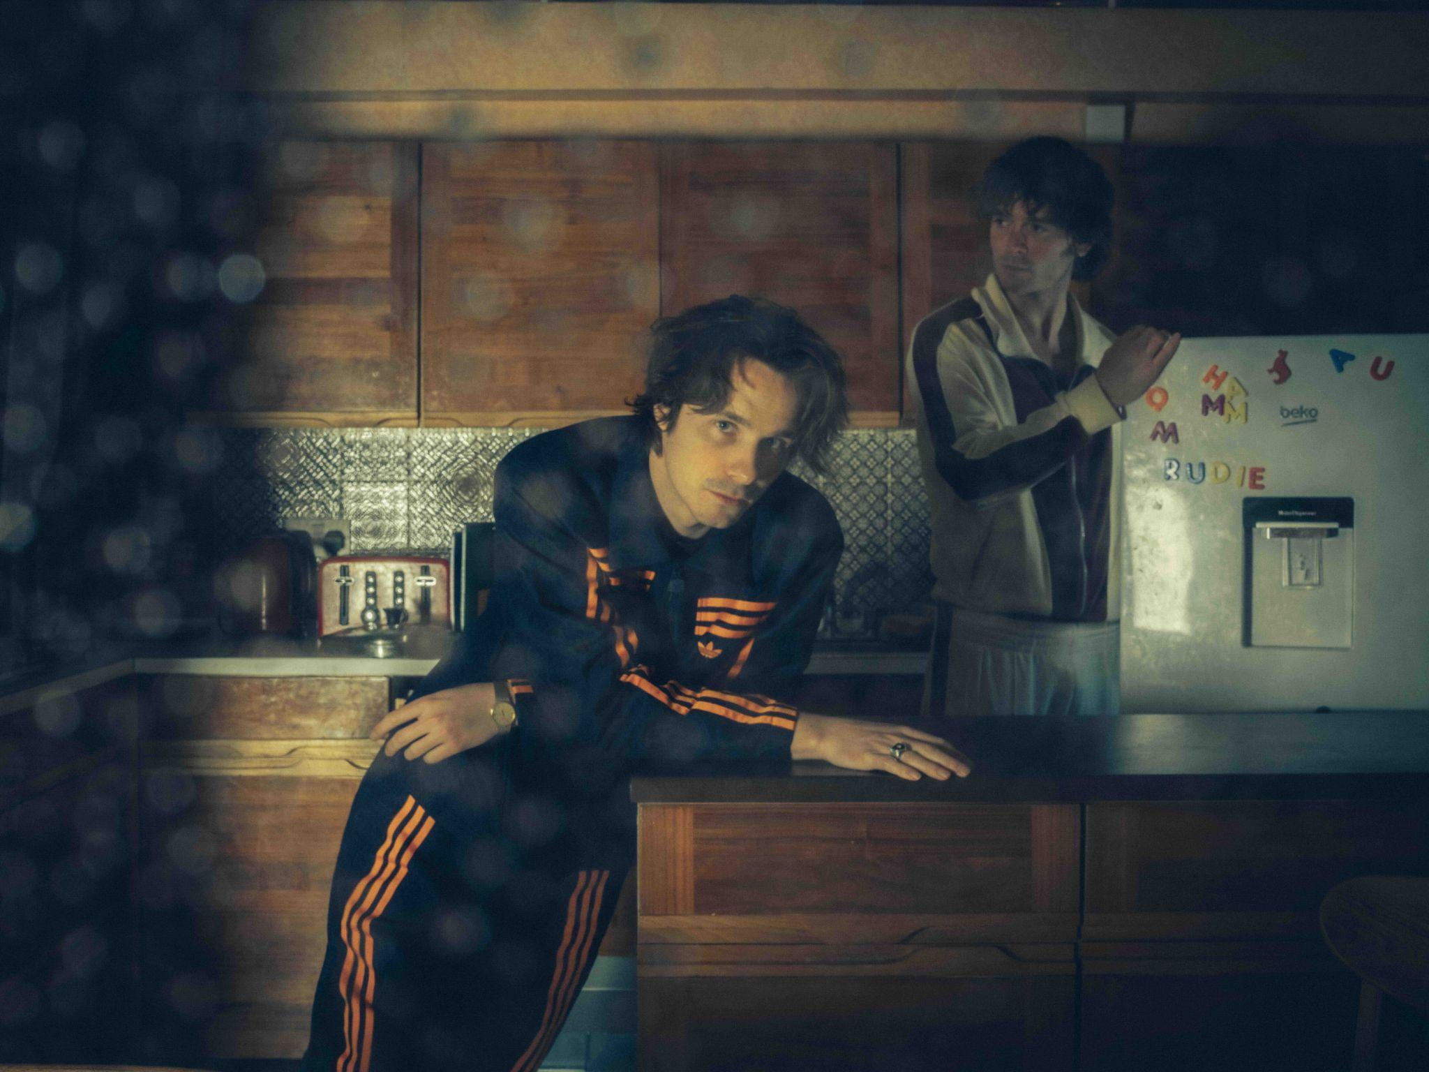
Photo credit: Adrian Lee
Praise for the album:
Imbued with a real sense of healing and closure - 4/5 DIY

Dead Dads Club, helmed by Chilli Jesson, have today shared ‘That’s Life’, the final track to be taken from their self-titled debut album which is released on Fiction Records this Friday, 23rd January 2025.

Talking about the track Chilli said:

There may be many conflicting ideas on whether there is a set path through life, but the only true preordained path is death, which is certain. There is great liberation in accepting the chaos of every day.

Listen to ‘That’s Life’ HERE.

This follows previous singles ‘Don’t Blame The Son For The Sins Of The Father’, ‘Goosebumps’ and ‘Volatile Child’.

Also, they kick-off a run of in-store shows this Friday, the day of album release. The dates are as follows:

23.01.26 – Banquet – KINGSTON +
24.01.26 – Rough Trade East – LONDON +
25.01.26 – Sound Knowledge – MARLBOROUGH +
27.01.26 – Rough Trade – NOTTINGHAM +
28.01.26 – Jacaranda – LIVERPOOL +
29.01.26 – Vinyl Whistle – LEEDS +

31.01.26 - Papillon (So Young Weekender) - SOUTHAMPTON

28.03.26 - Ritual Union - BRISTOL

- In store shows

The track listing of the album, a deeply personal and affecting record which explores Chilli’s emotional journey following the death of his father and produced by Carlos O’Connell of Fontaines D.C. is as follows:

It’s Only Just Begun
Volatile Child
Humming Wires
Goosebumps
Junkyard Radiator
Running Out Of Gas
That’s Life
Don’t Blame The Son For The Sins Of The Father
Need This Around
Hospital Pillow
Need You So Bad

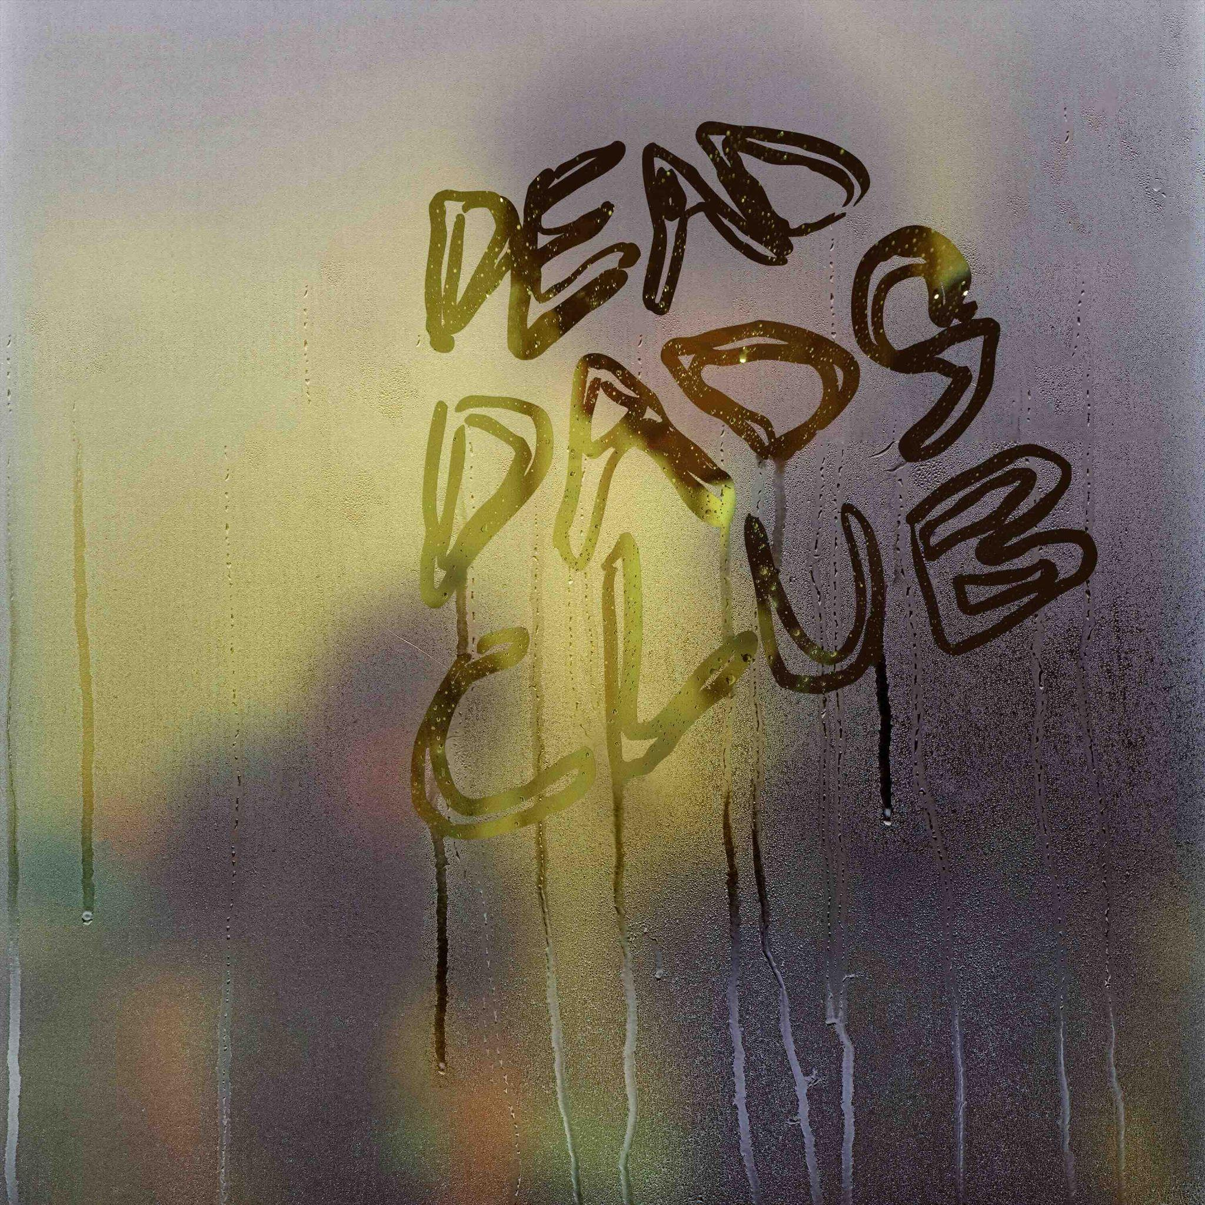

The album is available digitally and on CD & vinyl.
Cat. number: DDC001
Pre-order the album HERE.

…………………….

At 14, Chilli Jesson lost his father to drug addiction, a trauma he buried under rebellion and emotional suppression. His escape came through music, as his band Palma Violets skyrocketed to fame, landing on NME covers and topping charts. But when the band unexpectedly ended in his early twenties, Jesson was left disoriented. He tried to rebuild with a new project, Crewel Intentions, and later ventured into pop songwriting out of financial necessity.
Feeling disillusioned and creatively lost, Jesson stopped listening to the music that once defined him—until Fontaines DC invited him on tour. This rekindled his passion for raw, honest music. Inspired, he began crafting his most personal project yet: Dead Dads Club. Written with Rupert Greaves and produced by Fontaines DC’s Carlos O’Connell, the album chronicles Jesson’s grief and survival after his father’s death, from adolescence to present day.
The songs are emotionally candid and musically vibrant, blending gritty riffs with tender reflections. Tracks like ‘Don’t Blame The Son For The Sins Of The Father’ and ‘Running Out of Gas’ tackle strained familial relationships, while ‘Need You So Bad’ and ‘Need This Around’ reaffirm his commitment to music. Now on the verge of fatherhood himself, Jesson channels past pain into creative purpose. Dead Dads Club isn’t just an album—it’s a space for shared grief, resilience, and hope. As Jesson puts it: once you’re in the club, you’re in for life.

For further information about Dead Dads Club:
INSTAGRAM | FACEBOOK | TIKTOK | WEBSITE

For more information and press enquiries please contact

Warren & Harry
@chuffmedia.com

