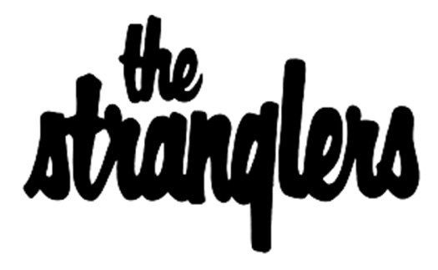
ANNOUNCE NEW ALBUM DARK MATTERS

RELEASE SINGLE ‘AND IF YOU SHOULD SEE DAVE…’
IN TRIBUTE TO DAVE GREENFIELD
PREMIERED ON BBC 6MUSIC

LISTEN HERE
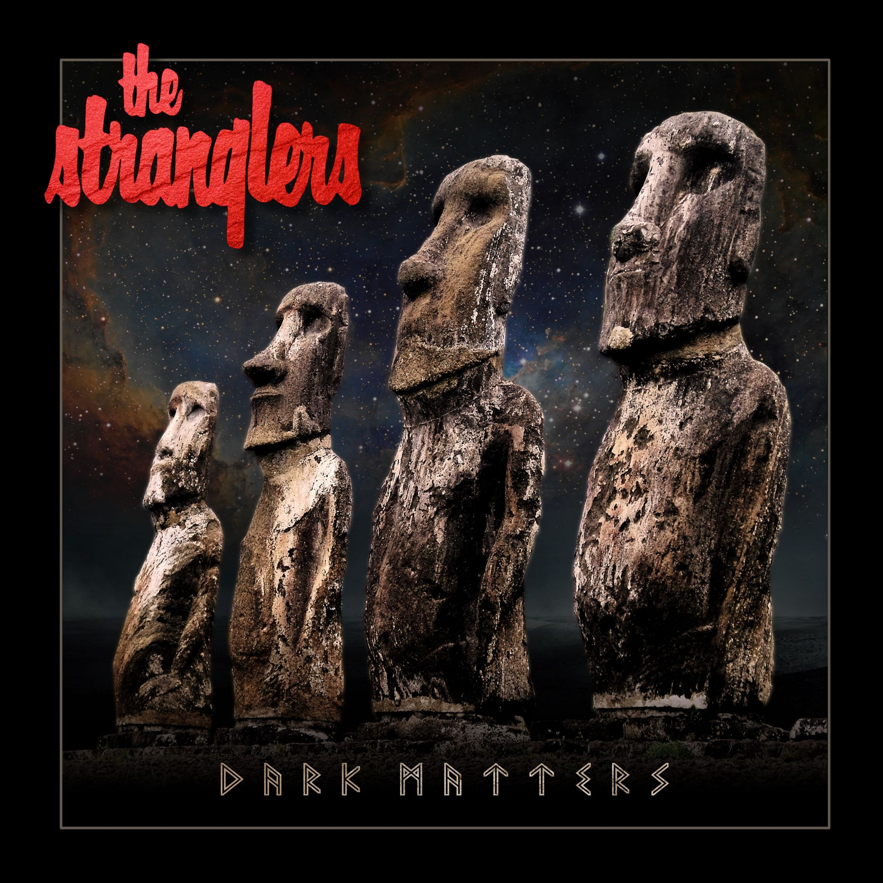
Click for info and images

One of the great British bands, The Stranglers, have announced their brand-new album, Dark Matters, due for release on 10th September 2021. The first single, ‘And If You Should See Dave…’, is an honest tribute to their much-missed keyboard player Dave Greenfield, who tragically passed away a year ago from Covid-19, and who features on many of the tracks recorded for the album.

“A year ago, on May 3rd my great friend and colleague of 45 years, Dave Greenfield, passed away, another victim of the pandemic.” says JJ Burnel.

“We had already recorded most of the album with him and during the lockdowns our only wish was to complete it as a fitting tribute to his life and work. I consider this to be one of our finest recordings.”

Surviving Stranglers band members, JJ Burnel and Baz Warne completed Dark Matters remotely during lockdowns, making it their first album since 2012. Adding to it a fitting tribute in ‘And If You Should See Dave…’, the first single from the album - a contemplative but uplifting dose of sixties sunshine-drenched rock, which is available to stream from Friday 14th May.

Greenfield himself features on 8 of the 11 tracks, which were made over the course of two years at the band’s studios in the rural idylls of Somerset, and in Southern France, produced by long-time collaborator Louie Nicastro.

A key member of The Stranglers for 45 years, Dave was a highly acclaimed keyboardist whose unique approach and instantly identifiable playing style massively contributed to the group’s inimitable sound. His contributions set the band apart from their peers and his skills are imprinted across Dark Matters.

First formed in 1974, The Stranglers no bull***t attitude was embraced by the punk movement of the late 70s. But their musicianship and menace transcended the genre, creating a sound unique to themselves. With their first three albums (Rattus Norvegicus, No More Heroes and Black and White) being released within an astonishing 13 months of each other, scoring hit singles with ‘Peaches’, ‘No More Heroes’ and ‘Walk On By’. Further success was to follow with ‘Always The Sun’, ‘Strange Little Girl’ and the mercurial ‘Golden Brown’, amongst many others, earning the group 24 Top 40 singles and 18 Top 40 albums in a career spanning six different decades.

Dark Matters is out on 10th September 2021 on the band’s own Coursegood imprint, via Absolute, and is available to pre-order from all good record stores. The Stranglers official store hosts a variety of special items from a limited-edition cassette album to ‘red/black smoke’ coloured limited edition heavy-weight vinyl.

In addition, all pre-orders for the album (on any format) will receive a special bonus CD titled ‘Dave Greenfield – A Tribute’ through the official store. This bonus CD, featuring 8 unreleased live recordings, was selected by the surviving members with a view to celebrating Dave’s unique talent. It includes two of the new tracks performed by Dave, live versions of four Stranglers songs that Dave is famous for having performed vocals on, and one of the last ever recordings of the band from their 2019 Japanese tour. Pre-order now at www.thestranglers.co.uk.

Dark Matters - Album Track listing
1. Water
2. This Song
3. And If You Should See Dave…
4. If Something’s Gonna Kill Me (It Might As Well Be Love)
5. No Man’s Land
6. The Lines
7. Payday
8. Down
9. The Last Men On The Moon
10. White Stallion
11. Breathe

The Stranglers announced their ‘full final tour’ of the UK and Europe and have decided to proceed with the 47-date run which includes two sold out performances at Brixton Academy, in Dave’s memory.

Full Final Tour UK 2022 *dates added*

25 Jan Engine Shed, Lincoln
27 Jan Music Hall, Aberdeen
28 Jan O2 Academy, Glasgow
29 Jan O2 Academy, Glasgow - SOLD OUT
31 Jan Victoria Hall, Stoke
1 Feb UEA Nick Rayns, Norwich
3 Feb G Live, Guildford - SOLD OUT
4 Feb O2 Academy, Brixton
5 Feb O2 Academy, Brixton - SOLD OUT
7 Feb Parr Hall, Warrington
8 Feb Rock City, Nottingham
10 Feb Uni Great Hall, Cardiff
11 Feb O2 Apollo, Manchester
12 Feb O2 Academy, Leeds
14 Feb Guildhall, Portsmouth
15 Feb Cliffs Pavilion, Southend
17 Feb Dome, Brighton
18 Feb O2 City Hall, Newcastle
19 Feb O2 Academy, Birmingham
21 Feb O2 Academy, Bristol - SOLD OUT
22 Feb Hexagon, Reading
24 Feb City Hall, Sheffield
25 Feb De Montfort Hall, Leicester
26 Feb Corn Exchange, Cambridge - SOLD OUT

- ENDS -

For full tour details and more information visit www.thestranglers.co.uk

For all media enquiries please contact Warren@chuffmedia.com on 07762 130510

