Announces his first album in five years:
Cult Leader Tactics
28th January 2022 - Kscope

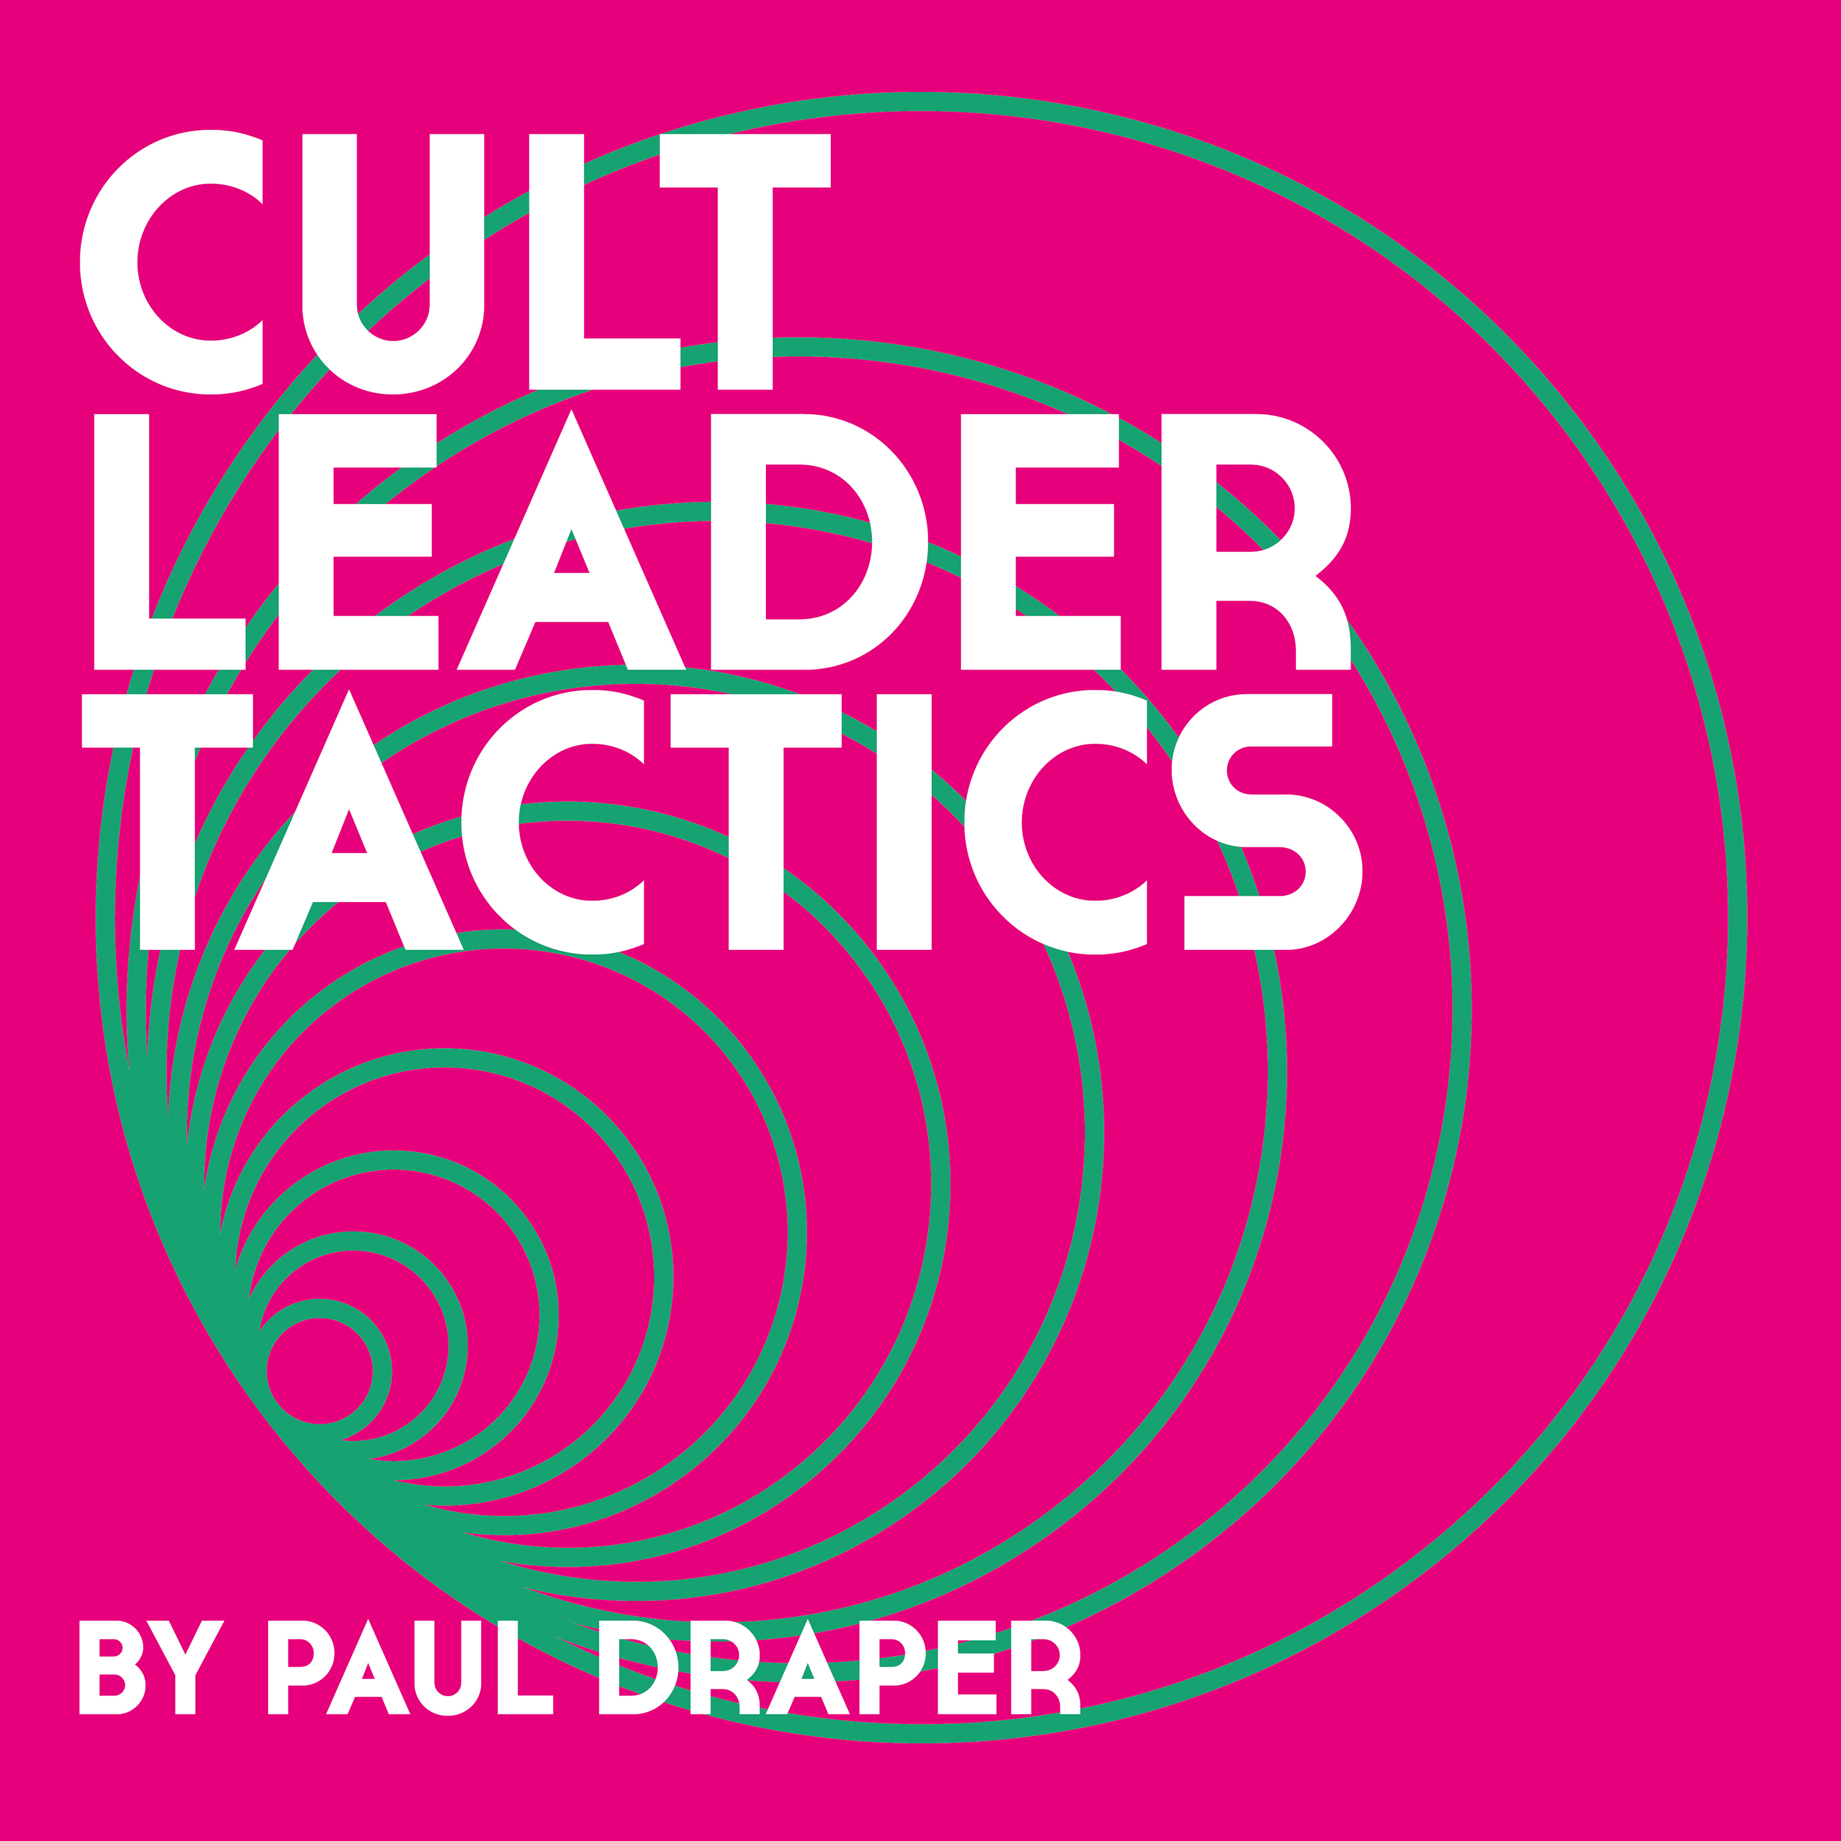

Co-produced by Paul ‘P-Dub’ Walton (Massive Attack, The Cure, Bjork)
Featuring Gam from Sweat, the 288-person C.L.T. Lockdown Choir and a collaboration with acclaimed musician and producer Steven Wilson

Supported by a 21-date UK tour throughout February and March

HI-RES ARTWORK & NEW PHOTOS:
https://kscopemusic.com/media/pauldraper/

On 28th January, acclaimed songwriter and former Mansun frontman Paul Draper will release Cult Leader Tactics – his first album since 2017’s lauded Spooky Action - via Kscope.

Cult Leader Tactics is a satire on the genre of self-help manuals. It details how to get to the top of your chosen profession, or how to get on in life in general and in affairs of the heart, by acting in a Machiavellian manner and employing dirty tricks or ‘Cult Leader Tactics’ to achieve your life goals.

Lyrically the album is made up of extracts from a fictitious self-help manual ‘Cult Leader Tactics’, a parody of the self-help manual genre. After experiencing these types of human behaviour and themes, the album arrives at the conclusion the only true answer in life is love.

These and other themes are subtly referenced in each song and explored on a collection of Paul’s best songwriting since Mansun’s imperial phase. Nowhere is this exemplified more than on the instantly catchy and destined to be classic, ‘You’ve Got No Life Skills, Baby!’, which is reminiscent of the best artrock-meets-pop moments of Mansun’s Attack Of The Grey Lantern.

Paul plays the majority of the instruments on Cult Leader Tactics 11-tracks, including guitars, drum machines and synthesisers, on an album produced with long-time collaborator and acclaimed producer Paul ‘P-Dub’ Walton at the latter’s Loft Studios, with additional engineering by Scott Knapper.

Cult Leader Tactics features guest appearances from revered musician and producer Steven Wilson, who co-wrote and plays on ‘Omega Man’ – a collaboration about his and Paul’s feelings of isolation during lockdown. The accompanying video clip was filmed in Chernobyl.

Watch OMEGA MAN video here

The album also features Gamaliel ‘Gam’ Rendle Traynor from the band Sweat, who played, arranged and engineered all strings (recorded at Sweat Studios, Peckham, London), as well as a 288-person C.L.T. Lockdown Choir who sing on ‘Lyin’ Bout Who U Sleep With’.

Cult Leader Tactics tracklist:
- Cult Leader Tactics (watch the lyric video here)
- Internationalle
- Dirty Trix
- Cult Leader Tactics in E-Flat Minor
- You’ve Got No Life Skills, Baby!
- U Killed My Fish
- Everyone Becomes A Problem Eventually
- Annie
- Talkin’ Behind My Back
- Omega Man (featuring Steven Wilson)
- Lyin’ ‘Bout Who U Sleep With

Cult Leader Tactics will be available on the following formats and is available to pre-order here:
- 4CD Deluxe Book Edition, including a 60 page hardback book
- Gatefold single LP
- Gatefold single LP indie-only release, comes with a bonus 7” featuring a second collaboration with Steven Wilson
- Gatefold single coloured LP
- Digipack CD
- Digital

PAUL DRAPER INSTORES
Paul will be doing a series of instore appearances to support the release of Cult Leader Tactics, performing an acoustic set and signing copies of his new album:

28th Jan – Edinburgh - Assai
29th Jan – Newcastle - Beyond Vinyl
30th Jan – Bolton X-Records (1pm performance)
30th Jan - Preston – Action (7pm performance)
31st Jan – Nottingham – Rough Trade
1st Feb – Mold - VOD
2nd Feb – Bristol – Rough Trade
3rd Feb – London – Rough Trade East

PAUL DRAPER – LIVE IN 2022
Paul and his band will undertake a 21-date tour at the end of February, playing stripped back versions of songs from Cult Leader Tactics, Spooky Action and Mansun classics and rarities:

February
27th – Oxford – O2 Academy 2
28th – Reading – Sub89

March
1st – Chester – The Live Rooms
2nd – Leeds – Brudenell Social Club
4th – Aberdeen – The Tunnels
5th – Glasgow – King Tut’s Wah Wah Hut
6th – Birmingham – The O2 Institue 2
8th – Norwich – The Waterfront Studio
9th – Manchester Gorilla
10th – Hull – Social on Humber Street
11th – Sheffield – The Leadmill, The Steel Stage
12th – Newcastle – St Doms
14th – Cardiff – The Globe
15th – Exeter – Phoenix
16th – Bristol – Fleece
17th – Leicester – O2 Academy 2
18th – Bedford – Bedford Esquires
20th – Bournemouth – The Old Fire Station
21st – Portsmouth – Wedgewood Rooms
22nd – Brighton – Komedia
23rd – London – Islington Assembly Hall

For more information please contact warren@chuffmedia.com

