**KINGS OF LEON**

**ANNOUNCE BRAND NEW ALBUM *CAN WE PLEASE HAVE FUN,* PRODUCED BY KID HARPOON**

**OUT MAY 10 VIA POLYDOR RECORDS**

**FIRST SINGLE, “MUSTANG” IS OUT NOW,**

**WATCH THE VIDEO** [**HERE**](https://kingsofleon.lnk.to/Mustang/youtube)

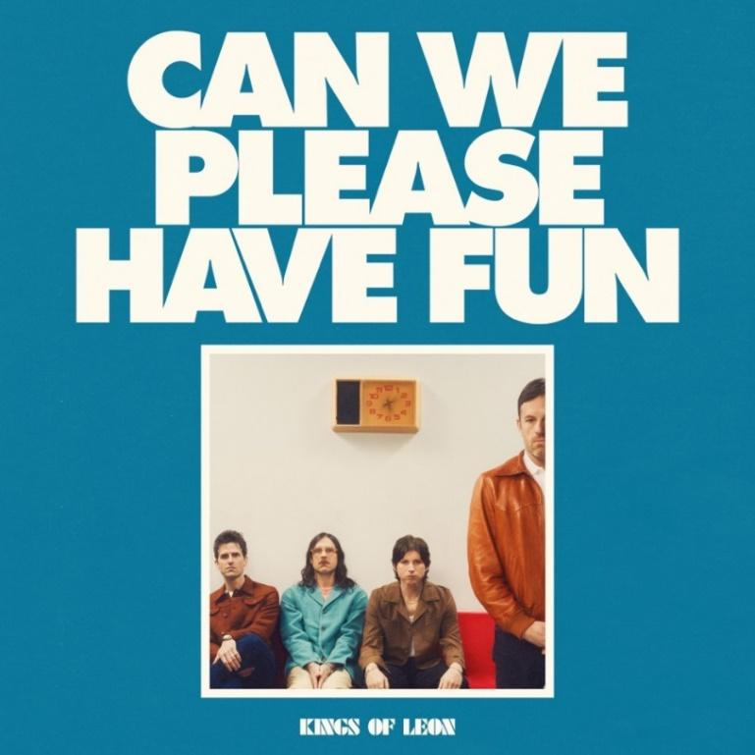

Download Album Art [HERE](https://umusic.ent.box.com/s/7tu1nvguutev5qjboe9eojcpy6ska9np)

Download Press Photo [HERE](https://umusic.ent.box.com/s/31hbobzg1z8vsum8ev77h2ulqi5b0yw4/file/1444140214984)

Multi-Platinum, multi-award winning rock band Kings of Leon are back with their brand new album, 'Can We Please Have Fun’, out May 10, via Polydor Records. The hard-charging lead single “Mustang” is available now, accompanied by a high-flying music [video](https://kingsofleon.lnk.to/Mustang/youtube) that sets the pace for the rest of the album.

Kings of Leon will headline BST Hyde Park on Sunday 30 June, alongside special guest Paolo Nutini, with the full line-up still to be announced. Tickets go on sale at 10am GMT on Wednesday 28 February and are available at [www.bst-hydepark.com](http://www.bst-hydepark.com/)

‘Can We Please Have Fun’, as its title suggests is a document of one of this era’s great rock & roll bands cutting loose, trying new things, and yes, having some fun. Recorded at Dark Horse studio and produced with new collaborator Kid Harpoon (Harry Styles, Florence + the Machine), the album sees the band hark back to their gritty origins, while simultaneously finding new gears. It’s the sound of a band unified in vision and purpose, freed from any expectations and the album the band says they’ve always wanted to make.

*“It was the most enjoyable record I’ve ever been a part of,”* Caleb says. *“It’s like we allowed ourselves to be musically vulnerable,”* Nathan adds. *“I love it when a rock band is not embarrassed to admit that every song doesn’t have to be on 11.”*

The group is gearing up for a monumental year, and they’re ready to take the world by storm. *“When you have a band, there’s a bond like no other, and when you have family, you have a bond like no other,”* Caleb says. *“We have both of those things. I thought, if we put all our energy toward something, who is gonna stop us? Who can stop us except us?”*

**Pre-order ‘Can We Please Have Fun’** [**HERE**](https://kingsofleon.lnk.to/CanWePleaseHaveFun)**.  
Listen to ‘Mustang’**[**HERE**](https://kingsofleon.lnk.to/Mustang)**.  
Watch the video for ‘Mustang’**[**HERE**](https://kingsofleon.lnk.to/Mustang/youtube)**.**

*Can We Please Have Fun* – Tracklist:

*Ballerina Radio*

*Rainbow Ball*

*Nowhere To Run*

*Mustang*

*Actual Daydream*

*Split Screen*

*Don’t Stop The Bleeding*

*Nothing To Do*

*Television*

*Hesitation Generation*

*Ease Me On*

*Seen*

About Kings of Leon:

Since their debut in 2003, Kings of Leon (Caleb (guitar/vocals), Nathan (drums), Jared (bass) and Matthew Followill (guitar)) has released eight albums (Youth & Young Manhood (2003), Aha Shake Heartbreak (2004), Because of the Times (2007), Only by the Night (2008),Come Around Sundown (2010), Mechanical Bull (2013), WALLS (2016), When You See Yourself (2021) and sold over 20 million albums and nearly 40 million singles worldwide. They have three Grammy Awards, three NME Awards, two BRIT Awards, and one Juno Award. They have toured all over the world, playing at stadiums and arenas and headlining major festivals including Glastonbury, Coachella, Lollapalooza and Reading & Leeds on three separate occasions. The band will release their highly anticipated ninth full-length studio album, 'Can We Please Have Fun', on May 10 via Polydor Records.

**For more information please contact** [**warren@chuffmedia.com**](mailto:warren@chuffmedia.com)