Unique, Bold & Scottish

The LaFontaines
New Album Business As Usual
Summer 2024 via So Recordings

NEW SINGLE BUSINESS AS USUAL VIDEO OUT NOW

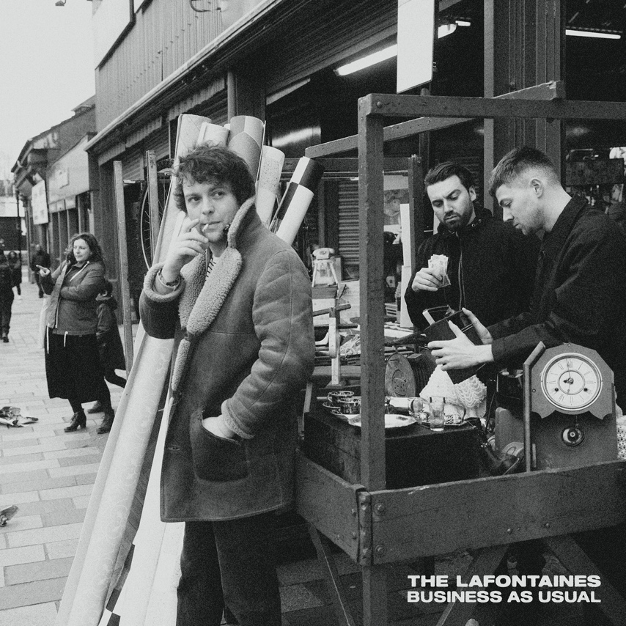

The LaFontaines never went away, they’ve just had a short time out…

Fifteen years since their inception in Motherwell Scotland, Kerr Okan (vocals), Jamie Keenan (drums, vocals) and Darren McCaughey (guitars, production) have long held a unique space within the UK music scene with The LaFontaines sound as instantly recognisable as singer Kerr’s vocals.

For Kerr the first single, the album’s title track, Business As Usual “…is the song that saved the band. Just as I was about to down tools, Jamie sent me the chorus. I hadn’t written anything since the pandemic, but this song seemed to finish itself. It was the catalyst for the full album. It’s The LaFontaines summed up in 3:23 seconds. Unique, bold, and Scottish. Back at it - Business As Usual”

The bands personality, charm and charisma shines through their output, which coupled with their already unrivalled unique offering has earned them a dedicated, loyal fanbase - who
identify with the band through more than just the music.

Their live shows are their superpower – a guaranteed good time which sees the band connect with their audience on a level that most live acts never achieve. There is no one like The LaFontaines.

Said frontman, Kerr Okan, “To be a band at this point, 15 years deep, on the verge of releasing our 4th studio album says it all really. To still be going hard at it shows the love we have for the music. To have a fanbase that continues to grow proves we’re not f%@kin’ mental, and to have a live show that is genuinely one of the best in Britain, is the reason we keep selling out shows with no industry backing. This record is far from a farewell; it’s a resolute declaration that it’s ‘Business As Usual”

Across their career, The LaFontaines have performed across the globe with festival highlights including TRNSMT in Scotland, VERY TV Festival in Bangkok, the Radio 1 Dance Tent at Reading & Leeds Festival in England and the NH7 Weekender in India. They have toured everywhere from New York to Paris with the likes of Linkin Park’s Mike Shinoda, Anderson .Paak, Don Broco, Deaf Havana and Example to name a few.

The LaFontaines third studio album Junior was released via SO Recordings in June 2019 to critical acclaim. The album charted at number 33 in the UK Albums Chart, giving the band their first top 40 record.

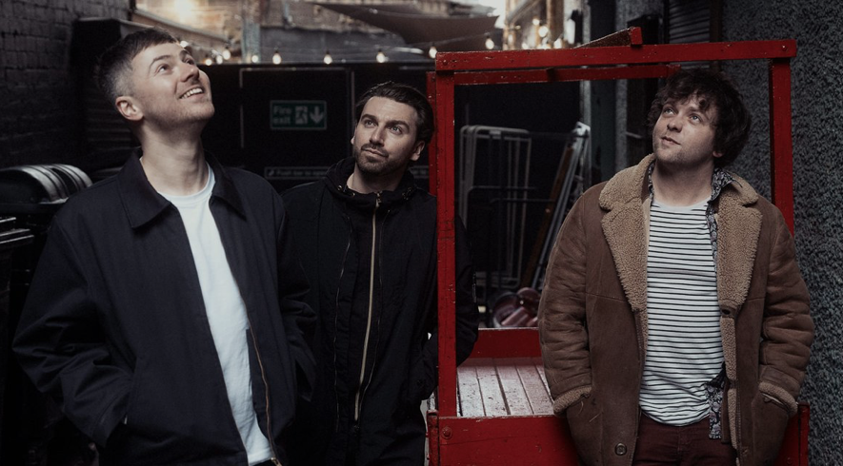

Connect with The LaFontaines
Instagram | TikTok | Spotify| YouTube | Website

For all media enquiries please contact warren@chuffmedia.com

