GOOD NEIGHBOURS

Announce debut album Blue Sky Mentality - due for release on September 26th, 2025
(Pre-Order)

+ share new single ‘Suburbs’
(Listen / Watch)
- Announce intimate indie store tour for September
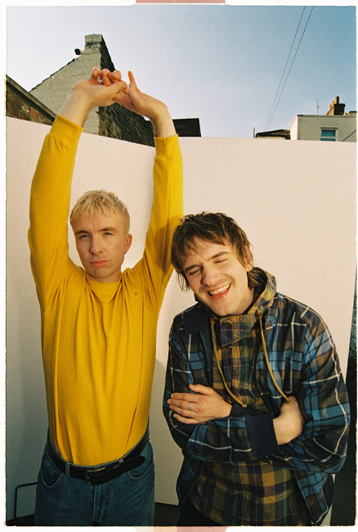
(Photo Credit: Isaac Lamb)
Fresh off the back of their hugely successful Glastonbury debut and a storming North American tour with Mumford & Sons, Good Neighbours are back to announce their highly anticipated debut album Blue Sky Mentality, which lands on September 26th via Polydor Records.
The announcement comes alongside the release of new single ‘Suburbs’ which premiered as BBC Radio 1’s Hottest Record last night as is the band’s latest glimpse of what’s to come from the debut LP.
‘Suburbs’ is a widescreen burst of nostalgia and defiance - pairing Good Neighbours’ signature sun-drenched euphoria with a coming-of-age clarity. Anchored by soaring vocals and luminous synths, it’s a bold, bittersweet anthem about shaking off small-town shackles and believing in The Dream.
The band say of the song: "Suburbs is a message back to our younger selves. Coming from small towns outside of London, it was hard to dream big without getting shot down. This track is our anthem for breaking free from that mindset and chasing something bigger."
This album news arrived with a sense of full-circle occasion as Scott and Olil marked the occasion with a tiny, packed-to-the-rafters live show at the Sebright Arms in London last night - the very same venue that hosted their debut gig just 18 months ago, in November 2023.
Written during a year that saw Scott and Oli navigating new cities, late nights, and long-haul flights, Blue Sky Mentality captures the delicate feeling of distance and of returning home. Retaining connection with the people you love and with the person you once were. It’s a record bursting with songs that feel as cinematic and far-reaching as they are grounded in everyday realities: indie-pop nostalgia washed in shimmering choruses, hopeful charm and introspective clarity. The 14-track collection includes the band’s breakout hit ‘Home’, alongside previous singles ‘Ripple’, and ‘Starry Eyed’, and is available to pre-order now on digital, vinyl and CD.
Speaking on the album, the band share: “Blue Sky Mentality has been our motto since day one. Our band began as a kind of light relief - a creative outlet to break from jobs that we couldn’t stand and some tough personal times. Over the last year, we ran with that feeling, writing our debut album on the road - in the back of tour buses, hotel rooms, and scattered corners of the world. That’s what Blue Sky Mentality means to us - finding light, friendship and a sense of escapism wherever you are.”

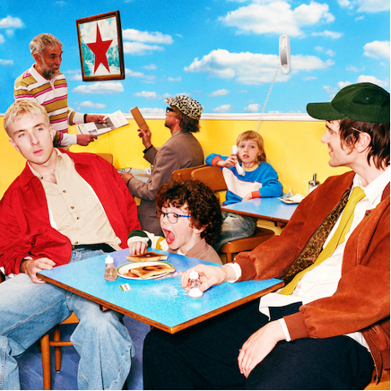
(LP Artwork)

Blue Sky Mentality tracklist:
1. Keep It Up
2. Skipping Stones
3. Ripple
4. found u/me*
5. Walk Walk Walk
6. Kids Can’t Sleep
7. Home
8. Small Town
9. Starry Eyed
10. People Need People
11. Left Hand Man
12. Suburbs
13. Wonderful Life
14. The Buzz
*Vinyl edition includes ‘Somebody’ instead of ‘found u/me’

Currently enjoying a run of huge summer festivals including Glastonbury (UK), Osheaga (CA), Outside Lands (US), Rock en Seine (FR) and Reading & Leeds (UK), Good Neighbours will be back on home soil around Blue Sky Mentality’s release to play a run of intimate shows at select indie stores - tickets go on sale on Friday July 11th at 10am HERE.
UK Indie Store tour dates:
22/09 – Rough Trade, Bristol
23/09 – HMV, The Vault, Birmingham
25/09 – Banquet / Pryzm, Kingston
26/09 – Jacaranda, Baltic, Liverpool
27/09 – Crash Records, Wardrobe, Leeds
29/09 – Assai, Caves, Edinburgh
30/09 – Rough Trade, The Saltbox, Nottingham

Follow Good Neighbours:
TIKTOK | INSTAGRAM | TWITTER/X | FACEBOOK | YOUTUBE

For more information and press enquiries please contact

Jenny Entwistle
Jenny@chuffmedia.com

