Another Sky Announce New Album Beach Day

Out On 1st March via Fiction Records

Listen To New Track 'Aimee Caught A Moth'

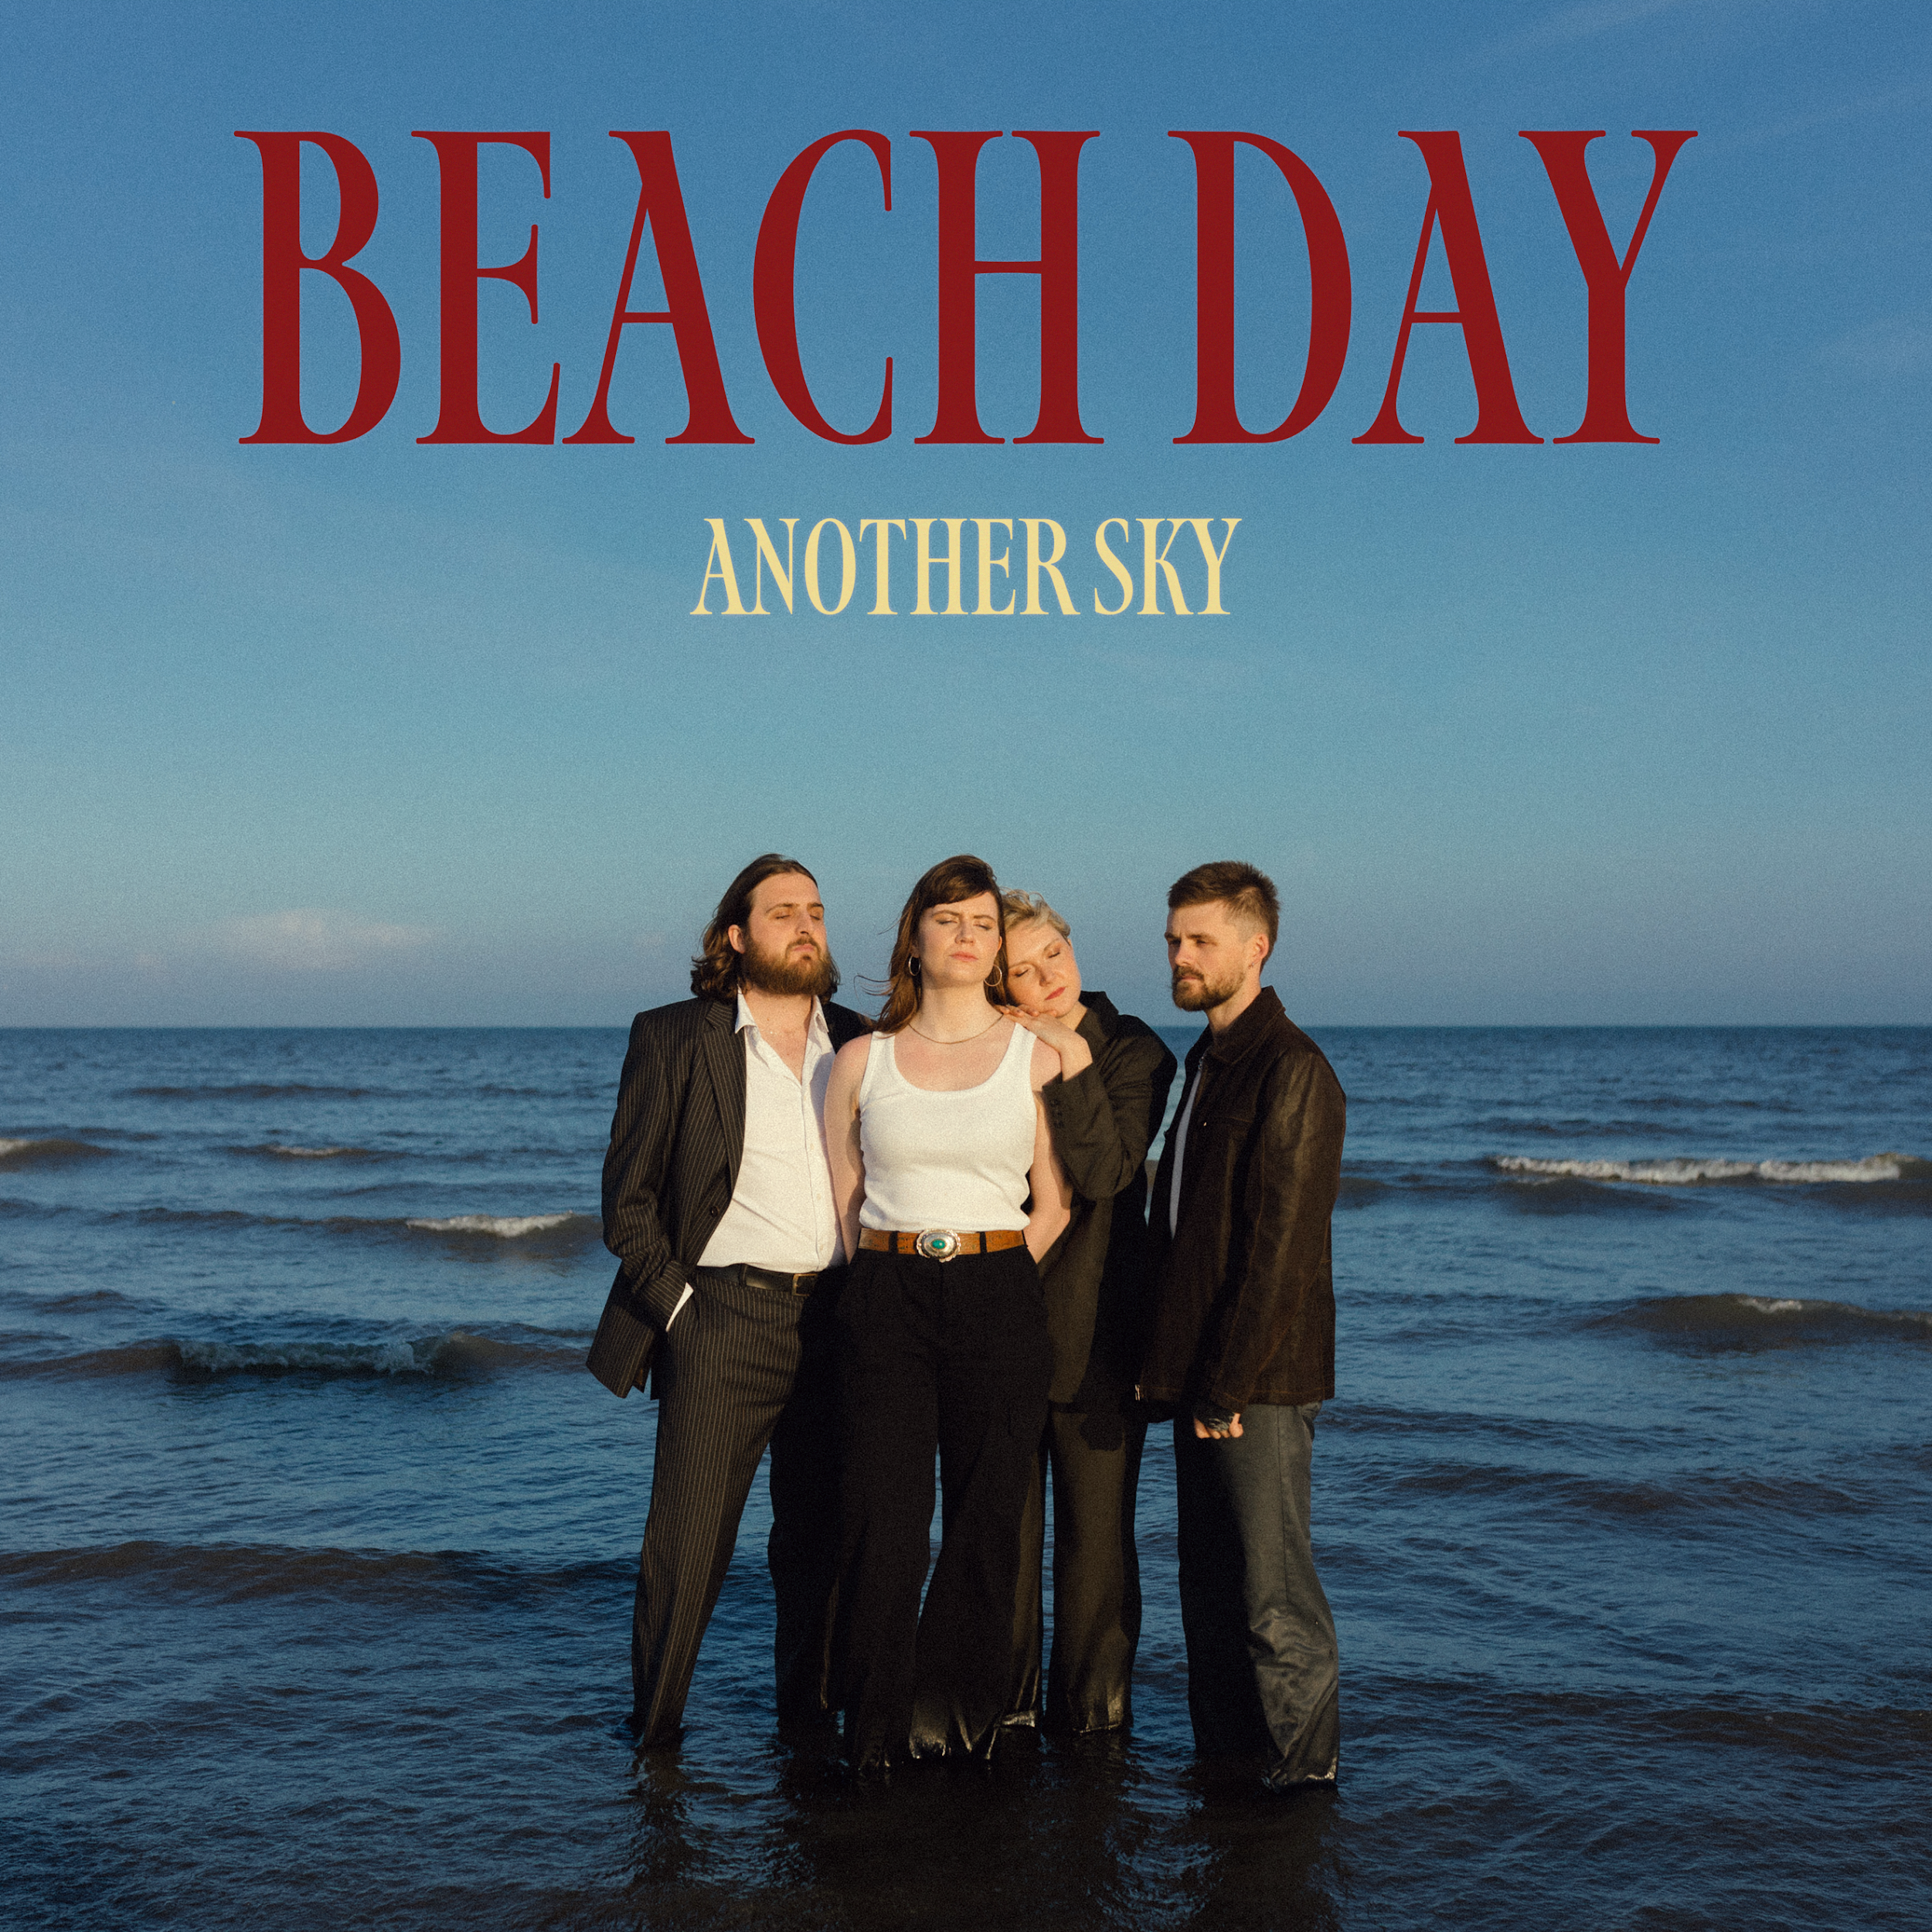
(Beach Day artwork // credit: Darina)
Another Sky are excited to announce their new album Beach Day, due for release on 1st March 2024 via Fiction (world excl North America) & Republic Records (North America). The band have spent the last few months teasing today’s announcement with a series of hard-hitting and exciting comeback singles.

“Psychopath” was a far more punchy and direct rock song than anything the band had previously released, and was followed up with ‘A Feeling’ which received strong support across BBC Radio 1 and 6 Music. Continuing the ferocious sentiments and instrumentation of the previous two singles, they swiftly followed with ‘Burn The Way’ and last month released ‘Uh Oh!’ which saw the South London quartet wrestling with their newly found creative zest, holding frustration and hindsight with both hands, and having a lot of fun with it too. This run culminated in a sold out headline show at London’s Lafayette.

Today’s announcement is accompanied by a brand-new track which does not appear on Beach Day, ‘Aimee Caught A Moth’.

Explaining this decision, vocalist and lyricist Catrin Vincent says –
“We weren't sure exactly how to announce the record. It felt like it needed more than words. And we've already released plenty of songs from it. So we gift to you a B-side, "Aimee Caught A Moth". This was one of the songs that fell through the net but one we still love.
It's a very literal song written in the depths of lockdown, when my flatmate Aimee caught and released a moth from a cobweb. It felt incredibly significant and songworthy. Aimee is an incredible person and deserves a song.”
Discussing Beach Day, Catrin adds
"We thought we'd finished our second record back in 2019 when we released I Slept On The Floor. But time is a complicated beast. And in the depths of lockdown, a completely new vision arose, one that we all knew we needed to follow instead.
That vision was Beach Day. It's a story about moving through personal winters and finding the light. It's about acknowledging your whole self; your shadow side, your anger, your sadness… and learning to love those parts of yourself in order to move through it. We hope you can hear the beginnings of transformation in it."
Pre-Order Beach Day Here

About Beach Day –

At this moment in time for Another Sky, there are maybe three certainties in this life: death, taxes, and rage. White-hot rage that takes you inwards, deeper into yourself, your fears, all the hidden truths you desperately tried to keep quiet while finding yourself.

With the band’s sophomore album Beach Day, that feeling opens a doorway to the most confident, fully formed and forthright version of Another Sky so far. Frontwoman Catrin Vincent points out the relationship between anger and freedom on this record. “If you don't move through anger, it'll calcify into bitterness, and it's not worth it,” she says, “but it’s about having the freedom to find and feel that anger. How can you move through something you don’t even know is there?”.

The album gave Vincent the opportunity to go more personal than ever – Another Sky has always supported and valued their front-woman’s vulnerability, but here it’s at its rawest. “Wait, why did I do this? Wait, why did I do this in the first place?” Vincent sings in the propulsive, almost euphoric climax of ‘Death of the Author’, one of many tracks on the album wrestling with a lack of control and surrender to the circumstances that great wreckage leave you with, whether you like it or not. The least you can do is make something of the rubble.

That rubble was rebuilt in the crypt of a church for Another Sky: the Covid years saw the band’s former studio flooded, as well as the painful consequences of a personal betrayal for all the band members (“all I had to do was be a good view as I fell from the sky you built for me,” Vincent spits on the explosive and impossibly direct lead single ‘Psychopath’). Both huge blows razed what you could perhaps call the first version of Another Sky to the ground. They needed a new space, and a new perspective, so they called out to their friends to help. “Does anyone know of any community spaces?”, they asked, and a Vicar, an avid Idles fan desperate to help some musicians, answered.

They built the crypt-based studio from scratch Another Sky, with help from guitarist Jack Gilbert’s builder Dad, where Gilbert produced much of the album himself – costing less and giving the band infinitely more freedom to take back control of their own narrative.

The anger and the fight is real, and it’s everything – but that doesn’t mean it always will be. Hold onto that feeling while it lasts: Another Sky are steadfast and galvanised to make you understand everything that got them here. How they survived. All you have to do is listen.

Track-Listing
- Beach Day
- The Pain
- A Feeling
- Uh Oh!
- I Never Had Control
- Death Of The Author
- Burn The Way
- Psychopath
- Playground
- City Drones
- I Caught On Fire
- Star Roaming
- Swirling Smoke

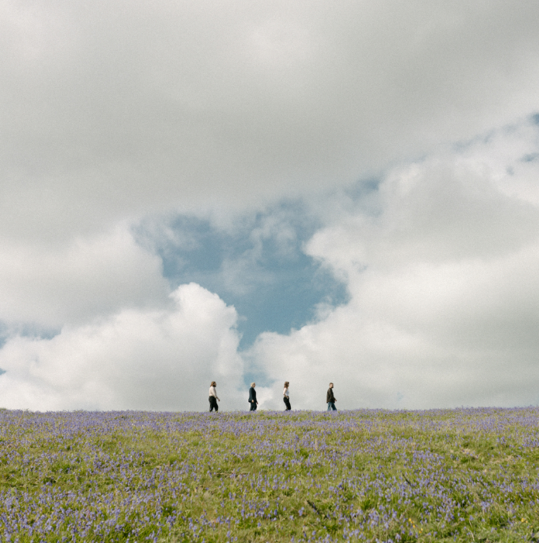
(Aimee Caught A Moth press shot // credit: Darina)

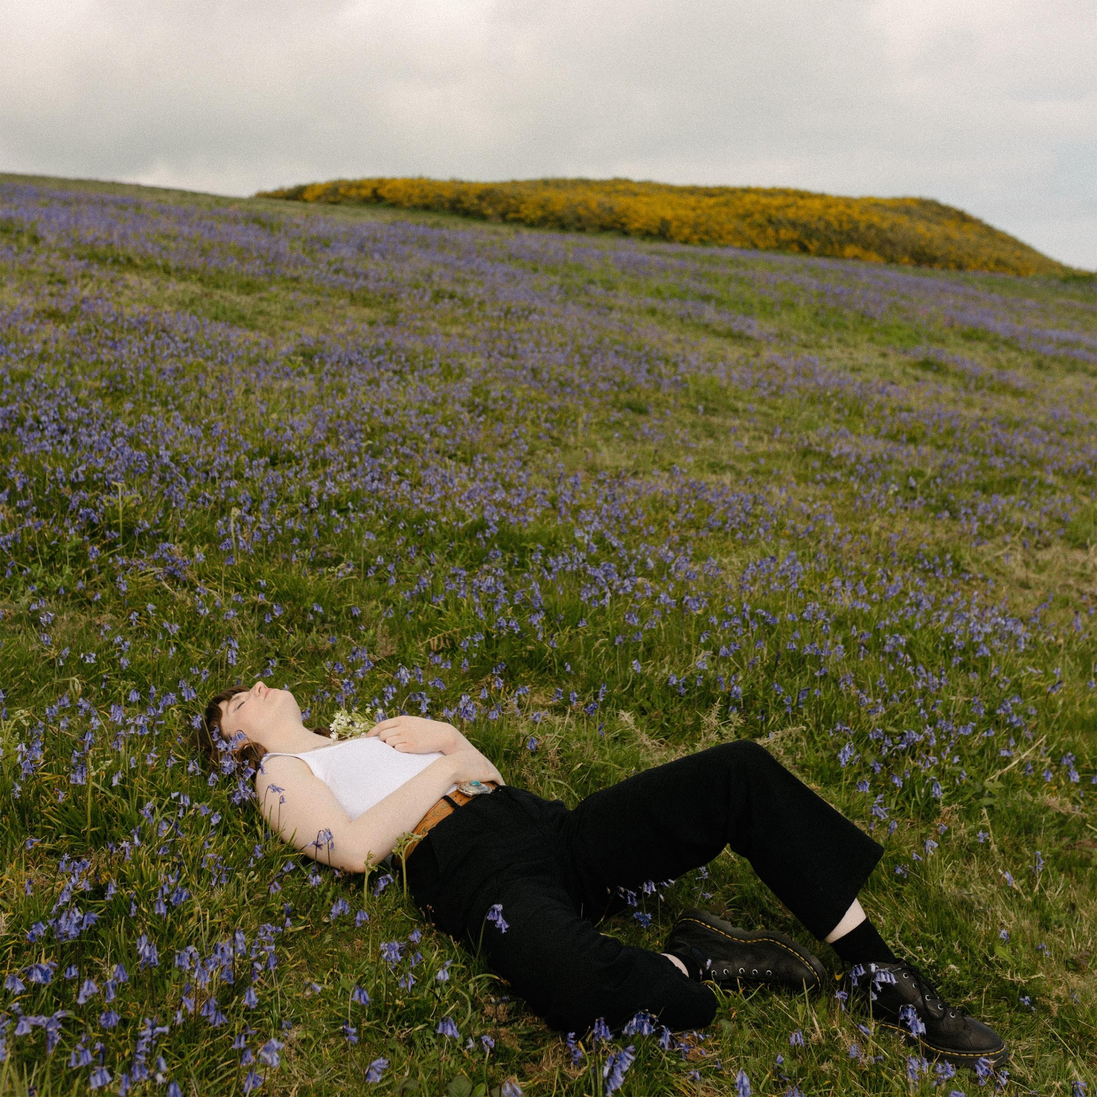
(Aimee Caught A Moth artwork // credit: Darina)

For more on info contact warren@chuffmedia.com

