

VIOLET GROHL
ANNOUNCES DEBUT ALBUM
BE SWEET TO ME
OUT MAY 29 ON AUROURA RECORDS/REPUBLIC RECORDS

SHARES NEW SONG AND VIDEO “595”

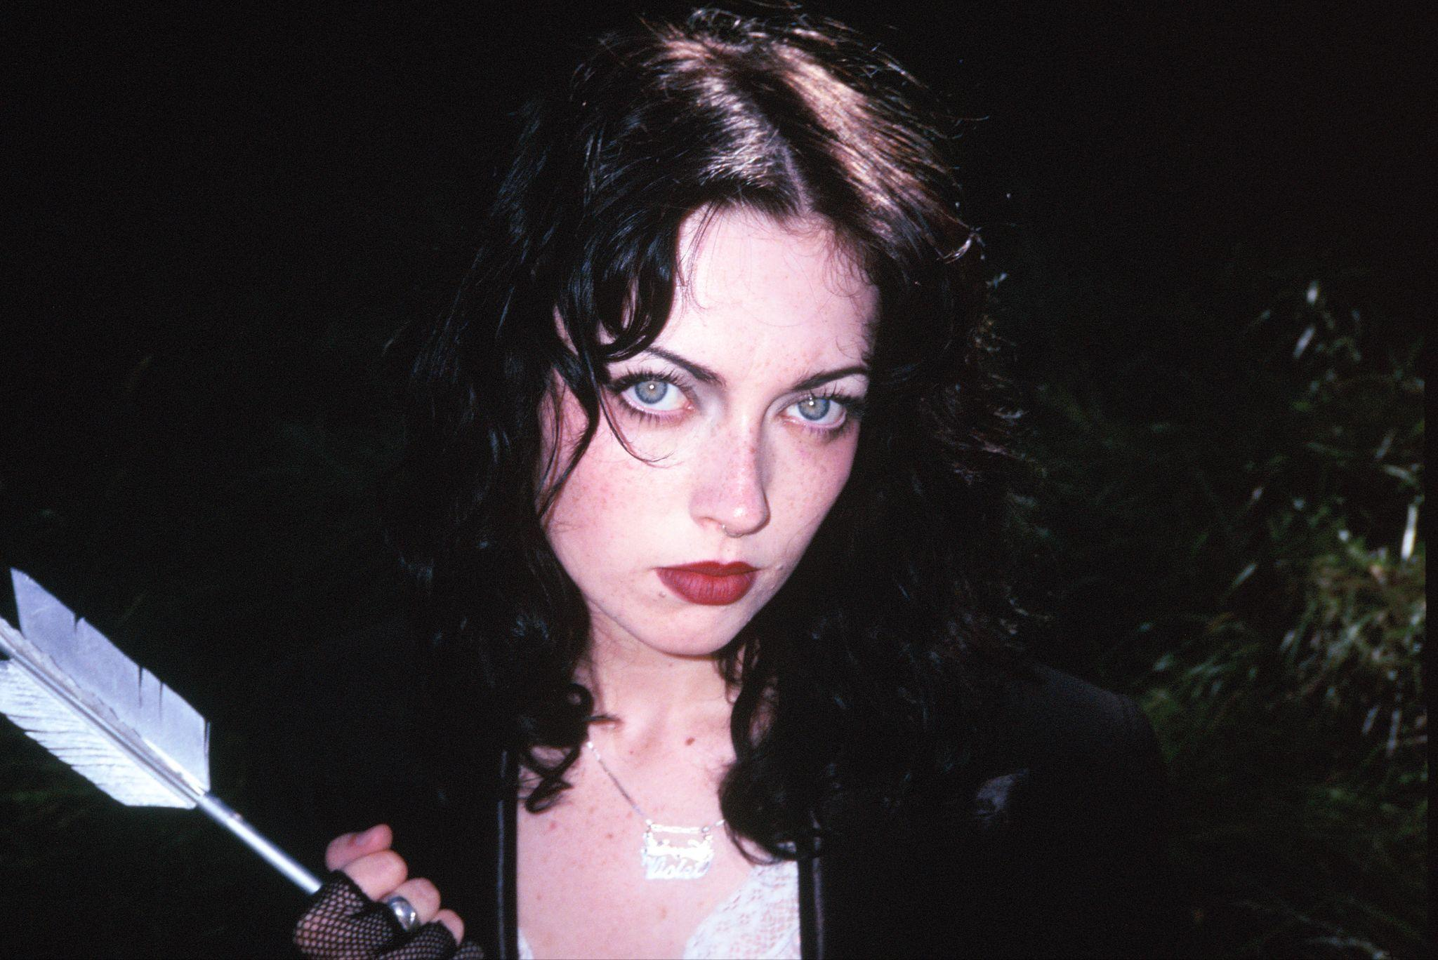
Photo Credit: Bella Newman | Download Hi-Res
"Enough melodic verve to suggest a musical signature all her own.”
-Consequence

"‘Muscular riffs and raw, unvarnished emotions… Cinematic flair and tender production."
-NME

Violet Grohl announces her debut album, Be Sweet To Me, set for global release on May 29th via Auroura Records / Republic Records. Following the 2025 release of “THUM” and “Applefish,” today Violet also unleashes a new album track “595,” accompanied by a Nikki Milan Houston-directed video.

Inspired by a vintage t-shirt advertising a phone sex line, new song “595” is a sly and sexy slasher filled with jolts of noise and a killer chorus: “I'll be your 1-900-G spot, baby / 595 I'm on the line / You won't last.”

WATCH THE “595” VIDEO

Be Sweet To Me was recorded from late 2024 into early 2025 at producer Justin Raisen’s (Kim Gordon, Charli XCX) Los Angeles home studio alongside musicians assembled in the spirit of the Wrecking Crew session players in the ’60s and ’70s. The first song Violet wrote with her collaborators, a fuzzy ripper called “THUM,” was influenced by the old-school packaging of anti-nail-biting polish that Grohl brought into the studio. “Self help me/Self help myself/Chew my bitter fingers,” she snarls in a honeyed voice over ecstatic squall.

Alternative music from the late ‘80s and early ‘90s is a perpetual influence. “There’s something so powerful about that period of music, from the messaging to the visuals, it’s authentic and raw.” Pixies, Soundgarden, Cocteau Twins, The Breeders, PJ Harvey, The Muffs, Björk, Alice in Chains, L7, Juliana Hatfield: “I've listened to that stuff since I was a kid,” Grohl says.

The songs on Be Sweet To Me were conjured from the immediate present and tend to be impressionistic, colored by Grohl’s love of film, particularly the work of David Lynch. The slippery and melodic “Bug In A Cake” recalls the paranormal activities surrounding Grohl’s recent move into the home of her late paternal grandma, a beloved “guiding force” in her life. “Turn the TV off so it turns back on/Come on, grandma, play me your favorite song,” Grohl roars.

In addition to CD, Be Sweet To Me is available to preorder in black, blueberry jam (exclusive to indie retailers) and ivory vinyl (exclusive to the official artist store). Pre-Save + Pre-Order HERE.

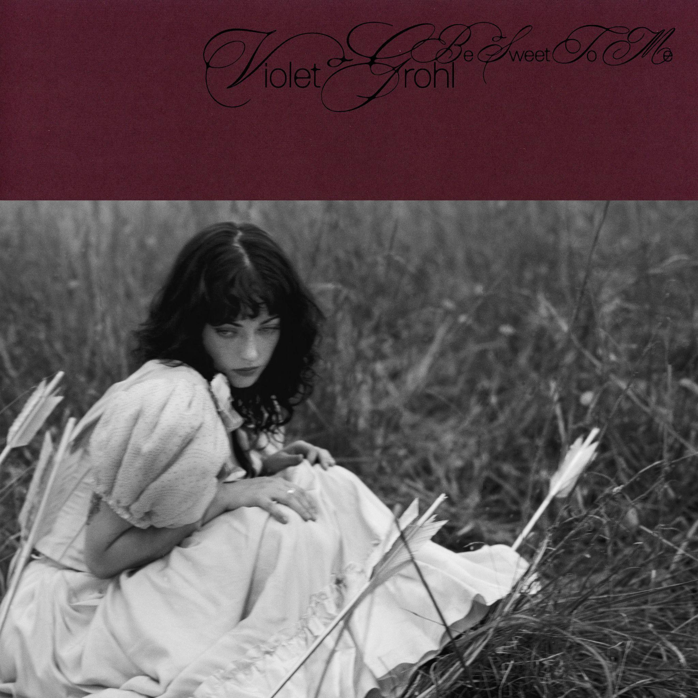
Album Artwork | Download Hi-Res
Art direction & design by Samuel Burgess-Johnson

BE SWEET TO ME TRACKLIST
1. THUM
2. 595
3. Bug In The Cake
4. Last Day I Loved YOU
5. Big Memory
6. Mobile Stars
7. Often Others
8. Applefish
9. Cool Buzz
10. Pool Of My Dream
11. Plastic Couch

In January, Violet released “What’s Heaven Without You,” a haunting track written in the aftermath of the Altadena fires in Los Angeles, inspired by David Lynch. The track will be available along b-side “Swallowtail” as an exclusive 7” Record Store Day release on April 18th. FLOOD Magazine said it "features an atmospheric instrumental bolstered by a marching snare drum and ethereal synths,” while Alternative Press said it “shows Grohl’s voice drifting over an enigmatic instrumental as she grapples with an internal monologue, feeling trapped between devotion and self-protection.

Grohl has been announced as a performer at this year’s Shaky Knees festival in Atlanta (9/12). For updates on all tour dates, visit www.violetgrohl.com.

DISCOVER VIOLET GROHL:

WEBSITE | TIKTOK | INSTAGRAM | FACEBOOK
BANDCAMP | YOUTUBE | SPOTIFY | APPLE MUSIC

For more information and press enquiries please contact

Warren Higgins
warren@chuffmedia.com

