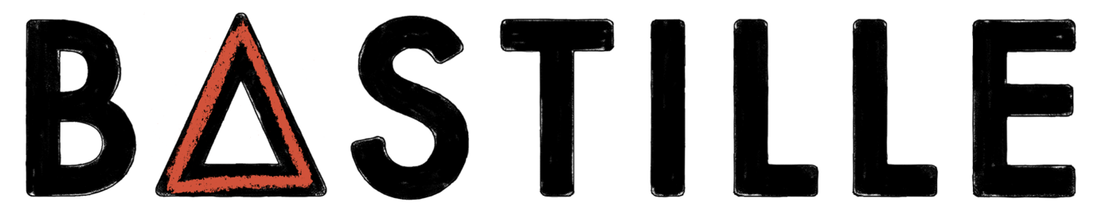

ANNOUNCE 10TH ANNIVERSARY SPECIAL EDITION VINYL OF DEBUT ALBUM, ‘BAD BLOOD’ OUT JULY 14TH 2023

PREORDER HERE

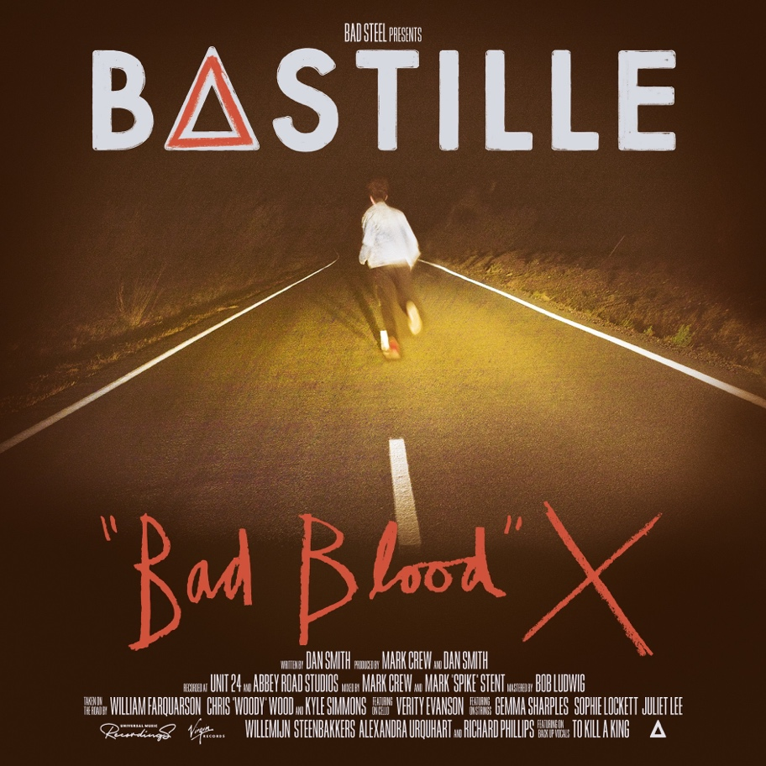
DOWNLOAD ARTWORK HERE

TICKETS FOR ‘BAD BLOOD X’ TOUR ON SALE HERE
INCLUDES LONDON ALEXANDRA PALACE SHOW ON 14TH JULY 2023

In celebration of the 10-year anniversary of their breakthrough debut album, “Bad Blood”, Bastille today announce the release of ‘Bad Blood X’, an extended vinyl edition of their multi-million selling, award winning album which catapulted the band from alt-pop newcomers to global chart-conquering festival headliners.

A truly fan-first release, the record is available exclusively on clear vinyl and includes a special 7” vinyl featuring two never-before heard demos, ‘Racing Heart’, an early version of the single, “Laura Palmer” and fan-favourite b-side, “Poet” recorded in Dan’s bedroom alongside the original tracks on the album. The record also includes a unique 12×12 insert featuring alternative artwork, handwritten annotations from each member of the band, and an abundance of unseen images.

Dan Smith says, ‘When I started working on the songs that became “Bad Blood” 10 years ago at a laptop in my bedroom, I never imagined that they’d be heard by so many people and then take us all over the world. It’s really mad to think about.

Ten years on, we wanted to put something special together to celebrate the album, whilst not messing with it too much. We had so much fun digging back through old artwork, photos and videos from that time to make a totally new package of artworks. My Dad even found an old CD-R of some of demos in the attic (that somehow people managed to pry out of my hands for a new 7” vinyl as part of this release - trust me… I didn’t think those versions would ever get heard). Putting all this together was such a nice way to step back into that world for a moment, and we really hope our fans feel the same way.”

Released on the 4th of March 2013, ‘Bad Blood’ charted at #1 on the UK Albums chart, spending 3 weeks at the top and earning the title of the biggest-selling digital album of 2013. Hailed as a trailblazing debut, the record featured the international hit single ‘Pompeii’ which peaked at #2 on the UK Singles Chart and became the eleventh best-selling song that year.

Bastille were crowned the British Breakthrough Act at the 2014 BRITS, along with receiving two Grammy nominations. ‘Bad Blood’ has since gone on to achieve triple platinum status, with over 1 million copies sold in the UK alone.

Alongside the release, the band have announced a series of special one-off shows this summer, giving fans the opportunity to hear the album played live in its entirety alongside other fan favourites. They will play 10 UK dates, with a London show at Alexandra Palace on Bastille Day 14th July 2023.

Bastille has also been announced as the main support for Duran Duran across their US shows this summer.

Bad Blood X Tour dates:
Weds 28th June - Dublin Trinity Summer Series
Friday 30th June - Newmarket Racecourses
Sat 1st July - Margate Dreamland
Sun 2nd July - Devon Powderham Castle
Fri 7th July - Manchester Castlefield Bowl
Sun 9th July - Bridlington Spa
Thurs 13th July - Leeds Millennium Square
Fri 14th July - London Alexandra Palace Park
Weds 19th July - Warwick Castle SOLD OUT
Sun 23rd July - Ludlow Castle SOLD OUT
Mon 29th July - Dundee Slessor Gardens

‘Bad Blood X’ vinyl tracklisting

Side A
Pompeii
Things We Lost in the Fire
Bad Blood
Overjoyed
These Streets
Weight Of Living, Pt.II

Side B
Icarus
Oblivion
Flaws
Daniel In The Den
Laura Palmer
Get Home
Weight Of Living, Pt.I

7"
Side A
Racing Heart (Laura Palmer Demo)

Side B
Poet (Dan’s Bedroom Demo)

BASTILLE: INSTAGRAM | TWITTER | FACEBOOK | TIKTOK | WEBSITE

For more information and press enquiries please contact

Jenny Entwistle
Jenny@chuffmedia.com

