

**NEW ALBUM ‘LOJA’ TO BE RELEASED DIGITALLY ON JUNE 6TH *PHYSICAL FORMATS TO FOLLOW ON AUGUST 23RD***

**\*PRE-SAVE** [**HERE**](https://orlandoweeksuk.lnk.to/LojaPR)**\***

**FIRST SINGLE ‘DIG’ FEATURING RHIAN TEASDALE OF WET LEG**

**LISTEN** [**HERE**](https://orlandoweeksuk.lnk.to/DigPR) **/ WATCH THE VIDEO** [**HERE**](https://orlandoweeksuk.lnk.to/DigPR/youtube)

**HOSTS AN ART EXHIBITION / ALBUM PERFORMANCE AT THE COPELAND GALLERY ON JUNE 6TH-9TH**

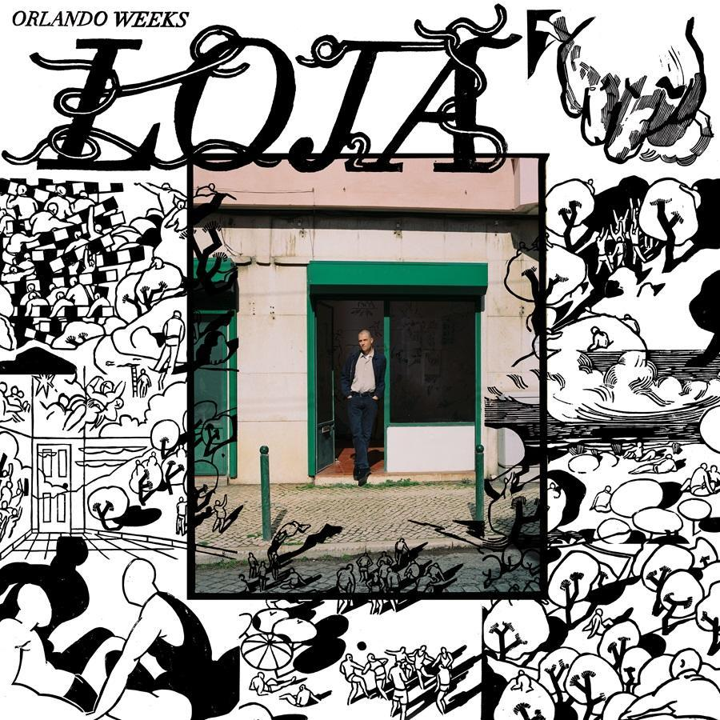 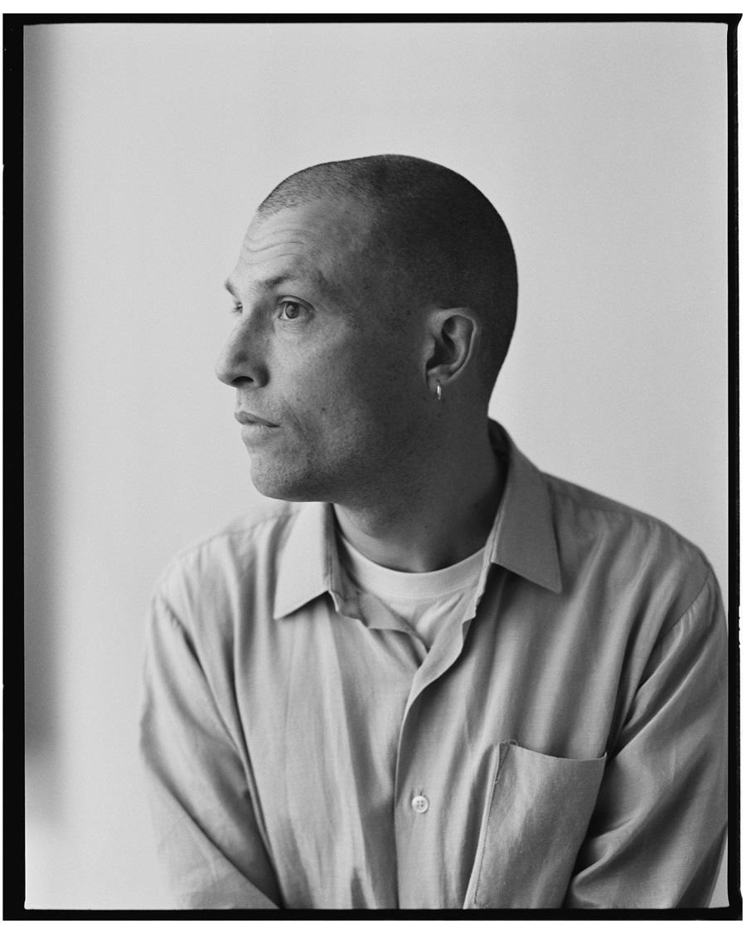

**Download album cover** [**HERE**](https://umusic.ent.box.com/s/mifx8uaj6bartl7jvut010n2a4qsar9p/file/1474704698070) **/ photo by Kate Friend** [**HERE**](https://umusic.ent.box.com/s/4tmkpkq2mtbksiq03ct8yq58wkhjf58s/file/1504929210351)

From his influential time with **The Maccabees** to the multi-faceted **‘Gritterman’** story and two highly acclaimed solo albums, **Orlando Weeks** has carved a niche as one of the **UK’s** most singular talents. That reputation will further flourish with the news that he will release his new album **‘LOJA’** digitally on all platforms on June 6th; with physical formats to follow on **August 23rd via Fiction Records**. Available to pre-save [HERE](https://orlandoweeksuk.lnk.to/LojaPR) across streaming platforms; **Orlando** previews the album by sharing its lead single **‘Dig’**, which features **Rhian Teasdale** of **Wet Leg**.

‘Dig’ is a driving, motorik groove which captures an *“under your breath half-argument, the kind that only ever happens in public.”* **Orlando** and **Rhian Teasdale** trade lines, the song’s inner tension building as his conspiratorial delivery is countered by her scathing, weary dismissal. Its social realist lyrics are given a fantastical twist with a video from director **Matt Harris-Freeth**, who previously helmed the **‘Look Who’s Talking Now’** [video](https://www.youtube.com/watch?v=zbs20sb7Zqs).

**Orlando** adds, *“‘Dig’ is a tit for tat exchange where long worn-out promises are remade and road weary offences retaken. The kind of disagreement that manages to be somewhere between outpouring of emotion and exposed internal monologue.”*

**‘LOJA’** is a record in which place is as vital a characteristic as the emotions and incidents that he explores. The overarching themes are optimism and reflection: the positive mindset that emerged as he left **London** for a new life in **Lisbon** together with a new-found awareness about the things that you have left behind. Contentment emanates like a comforting embrace from an old friend. Yet life can never be as linear or as pure as unfiltered unhappiness and so **‘LOJA’** on occasion captures more corrosive moods too, from whispered confrontations to witnessing shocking tragedy in otherwise beautiful serenity.

**Orlando** says, *“The great change in our lives was that we left London and moved to Lisbon, and the record definitely has elements of being a love letter to the place that we now call home. But I think the move provided a stirring of the waters. It threw up an awful lot of stuff and it gave us perspective and hindsight because suddenly there was distance. You can re-evaluate the things you were too close to, those things that there was no point spending time thinking about because it was the day-to-day bubble you were in.”*

**‘LOJA’** simmers with an engaging, organic warmth derived primarily from members of **Orlando’s** live band (**Sami El-Enany**, **William Doyle**, **Alexander Painter** and **Luca Caruso**), yet it also benefits from an array of nuanced details that, on first listen, hide stealthily in plain sight before revealing themselves with repeated listens. The process started late in **2022**, but only gathered pace after he relocated to **Lisbon** before the bulk of the record was made in thirteen days in **Chale Abbey Studios** on the **Isle of Wight** with producer **Sergio Maschetzko** (**Black Country New Road**) and his collaborator **David Granshaw**, before **Orlando** teamed up with **Nathan Jenkins (Bullion)** to add the finer final touches.

The title **‘’LOJA’** (a shop or a store) references a building that **Orlando** rented in **Lisbon** which he used as his first proper art studio, a place where he crafted all of the art that will accompany the album. The album will be **released digitally on** **June 6th** to coincide with the start of a special residence at **The Copeland Gallery, London** running from **June 6th-9th**, where by day **Orlando** will exhibit the paintings, sketches and prints he created there before it is transformed into a gig venue by evening, when he will perform tracks from the album for the very first time. The opening day quickly sold-out, resulting in the addition of three further sessions. Tickets are available [**HERE**](https://dice.fm/artist/orlando-weeks-vqag).

**‘LOJA’** tracklist:

**1. ‘Longing’**

**2. ‘Best Night’**

**3. ‘Wake Up’**

**4. ‘Dig’ featuring Rhian Teasdale**

**5. ‘You & The Packhorse Blues’**

**6. ‘Good To See You’**

**7. ‘My Love Is (Daylight Saving)’**

**8. ‘Please Hold’**

**9. ‘Sorry’**

**10. ‘Tomorrow’**

**11. ‘Beautiful Place’**

**Follow Orlando Weeks:**

[**Website**](http://www.orlandoweeks.co.uk) **|** [**Spotify**](https://open.spotify.com/artist/5K9Px0eeCuYatmBGFfhSOA) **|** [**Apple Music**](https://itunes.apple.com/gb/artist/orlando-weeks/201628833) **|** [**YouTube**](https://www.youtube.com/channel/UC2N065Sur6IbRdw-IwjMbrw) **|** [**Instagram**](https://www.instagram.com/orlandoweeks/)

**For more on info contact** [**warren@chuffmedia.com**](mailto:warren@chuffmedia.com)