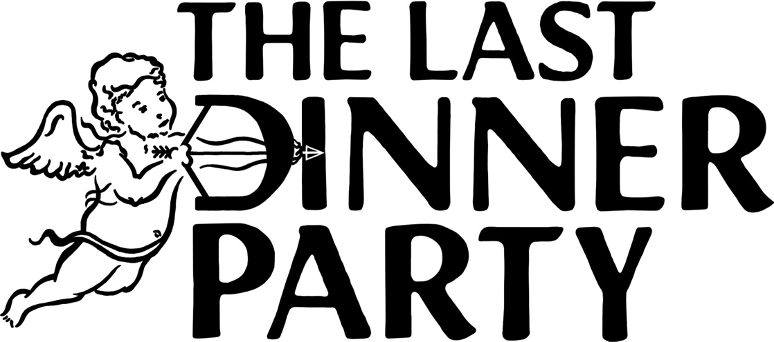

THE LAST DINNER PARTY ANNOUNCE NEW ALBUM

“FROM THE PYRE” RELEASED 17TH OCTOBER VIA ISLAND RECORDS

+ NEW SINGLE, THIS IS THE KILLER SPEAKING

The Last Dinner Party are very pleased to announce details of their second album, From The Pyre. It’s released on the 17th October 2025 through Island Records.

To coincide with the album’s announcement, the band share their first single, This Is The Killer Speaking. Watch the video/listen to the track here.

The London five-piece headed into the studio in late 2024 with Grammy Award winning producer Markus Dravs (Wolf Alice, Florence & The Machine, Bjork) to start work on the follow-up to their number 1 debut album, 2023’s Prelude to Ecstasy. From The Pyre is the sound of a band having a lot of fun rather than feeling any innate pressure to follow-up on what was an explosively successful debut record. It’s also the sound of a young band developing and maturing their songwriting together, as tight a unit as the endless months out on the road pay testament to.

The Last Dinner Party on From The Pyre:

“This record is a collection of stories, and the concept of album-as-mythos binds them. ‘The Pyre’ itself is an allegorical place in which these tales originate, a place of violence and destruction but also regeneration, passion and light.

“The songs are character driven but still deeply personal, a commonplace life event pushed to pathological extreme. Being ghosted becomes a Western dance with a killer, and heartbreak laughs into the face of the apocalypse. Lyrics invoke rifles, scythes, sailors, saints, cowboys, floods, Mother Earth, Joan of Arc, and blazing infernos. We found this kind of evocative imagery to be the most honest and truthful way to discuss the way our experiences felt, giving each the emotional weight it deserves.”

“This record feels a little darker, more raw and more earthy; it takes place looking out at a sublime landscape rather than seated an opulent table. It also feels metatextual and cheeky in places, like a knowing look reflected back at ourselves.”

With two BRIT Awards to their name (including Breakthrough Artist earlier this year), and having sold out virtually every show they played right across the globe (including three sold-out hometown shows at London’s Eventim Apollo), The Last Dinner Party’s arrival and subsequent worldwide success was one of the most thrilling introductions to a new British band in decades, and From The Pyre’s opening introduction suggests that unparalleled success story shows no signs of relenting.

Album Tracklisting:

Agnus Dei / Count The Ways / Second Best / This Is The Killer Speaking / Rifle / Woman Is A Tree / Hold Your Anger / Sail Away / The Scythe / Inferno

For more information contact Warren@chuffmedia.com

