Rose Gray announces
A Little Louder, Please

The deluxe version of her debut album, with features from Melanie C, JADE, Shygirl and CaseyMQ

- Shares new single ‘April’
LISTEN/WATCH



Press Shot HERE (Credit - Yana Van Nuffel)

Rose Gray returns with brand-new single ‘April’, alongside news of the deluxe version of her debut album Louder, Please (released January 2025). Titled A Little Louder, Please, the expanded edition arrives on October 24th via Polydor Records.

‘April’ is a shimmering, carefree ode to living in the moment - an extension of Rose’s bold, euphoric debut era. It arrives alongside a visualiser filmed in Chamonix, the same location where the deluxe artwork was shot, that acts as a playful juxtaposition to Rose’s sun-soaked debut. Speaking on the new track, she says:

“Show me what you live for. Have you ever met someone out and just thought, whatever ‘it’ is, you’ve got it? Carefree, sexy and completely in their body. That’s what ‘April’ is about. Someone I met on the dance floor who made me want to live a little more. ‘April’ feels like an extension of ‘Louder, Please’… the big sister. I’m so in love with the fact I get to release it now.”

Boasting features from Melanie C, JADE, Shygirl and Casey MQ, the expanded A Little Louder, Please also includes two brand-new bonus tracks (‘April’ and ‘Lotus’) alongside an additional disc of club edits, string versions and remixes, with reworks from the likes of Logic1000, Peach, Clementaum, Alex Chapman and more. Full tracklist below.

News of the deluxe album follows the release of Rose’s Hackney Wick mini doc, released this week and shot by HOWL (the team behind The Cube Sessions). The short film offers a vibrant portrait of Rose’s affinity with the East London suburb, the journey to her debut album and the beautifully messy nights that paved the way. Watch HERE.

Meanwhile Rose’s rise continues to accelerate: earlier this week, she announced her very first shows in Brazil in November alongside a performance at Corona Capital in Mexico City. which follow a whirlwind summer that saw her support Kesha and Scissor Sisters on their US ‘The Tits Out Tour’. Having already teased ‘April’ across her recent live shows, Rose will soon bring these songs back to the UK with her headline run this October, including two nights at London’s Village Underground. Tickets available HERE, full itinerary below.

Born on New Year’s Eve and raised in Walthamstow, Rose has lived her life through club music - from cloakroom shifts to dancefloor epiphanies - a spirit that infuses her art with hedonism, honesty and heart. Releasing her long-awaited debut album Louder, Please in January 2025 via Play It Again Sam - the record was introduced by a confident run of singles including the euphoric ‘Party People’, ‘Free’, ‘Angel Of Satisfaction’, ‘Switch’ and ‘Wet & Wild’. Across the album, Rose channels the chaos, catharsis and clarity of the dancefloor into a kaleidoscopic vision that fuses classic pop with rave sensibilities. Praised for its breadth of collaborators - spanning Justin Tranter (Lady Gaga, Chappell Roan) and Zhone (Troye Sivan) to underground electronic innovators Sega Bodega, Uffie and Alex Metric - Louder, Please cemented Rose as one of the UK’s most exciting new voices. Alongside the record, Rose collaborated with Ben Hemsley (‘Tidal’), Megra (‘Elixir’) and TSHA (‘Girls’), performed at Glastonbury with Shygirl, launched her own club night (Gray Selects), recorded a BBC Maida Vale session, played her first ever headline UK tour, bagged a win as MTV’s Push Artist of 2025 and supported Charli xcx at LIDO festival in London. Now newly signed to Polydor records, Rose is paving the way for yet another blockbuster year, and A Little Louder, Please is just the beginning.

A Little Louder, Please (Deluxe) – Tracklist

Disc 1
- Damn
- Free
- Wet & Wild
- Just Two
- Tectonic
- Party People
- Angel Of Satisfaction
- Switch
- Hackney Wick
- First
- Everything Changes (But I Won’t)
- Louder, Please
- April (bonus track)
- Lotus (bonus track)

Disc 2
- Damn – Club Edit
- Free – Fifi remix
- Wet & Wild – Alex Chapman remix
- Just Two – Clementaum’s ABRISA remix
- Tectonic – Strings Version
- Party People – KARL F RIVAS remix
- Angel Of Satisfaction (feat. JADE)
- Switch – Logic1000 remix
- Hackney Wick – Strings Version
- First (feat. Melanie C)
- Everything Changes (But I Won’t) (feat. Shygirl & Casey MQ)
- Louder, Please – Peach remix
- I Don’t Speak French (bonus track – digital only)
2025 Tour Dates
October 7th Dublin, Ireland - The Academy
October 8th Birmingham, UK - O2 Institute3
October 9th Glasgow, UK - King Tuts Wah Wah Hut
October 10th Leeds, UK - The Wardrobe
October 12th Manchester, UK - Gorilla
October 13th London, UK - Village Underground
October 14th London, UK - Village Underground

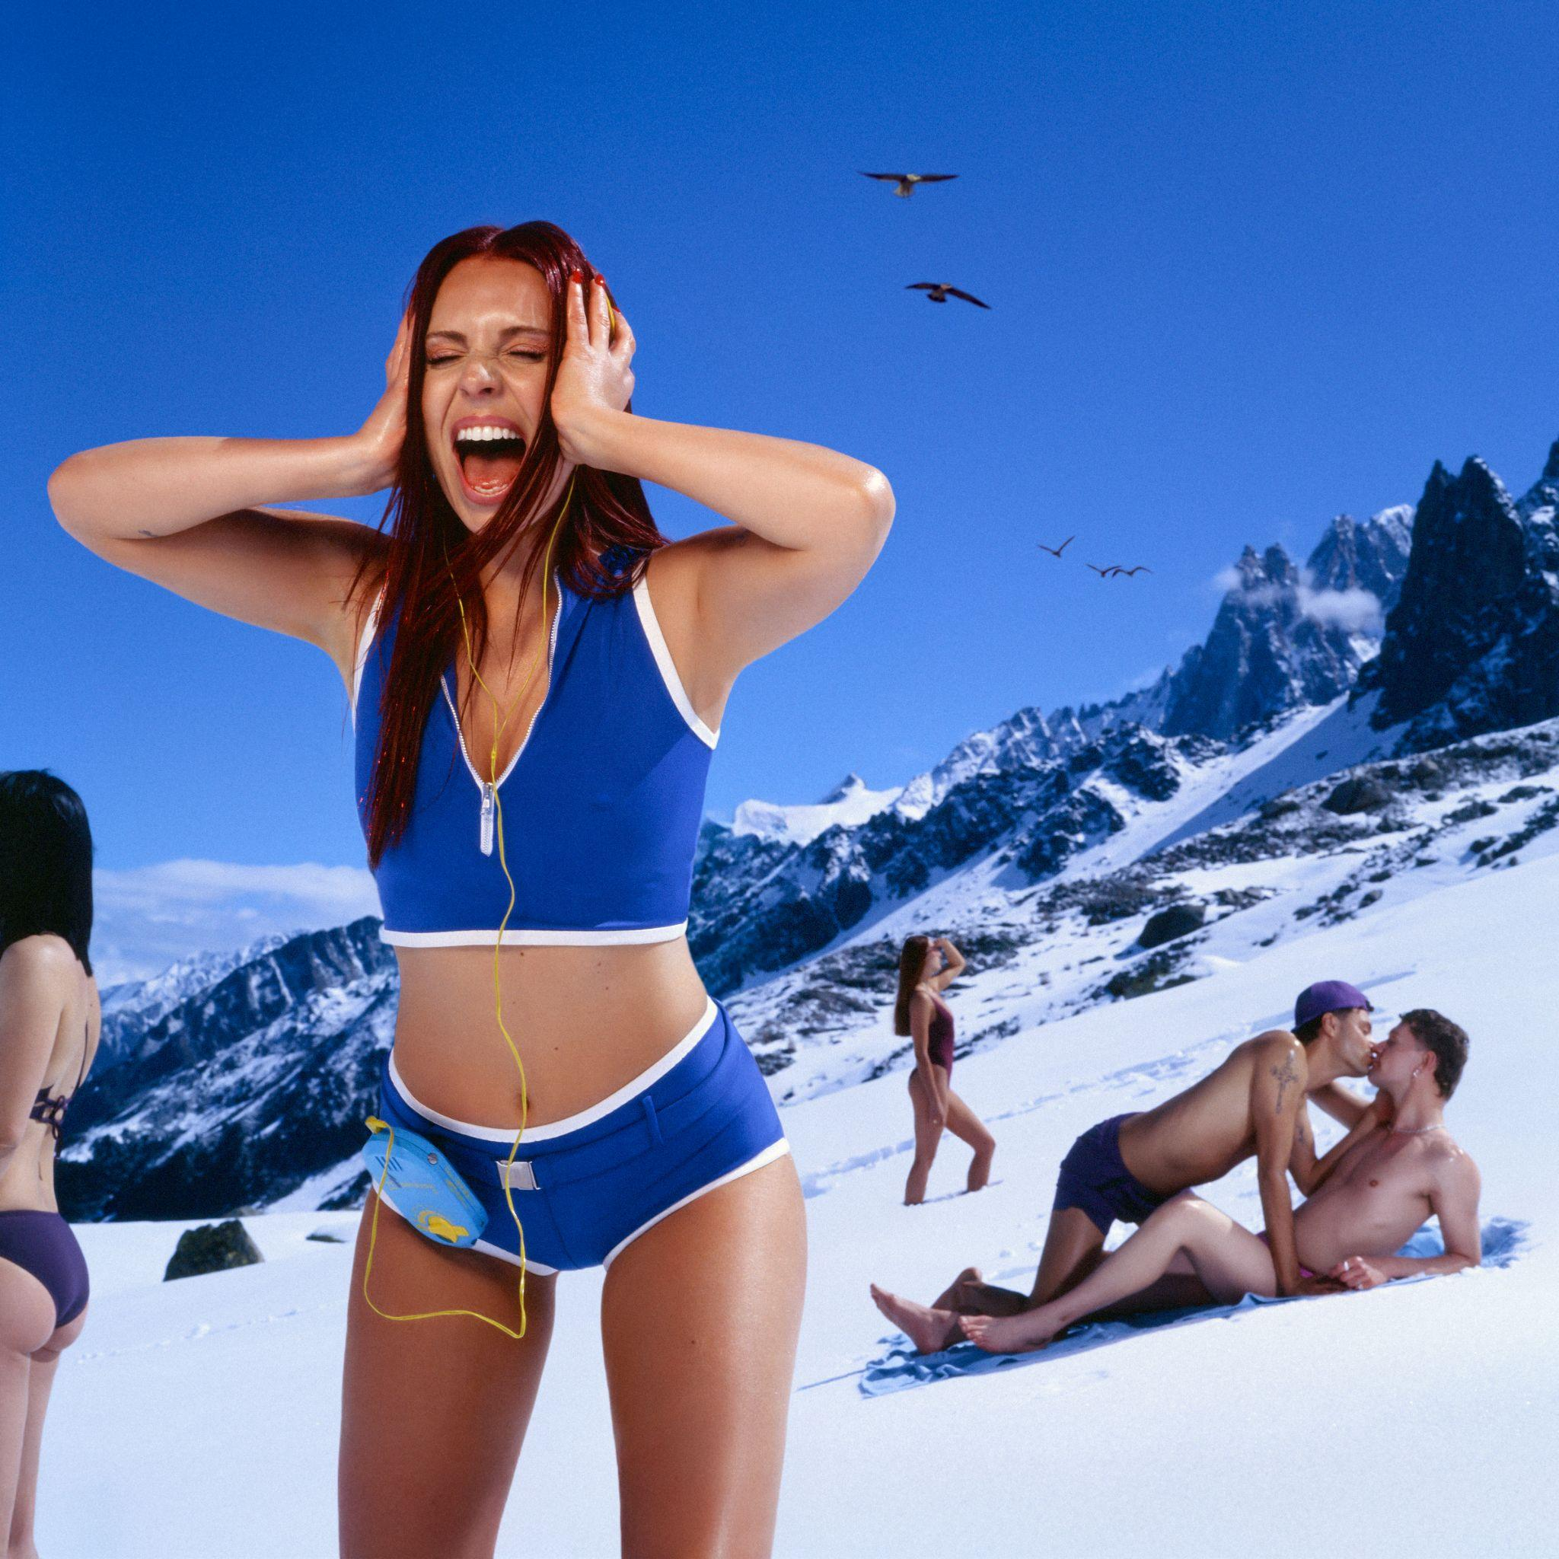
A Little Louder, Please Artwork HERE

Follow Rose Gray
Instagram | YouTube | Spotify | TikTok | X

For more information and press enquiries please contact

Harry Turnbull
harry@chuffmedia.com

