ENTER SHIKARI

Announce new album
A Kiss For The Whole World

Share new single ‘(pls) set me on fire’

Monthly residency shows in the UK through Feb, March & April

A Kiss For The Whole World out 21st April via SO Recordings / Ambush Reality

Enter Shikari | Photo credit: Jamie Waters | Download hi-res image here

Enter Shikari are today announcing that their highly anticipated new album, A Kiss For The Whole World, will be released on 21st April via SO Recordings / Ambush Reality. The band are also sharing the album’s lead single ‘(pls) set me on fire’ as well as news of some very special monthly residency shows in the UK this Spring.
Hear ‘(pls) set me on fire’ here
Pre-order A Kiss For The Whole World here.

Limited formats of the new album come packaged with the Live From Alexandra Palace 3 album & DVD, recorded live in December 2021 at the band’s sold out 10,000 capacity London show.

As the calendar now signals three years since Enter Shikari last released an album - their UK #2 charting album Nothing Is True & Everything Is Possible – it is useful to think back to the final question the band last posed fans: “Is this a new beginning? / Or are we close to the end?” Little could they know just how close to the end things would end up feeling as the events of the early ‘20s dimmed the light in the furnace of their live juggernaut, and connection to their fans. “At the time it felt like we ourselves, as musicians, were experiencing the death of our band,” says lead vocalist and keyboardist Rou Reynolds.

Unsurprisingly, the key in the band’s ignition came in the form of a live show as they headlined the Download Festival Pilot in front of 10,000 fans. Where not a single new word flowed from the pen of Reynolds in the two years prior, a realisation was born that would come to define the band’s seventh LP: “I just didn’t realise that the human and physical connection to other people were so central to how I write,” he says. Enter Shikari isn’t just four people – it’s hundreds of thousands.

As new single ‘(pls) set me on fire’ heralds the next stage in the band’s evolution, the first words we hear from Enter Shikari 2.0 don’t come in the form of a question this time, but a command: “Please set me on fire”. In other words, ignite the spark inside us and set us free. This may be a new Enter Shikari but they’ve lost nothing in their flair for bold opening gambits.

Reynolds comments on the single’s conception: "Honestly, I thought I was f*****. I’ve never felt so detached from my soul, my purpose, my f****** spirit. I didn’t write music for almost two years. The longest I’d gone before that was two weeks. I was broken. It’s almost as if my brain had asked: “What is the point in music if it cannot be shared? What is the point in writing music if it’s not to be experienced with others?” and then promptly switched itself off. ‘(pls) set me on fire’ grew out of that desperation. This song is a projectile vomit of positive energy. Every emotion trapped inside me for two years, finally set free.”

////

It was in the Spring of 2022 that the band descended to the coastal town of Chichester, and a delipidated farmhouse, to rebuild their studio setup and capture their renewed momentum on record. Using only solar power to track the album – in what Reynolds says was to “bring back some sense of naivety” – the life-giving properties and Technicolor palate of A Kiss For The Whole World were made real. Reynolds continues: “Back to basics. This band - my best friends - bundled into an old farmhouse, miles away from anywhere. Off-grid, and ready to rediscover ourselves. This album is powered by the sun, the most powerful object in our solar system. And I think you can tell. It’s a collection of songs that represent an explosive reconnection with what Enter Shikari is. The beginning of our second act”.

Enter Shikari have also detailed a collection of special 2023 UK residency shows to take place through the Spring. Reynolds explains their thinking: "It’s hard to do anything interesting with live shows today. We wanted to do something different. We're going to become a local band to five major cities in the UK. It’s going to be interesting to see how the shows evolve every time we return.”

Exclusive access to tickets begins 19th Jan for members of the band's fan club, or anyone pre-ordering the album here. General sale begins 26th Jan.

The full schedule of 2023 UK residency shows is below.

Feb 15 – HERE at Outernet, London, UK
Feb 16 – New Century Hall, Manchester, UK
Feb 17 – KK’s Steel Mill, Wolverhampton, UK
Feb 19 – SWX, Bristol, UK
Feb 20 – St Luke’s, Glasgow, UK

Mar 14 – New Century Hall, Manchester, UK
Mar 15 – St Luke’s, Glasgow, UK
Mar 16 – KK’s Steel Mill, Wolverhampton, UK
Mar 17 – HERE at Outernet, London, UK
Mar 18 – SWX, Bristol, UK

Apr 13 – St Luke’s, Glasgow, UK
Apr 14 – New Century Hall, Manchester, UK
Apr 15 – KK’s Steel Mill, Wolverhampton, UK
Apr 16 – SWX, Bristol, UK
Apr 17 – HERE at Outernet, London, UK

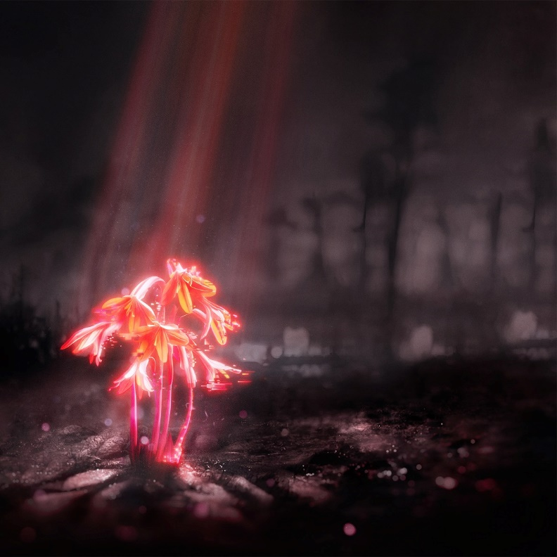

Enter Shikari - A Kiss For The Whole World album artwork | Download here

Enter Shikari – A Kiss For The Whole World album track listing

1. A Kiss for the Whole World x
2. (pls) set me on fire
3. It Hurts
4. Leap into the Lightning
5. feed yøur søul
6. Dead Wood
7. Jailbreak
8. Bloodshot
9. Bloodshot (Coda)
10. goldfĭsh ~
11. Giant Pacific Octopus (i don’t know you anymore)
12. giant pacific octopus swirling off into infinity…

Enter Shikari: Website | Facebook | Twitter | Instagram | TikTok

For more information and press enquiries please contact
Jenny Entwistle / Jenny@chuffmedia.com

