SELF ESTEEM
ANNOUNCES HER NEW ALBUM
A COMPLICATED WOMAN
DUE 25 APRIL VIA POLYDOR RECORDS

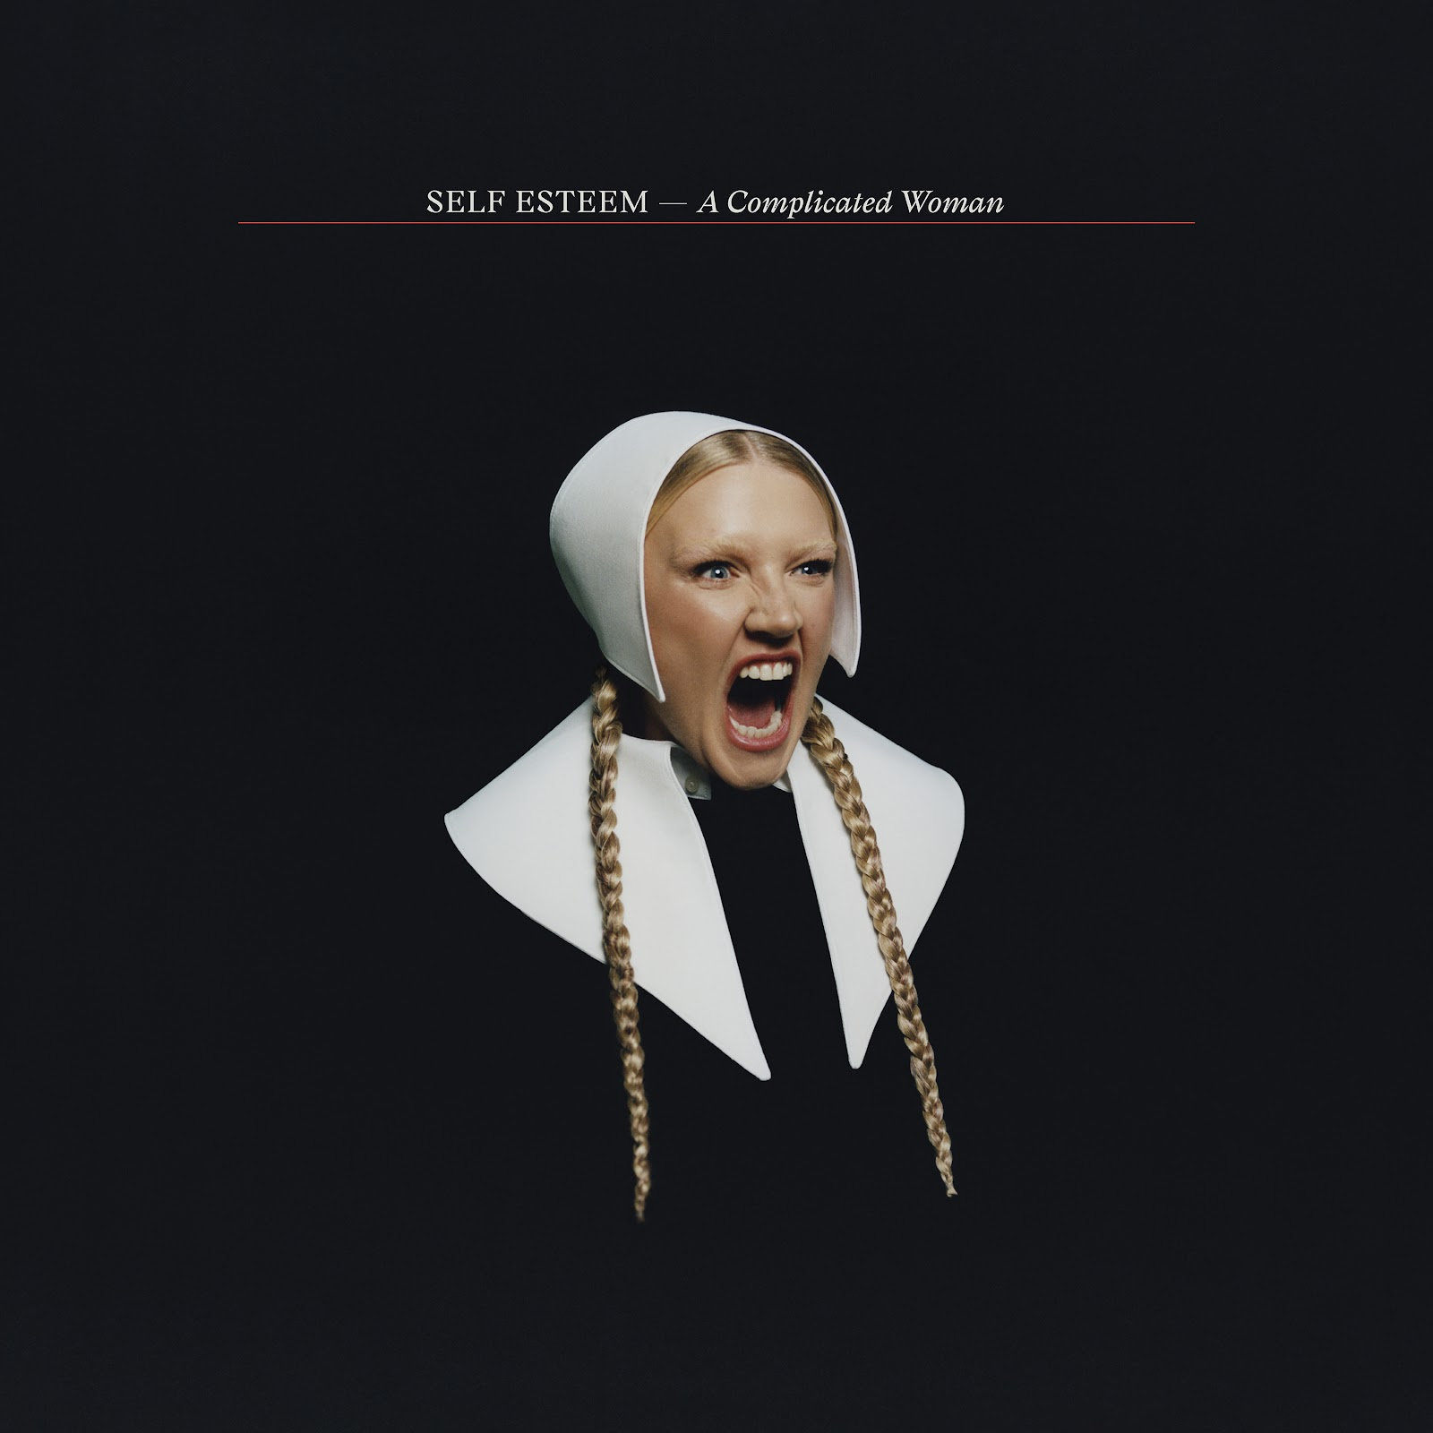
A Complicated Woman artwork (download assets here)

WATCH + LISTEN TO THE FIRST SINGLE
‘FOCUS IS POWER’

Self Esteem AKA Rebecca Lucy Taylor today announces her eagerly anticipated new album A Complicated Woman, due for release on 25 April in digital, CD, cassette and vinyl formats - including limited editions - via Polydor Records. The album is the follow up to the hugely acclaimed BRIT and Mercury Prize-nominated 2021 album Prioritise Pleasure - an album of the year everywhere from the Guardian to the Sunday Times.

Pre-order / pre-save A Complicated Woman

A Complicated Woman contains all Taylor’s musical thumbprints – complex thought processes unfolding in real time, an effortless knack of exposing the feelings women are required to labour under – but set on a larger, brighter landscape that is nothing short of exhilarating. Running through the album is a jubilant choir constructed of dozens and dozens of mostly female voices - “a community of people. I want you to hear and feel the connection” - including close friends, her band and collaborators, that includes - but is not limited to - singer-songwriters Nadine Shah, Moonchild Sanelly and Sue Tompkins from Life Without Buildings; a personal hero, the drag queen Meatball and a bona fide Lancaster legend, the actress Julie Hesmondhalgh.

A Complicated Woman is about taking control of your life, summed up in the astonishing first single ‘Focus Is Power’. Inspired by words Taylor wrote on a sticker, working from her mum and dad’s shed in the pandemic - “You see, it wasn’t up to me but now it could be / But now I see it clear with every passing of each year / I deserve to be here…” - the lyrics become an incantation when shared between the choir, something the accompanying music video (shot by long time collaborator Piers Dennis) echoes in its community hall performance.

Listen / watch ‘Focus Is Power’

A Complicated Woman tracklisting
1.⁠ ⁠I Do And I Don’t Care
2.⁠ ⁠Focus Is Power
3.⁠ ⁠Mother
4.⁠ ⁠The Curse
5.⁠ ⁠Logic, Bitch! ft Sue Tompkins
6.⁠ ⁠Cheers To Me
7.⁠ ⁠If Not Now, It’s Soon
8.⁠ ⁠In Plain Sight ft Moonchild Sanelly
9.⁠ ⁠Lies ft Nadine Shah
10.⁠ ⁠69
11.⁠ ⁠What Now
12.⁠ ⁠The Deep Blue Okay

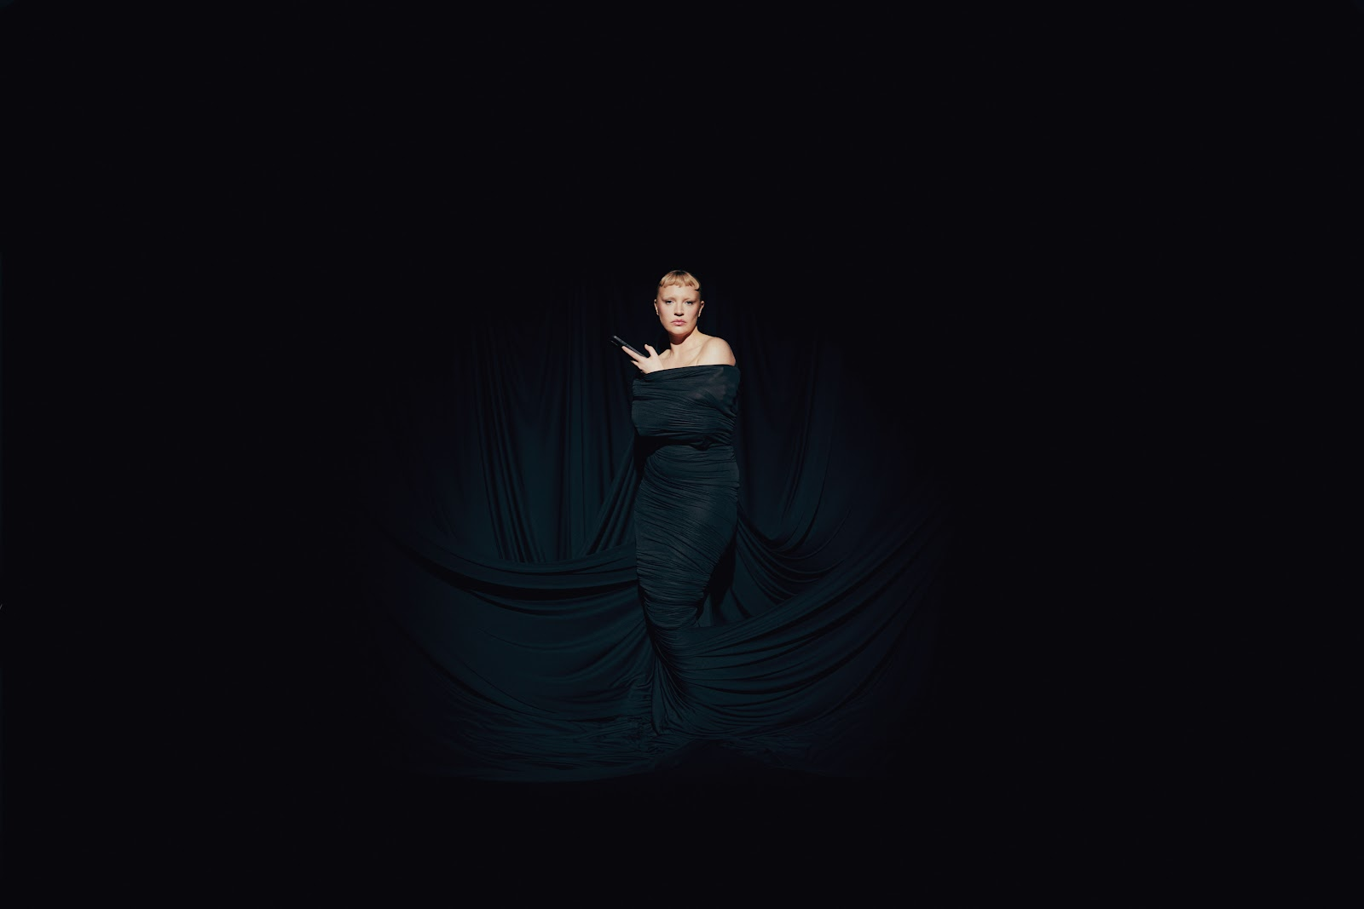
Self Esteem - photo credit: Scarlett Carlos Clarke (download assets here)

About Self Esteem
One of the UK’s most exciting breakout stars of the past decade, Rebecca Lucy Taylor, AKA Self Esteem emerged from cult favourite status to mainstream hero following the huge success of her empowering, truth-telling 2021 single ‘I Do This All The Time’. The song resonated intensely as a perfect example of Taylor’s affectionately termed ‘trojan horse’ or ‘salad and chips’ approach, fearlessly packing important, emotive messages into witty, resonant pop music.

Self Esteem’s wildly acclaimed second album Prioritise Pleasure quickly followed, tackling the hypocrisies and joys found in her experiences of modern day womanhood across dating, friendship, comparison culture, self love, women’s safety and sexual assault and much more. Prioritise Pleasure received Mercury Prize, BRIT Award, Sky Arts and NME Award nominations, was crowned The Guardian and Sunday Times Culture’s Album of the Year, and ‘I Do This All The Time’ was also named The Guardian’s #1 song of 2021.

Quite the opposite of an overnight success, Taylor spent a decade as one half of indie duo Slow Club before adopting the pop star persona she’d always dreamed of. She released her first Self Esteem album Compliments Please in 2019, featuring fan favourite singles ‘The Best’, ‘Girl Crush’ and more.

Gathering a passionate and vast legion of fans ever since, Taylor has appeared on The Graham Norton Show, Celebrity Gogglebox, Friday Night Live, performed three times on Jools Holland including the NYE Hootenanny, graced the covers of magazines from Grazia to NME to Sunday Times Style, and is one of a handful of artists to have been playlisted across BBC Radio 1, 2 and 6 Music simultaneously.

Having reached new heights of acclaim, Taylor has continued to grow, diversify, and create in 2024. Branching out into the world of acting, Taylor starred in a regular role in the Sky series Smothered, before completing a run playing Sally Bowles in the multiple Olivier Award-winning production of 'Cabaret at the Kit Kat Club' in London's West End. Starring alongside Jake Shears (lead singer of Scissor Sisters) as Emcee, the pair’s time on stage was extended due to popular demand, and showcased the sheer range of talent in Taylor’s repertoire. A one-off collaborative single with Moonchild Sanelly, ‘Big Man’, was released in the summer of 2024.

Connect with Self Esteem
Website / Instagram / Facebook / X / TikTok

For all media enquiries please contact Warren@chuffmedia.com on 07762 130510

