NELLY FURTADO ANNOUNCES 7, HER EAGERLY AWAITED NEW STUDIO ALBUM,
TO BE RELEASED SEPTEMBER 20

NEW SINGLE “CORAZÓN” FEAT. BOMBA ESTÉREO OUT TODAY
ALONGSIDE OFFICIAL VISUALIZER

WATCH HERE

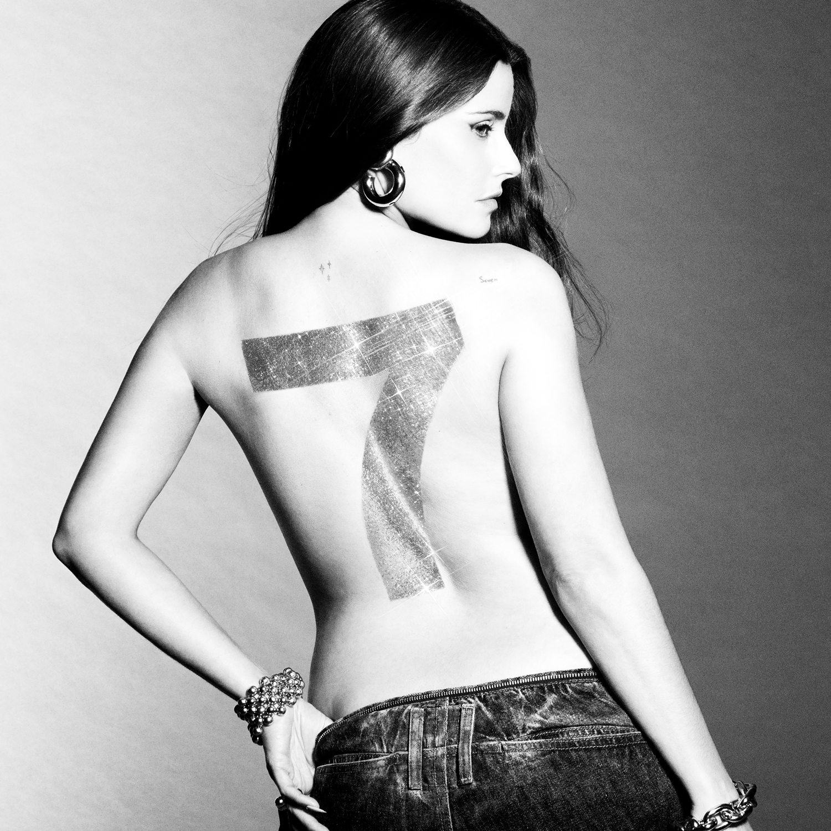

“I love your music, I’ve loved it from the beginning when you came out, and I love you taking your time to return. It sounds like you know yourself on this. There’s new territory for you, but it also feels like it’s where you belong. – Zane Lowe

“Nelly Furtado is back in the studio, although her impact on music never left.” – PAPER Magazine

“Furtado has been, and will always be, a mainstay in pop” – OUT Magazine
“… over the past year, the Canadian Prime Minister of Pop, Folk-Pop and Urban [insert any genre here, really] has been having a well-deserved resurgence (thank f**k)” – Gay Times

“00’s icon Nelly Furtado is back, and we were so ready for it.” – Wonderland
“The pop queen is ready to reclaim her throne” – CLASH Magazine
GRAMMY Award-winning global superstar Nelly Furtado has announced her highly anticipated new studio album, 7, releasing on September 20 via Nelstar/21 Entertainment/Universal Music Canada/Republic Records/Casablanca Records/Polydor Records.

Pre-order / Pre-save 7 HERE

Her most inspired and personal collection to date, 7 is the culmination of four years of artistic rediscovery. After years of focusing her energy on motherhood, Furtado felt the magnetic pull to go back into the studio. “I started going out again and I kept hearing my music being played and remixed by DJs, and at the same time, my eldest daughter was showing me how the online community - including a whole new audience of Gen Z fans - were discovering and embracing my music, 20 years later,” shares Furtado. “I heard the calling!”

A prolific songwriter and collaborator, Furtado wrote 400 songs and collaborated with artists, songwriters, musicians, and producers from around the world over those four years. “I found my voice again,” reflects Furtado. “I came to the studio lost and searching for my artistic identity. I had done a lot of reflection and self-work during my seven years outside of music so I was bringing that growth into the studio with me.” She continues, “This collection of songs is so personal. It reflects my journey through heartbreak and finding my confidence as an artist again, into the pure joy and celebration you feel when you’re nurturing your passion and are part of a community.”

Her new single released today, “Corazón” feat. Bomba Estéreo was one of the first songs on the album that Furtado wrote. After being introduced to Bomba Estéreo’s Liliana Saumet by Furtado’s close friend, Canadian Colombian artist Lido Pimienta, Furtado jumped on a plane to stay with her in Santa Marta, Colombia and begin creating music. Surrounded by the support of women, Furtado found a sense of community among fellow artists who were also mothers, and her artistic voice was awakened. It was in Colombia with Liliana where the spirit of “Corazón” was born. Featuring Grammy-nominated Colombian band Bomba Estéreo and co-produced by Nelly Furtado and T-Minus, “Corazón” is a celebratory global pop song. Its potent blend of unique vocal hooks, empowering lyrics in English and Spanish over soaring melodies, pulsing rhythms, and eclectic instrumentation solidifies “Corazón” into Furtado’s canon of innovative pop music that resonates with global audiences.

Watch the “Corazón” visualizer featuring Nelly Furtado, Liliana Saumet, and Lido Pimienta HERE

“Corazón” is the second single to be released from 7 following Furtado’s pop anthem “Love Bites” feat. Tove Lo & SG Lewis. Released alongside an interview with Zane Lowe, “Love Bites” has amassed over 13 million streams to date, has received worldwide critical praise from publications such as Billboard, Rolling Stone, PAPER, Wonderland, The Line of Best Fit, Stereogum, CLASH Magazine, CBC, EUPHORIA. Magazine, and UPROXX, and was recently remixed by Don Diablo - listen HERE.


Photo Credit: Valentin Herfray

Over the past year, Nelly Furtado, an undisputed icon of millennium pop, has connected with a brand-new audience of Gen Z fans who have surged her multi-platinum hit singles. In 2023 alone, Furtado racked up 1.5 billion streams bringing her global streaming tally to over 20 billion. Nelly Furtado recently entered the YouTube Billion Views Club as the music video for her RIAA 4x Platinum Certified single “Say It Right” reached over 1 billion views. The global superstar performed “Say It Right” among her many iconic hits for her Tiny Desk Concert which was immediately deemed a must-see performance across social media and by Billboard, Buzzfeed, and Rolling Stone. Her acoustic set, performed by some of Furtado’s closest collaborators and featuring creative direction by her daughter, included her multi-platinum and GRAMMY® Award-winning hits, her rare remix of Missy Elliott’s “Get Ur Freak On”, and her debut performance of “Love Bites”. Watch Nelly Furtado’s Tiny Desk Concert HERE.

As her music trends on social media and is remixed by DJs around the world, Nelly Furtado has been thrilling her global fan base with live performances - from Coachella and Mighty Hoopla to North Festival in Portugal and co-headlining Fan Fest EURO 2024 alongside Ed Sheeran - watch the pair singing “I’m Like A Bird” in a backstage jam HERE. Furtado will continue her run of live performances in the US, UK, Mexico, and Europe throughout the summer, including Isle of MTV Malta with DJ Snake and RAYE, HARD Summer in Los Angeles, and more. Visit Nelly Furtado’s website HERE for ticket details.

Sign up to Nelly Furtado’s mailing list HERE for exclusive content, music news, merch drops, upcoming performances, and more.

Follow Nelly Furtado:

Website | YouTube | TikTok | Instagram | X | Facebook

About Nelly Furtado:

With over 20 billion streams, 35 million albums sold worldwide, and multiple #1 hit singles, Nelly Furtado is an undisputed icon whose innovative songwriting shaped an era and transformed pop music. Her unique "Nelly sound" has earned her Grammy and Latin Grammy Awards, 10 JUNO Awards, Multi-Platinum certifications, and millions of fans around the world. Effortlessly maintaining her place at the forefront of culture, the multi-talented musician and songwriter has landed three #1 songs on the Billboard Hot 100, five within the top ten, has charted #1 on the US Latin Billboard chart, and has sold-out arenas around the world. Since teasing her new album over the past year, her ever-growing global fan base has been glued to her socials, buzzing with anticipation, as she shares glimpses into collaborative studio sessions that last from sunset to sunrise. Inspired by an "inner-revolution", Nelly Furtado has been drawn to the studio, prolifically creating some of her most personal and innovative music to date, sure to dominate the charts and further cement her superstardom.

For more information and press enquiries please contact
Jenny Entwistle
Jenny@chuffmedia.com

