ANDY C x BECKY HILL

RELEASE THE LONG-AWAITED COLLABORATION ‘INDESTRUCTIBLE’
LISTEN/WATCH HERE



Two titans from the dance world, drum ‘n’ bass icon Andy C and two-time BRIT Award winner Becky Hill fire up their combined talents on new collaboration ‘Indestructible’. Both artists have been playing the song out all summer, building on immense fan anticipation which dates back to when Andy C included a very early version of duo’s track in his set almost a decade ago.

‘Indestructible’ more than lives up to the hype. Becky Hill quickly ramps up the excitement as her towering, instantly recognisable vocal sets the mood with lyrics of pure positive motivation. Andy C detonates the beat as ‘Indestructible’ hits maximalist euphoria with thumping heavyweight bass, fluid, full-throttle breaks and distorted synths blazing through the melody.

While ‘Indestructible’ is the pair’s first release together, it’s not their first collaboration. Andy C was a guest on the first season of Becky’s critically lauded podcast, ‘The Art Of Rave’, and saw the duo sharing an illuminating conversation about his early music passions and some of the defining moments of his career to date.

Andy C says, “It’s an honour to finally work on a tune with Becky. Her incredible voice and lyrics convey the feeling of unity in our scene…. “How did we end up here, look how far we’ve come”, say it all… it sums up my relationship with DnB, how popular the genre is right now as well as how huge Becky’s career is. It’s just so magical. This has been a huge part of my set over the last 12 months and the amount of messages I get for it are insane! I’m so proud that Becky and I are finally seeing it released to the world!”

Becky Hill adds, “Andy C has always been a hero of mine! He was one of my guests for my podcast, The Art Of Rave, and is one of the drum & bass greats who was still on my hit list to work with. Well now, I finally have a tune with him and its massive. I wrote this record when I was 21 and Andy sent it back to me 9 years later! I’m very excited for this one to come out, especially with the one & only Executioner!!!”

Andy C has been an influential force in drum ‘n’ bass since the early ‘90s, his RAM Records label being one of the genre’s big hitters that helped launch the careers of acts such as Chase & Status, Sub Focus and Wilkinson. Andy’s early work with Ant Miles as Origin Unknown delivered some all-time classics such as ‘Valley of the Shadows’. His subsequent success as a DJ has taken him all over the world performing to sellout crowds, regularly dominating all of the key Best DJ lists, dropping big originals such as ‘Heartbeat Loud’, Back & Forth, Boom and ‘Ghost’, remixing everyone from The Prodigy to Major Lazer, and selling out premier UK venues Brixton Academy, Wembley Arena, Alexandra Palace and most recently The O2 Arena. Later this year, he will headline Alive 3.0 at London’s Drumsheds on November 8th - tickets available here. All Andy C live shows are listed here.

‘Indestructible’ adds another special moment to a phenomenal year for Becky Hill. Her second album ‘Believe Me Now?’ became her most personal and critically acclaimed body of work to date and achieved her highest album chart debut position at #3, after a campaign which included another Top 10 smash and Platinum-certified ‘Disconnect’ with Chase & Status and a US #1 airplay hit, ‘Never Alone’ with Sonny Fodera.

2024 has already seen Becky tour extensively, with Radio 1’s Big Weekend, a headline set at Parklife, and her debut European headline tour among the many highlights. October will see her play her biggest UK Arena shows to date, including the OVO Arena Wembley, with most of the tour sold-out months in advance. Limited tickets for some shows available here.

BECKY HILL UK DATES
August
29th - UK, Scarborough, Open Air Theatre
30th - UK, Sheffield, Rock ‘n’ Roll Circus
31st - UK, Margate, Dreamland (SOLD OUT)
September
1st – UK, Margate, Dreamland
October
12th - UK, Glasgow, OVO Hydro
13th - UK, Newcastle, Utilita Arena (SOLD OUT)
15th - UK, Nottingham, Motorpoint Arena (SOLD OUT)
16th - UK, Leeds, First Direct Arena (SOLD OUT)
18th - UK, Exeter, Westpoint Arena (SOLD OUT)
19th - UK, Birmingham, Utilita Arena (SOLD OUT)
20th - UK, Manchester, AO Arena (SOLD OUT)
22nd - UK, Cardiff, Utilita Arena (SOLD OUT)
24th - UK, London, OVO Arena Wembley (SOLD OUT)

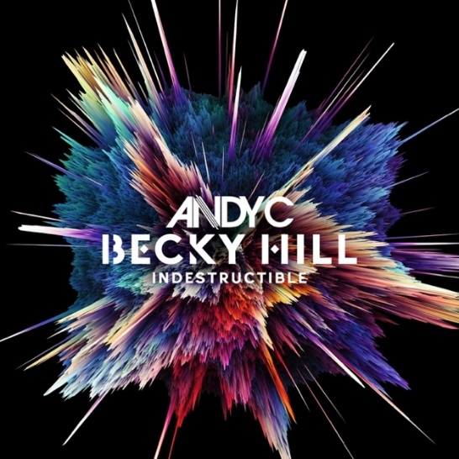

Follow Becky Hill:
Spotify | Apple Music | YouTube | TikTok | Instagram | Facebook |X | Website

For more info contact warren@chuffmedia.com

