AMAZON MUSIC SOUNDTRACKS THE HOLIDAY SEASON WITH NEW AMAZON ORIGINAL SONGS FROM SAM RYDER, JORJA SMITH AND ANNE-MARIE
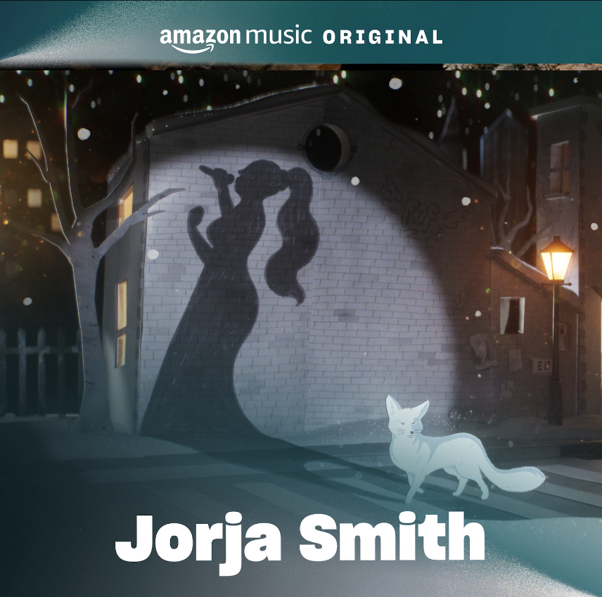

DOWNLOAD ASSETS HERE

Sam Ryder and Anne-Marie’s Amazon Original songs will feature in the new Prime Video Original film Your Christmas Or Mine 2

Fans can head to Amazon Music to listen to the full slate of holiday songs and curated Christmas playlists today

7th November 2023: Amazon Music today announce the release of three brand new Amazon Original tracks from Sam Ryder, Jorja Smith and Anne-Marie to help kick start the festive season, available exclusively on Amazon Music.

Two brand-new festive songs are set to make the holiday season brighter. "You're Christmas To Me" by Sam Ryder, BRIT Nominee and the most successful British breakthrough artist of 2022 and "Christmas Without You" by Anne-Marie, 10-time BRIT Award Nominee and pop sensation. Both tracks will be featured in Prime Video's heartwarming Original comedy film, Your Christmas Or Mine 2. Additionally, BRIT Award winner Jorja Smith has also created a stunning, reimagined Amazon Original cover of East 17’s classic, “Stay Another Day”. Listen to all tracks exclusively on Amazon Music here.

Your Christmas Or Mine 2 will premiere on Prime Video worldwide on 8th December.

The tracks from Sam Ryder and Jorja Smith will also be supported by music videos which will be launching in the run-up to Christmas. The videos will be available to watch in December.

The new Amazon Music Original songs are the latest releases to join a growing list of holiday tunes released exclusively on Amazon Music including tracks from influential stars like Taylor Swift, Katy Perry, Justin Bieber, John Legend, Camila Cabello, Carrie Underwood and H.E.R. Many have become holiday favourites like Katy Perry’s “Cozy Little Christmas,” which is certified platinum, while John Legend’s “Happy X Mas (War Is Over)” is certified gold, and tracks from artists like Kane Brown, Lauren Spencer, and Ellie Goulding topped the Billboard and UK Singles charts for consecutive weeks.

In addition to new holiday songs, Amazon Music listeners can explore hundreds of festive playlists and stations across artists and decades, including “Christmas Present”, “Christmas Past”, “Christmas for Kids” and the all-encompassing “Christmas Music” station. “Fluent Holidays” is a new playlist, featuring Spanish and bilingual holiday tunes from artists including Reik, Sebastián Yatra, Camila Cabello, Katy Perry, and Sech.

Sam Ryder said, “Imagine blasting through the sky on a runaway sleigh with a skin full of mulled wine next to the big red guy…That’s my Christmas song.”

Joja Smith comments, "I had a lot of fun putting my own unique spin on this timeless Christmas classic… Hope you all enjoy it!”

Anne Marie adds, "'Christmas Without You' holds a special place in my heart, and I'm thrilled to share my Amazon Original version with the world. This song is a reminder that the most precious gift during Christmas is the presence of loved ones."

For more information please contact warren@chuffmedia.com on 07762 130510

