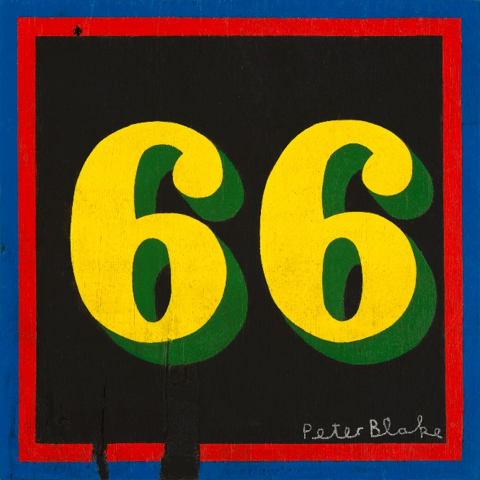

PAUL WELLER
New album “66”

Front cover artwork by Sir Peter Blake
Released May 24th on Polydor Records

In the ever-evolving landscape of contemporary music, few artists possess the enduring influence and innovative spirit of Paul Weller. A recording career that began in 1977 now takes in the release of his 17th solo album and his 28th in total.

Weller has always demonstrated an unwavering commitment to pushing artistic boundaries while staying true to his roots. "66" promises to be no exception, offering a captivating journey through his continuing musical evolution.

As the title and artwork by Sir Peter Blake (his first for Weller since 1995’s Stanley Road) indicates, Paul Weller’s new album marks the completion of his 66th journey around the sun and is released on May 24th – the day before his 66th birthday.

“66” is quite a reflective and inward thinking album that pulls back the camera lens and shines a light on the way Weller’s creativity interacts with his wider world.
Continually finding new ways to alchemise the miracle of living and the meaning of it all, he draws on fragments of real life, ruminations on spirituality and even childhood memories. There are songs touching on faith, changing circumstances and the fractured realities of life in this turbulent age . But ”66” is positive at heart, bursting with the wisdom and perspective accrued by the business of someone who has really lived and loved

The 12 songs on “66” were worked up in Weller’s Black Barn studio over the course of three years with a host of guest musicians. In the recent past, Paul has been an enthusiastic collaborator, but “66” feels like the most fully-realised celebration of that process. Here, there are lyrical contributions from an esteemed roll-call including Suggs, Noel Gallagher and Bobby Gillespie (“Ship Of Fools”, “Jumble Queen” and “Soul Wondering” respectively). “66” also sees the co-writing return of Erland Cooper and duo White Label, and string arrangements from Hannah Peel. Additionally, there are two collaborations with French producer and recording artist Christophe Vaillant (Le Superhomard, while acclaimed Brooklyn trio Say She She add vocals to “In Full Flight”. Peppered throughout the album are turns from an array of old friends including Dr Robert, Richard Hawley, Steve Brooks and Max Beesley.

As a taster, the first track to be released from “66” is the chunky percussive groove of “Soul Wondering” which will be available on all digital platforms on February 23rd.

April 5th will see the first single proper to emerge from the record. “Rise Up Singing” is a perfect microcosm of what awaits new and old fans alike: a sustained sunburst of soul and spirituality.

"66" is set to be a landmark addition to Paul Weller's illustrious discography, further solidifying his status as one of the defining artists of his or any other generation.

The album will be available on all major streaming platforms, CD, and vinyl (formats here_

“66” Track-listing:

Ship of Fools
Flying Fish
Jumble Queen
Nothing
My Best Friend’s Coat
Rise Up Singing
I Woke Up
A Glimpse of You
Sleepy Hollow
In Full Flight
Soul Wandering
Burn Out

Produced by Paul Weller
Except:
My Best Friend’s Coat / A Glimpse of You – produced by Christophe Vaillant
In Full Flight – produced by Weller / White Label
Burn Out – produced by Weller / Charles Rees

Paul and his band will be touring the UK with following shows. Supports TBA

April 2024
04 – POOLE Lighthouse
05 – BRISTOL Beacon
06 – NEWPORT ICC Wales
08 – SOUTHEND Cliffs Pavilion
09 – LEICESTER De Montfort Hall
11 – SHEFFIELD City Hall
12 – STOKE Victoria Hall
13 – STOCKTON Globe Theatre
15 – DUNFERMLINE Alhambra
16 – BLACKBURN King George’s Hall
17 – YORK Barbican
19 – LINCOLN Engine Shed
20 – AYLESBURY Waterside
21 – CAMBRIDGE Corn Exchange

www.paulweller.com

For more info please contact Warren@chuffmedia.com on 07762 130510

