JAX JONES ANNOUNCES MAJOR UK LIVE TOUR FOR 2022

NEW SINGLE ‘OUT OUT’ WITH JOEL CORRY FEATURING CHARLIE XCX AND SAWEETIE OUT NOW – LISTEN HERE.
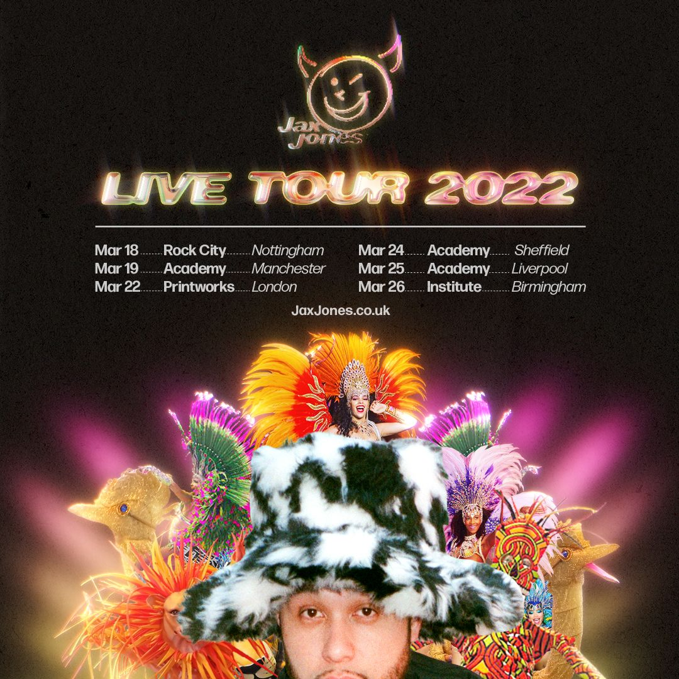

Ivor Novello, BRIT and Grammy nominated producer, DJ and UK House mainstay Jax Jones announces his major UK live tour. The UK house-pop connoisseur is back, having recently hit No. 6 in the UK charts alongside Joel Corry with Tik Tok dancefloor sensation ‘Out Out’ featuring Charlie XCX and Saweetie. The south-London raised DJ embarks on an immersive 6 date tour in March, kicking off in Nottingham’s Rock City and continuing onto major UK venues. Go grab your tickets now! http://gigst.rs/JaxJones

This will be Jax’s first major UK tour since his May announcement of a new music era via an open letter to fans on social media. Following this was the artist’s most prolific project to date in the form of a 4 track EP “Deep Joy”, released on his new record label WUGD, and designed to make people feel a sense of escapism, hope and freedom. Jax’s ambition for WUGD is to honour and empower grassroot talent and is in collaboration with his long-term manager Dan Stacey of Loving Alliance, and Polydor Records. This live tour aims to bring Jax’s most recent creations to life post-pandemic alongside his established hits, breaking out from the status-quo and delivering fans a more revolutionary experience than ever. Both the tour and Jax’s creation of WUGD represents an extension of Jax’s creative abilities as his multi-genre versatility becomes increasingly evident.

Jax has had a diverse journey into the industry, initially having produced beats for the early 2000’s garage and grime scene uprising, and working with North-West London’s finest, N-Dubz. A standout in the artist’s discography comes in the form of his ‘Snacks’ album, named the best-selling dance album of 2019. Jax’s infectious humour and knack for creative collaborations has resulted in him staying within the ears of UK house, amassing over three million single sales and 4 billion streams. But Jax explained how the last year has forced him to slow down, face past demons and seen him become a father, and this tour represents Jax’s refreshing new chapter in his sonic journey.

Jax on the tour: “Yo my gs’. In 2022 I'm bringing back the Jax Jones live experience to cities all round the UK. We’ve created some amazing memories so far but I'm working even harder to go next level on these shows so we can make more standout nights for us. You can expect all the bangers in ways you’ve never heard, unreleased stuff and of course next level production!!! I can’t wait to see you all there, all I ask is that you bring max energy and posi vibes! Lets go xxx”

With years of experience under his musical belt, having worked with UK legends from a plethora of genres including grime, garage and even indie, Jax’s musical influence is vast, boasting commendable collaborations including Duke Dumont, Raye, Years and Years and MNEK.

General sale tickets are available on Friday 10 September 2021 - 10:00 BST via www.gigsandtours.com.

Tour Dates:
Fri 18 Mar 2022 Nottingham Rock City
Sat 19 Mar 2022 Manchester Academy
Tue 22 Mar 2022 London Printworks
Thu 24 Mar 2022 Sheffield O2 Academy
Fri 25 Mar 2022 Liverpool O2 Academy
Sat 26 Mar 2022 Birmingham O2 Institute

FB / TWITTER / INSTAGRAM / YOUTUBE / WEBSITE

Find Jax Jones on gigsandtours.com here: http://gigst.rs/JaxJones

For more information & media enquiries contact jenny@chuffmedia.com

