The Birmingham Stage Company presents

HORRIBLE HISTORIES - LIVE ON STAGE

HORRIBLE CHRISTMAS

AT LONDON’S ALEXANDRA PALACE THEATRE
12TH DECEMBER 2024 TO 4TH JANUARY 2025

Press performances: Saturday 14th & Sunday 15th December at 2.30pm

The story of how Christmas came to be what it is today - in Horrible Histories style!

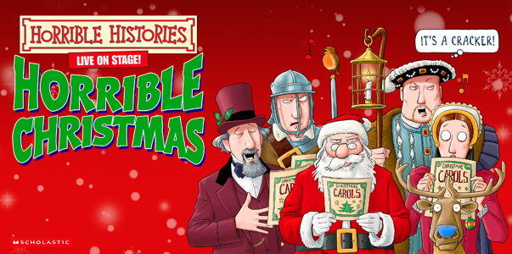

MEDIA ASSETS HERE

Bring the whole family to enjoy this festive adventure as Horrible Histories presents the terrific tale of Christmas. It's a celebration in the most wonderful, funny and moving way you'll ever see!

‘A flash, bang, wallop of a production!’ British Theatre Guide
‘That rare gem of a family show that genuinely appeals to all ages from four years old upwards. If you think you know about Christmas, this show will make you think again!’ Manchester Theatre Awards

TEN HORRIBLE FACTS ABOUT CHRISTMAS

- William the Conqueror was crowned on Christmas Day but when the guards outside heard a huge cheer they thought a rebellion had started and burnt all the houses in the area.
- In Greenland they eat a Christmas delicacy called Kiviak which is the body of a seal filled with hundreds of small birds left to ferment for three months.
- In 1644 the Puritans banned Christmas, mince pies and going to church (unless it was a Sunday) and ordered all shops to stay open.
- In a town in Sweden the people celebrate Christmas by burning down a giant figure of a goat.
- The reason that carol singers knock on your door and pester you is because Medieval priests threw them out of the church, so ever since they sing outside houses instead.
- An old English custom was to beat children on 28 December to remind them of Herod’s cruelty in massacring all the babies in Bethlehem.
- Nativity scenes in Catalonia feature a character doing a poo.
- The Good King Wenceslas celebrated in the carol was a duke not a king and was chopped into pieces by his mother and brother.
- The first ever bomb to land on British soil was dropped by a German airship at Christmas 1914.
- Brussels sprouts are first mentioned in books in 1587 and children have had to suffer them at Christmas ever since.

VENUE & DATES

Alexandra Palace Theatre
Alexandra Palace Way
London
N22 7AY

DATE DOORS START END
12 DEC 2024 18:00 19:00 21:00
13 DEC 2024 18:00 19:00 21:00
14 DEC 2024 13:30 14:30 16:30 *PRESS PERFORMANCE
14 DEC 2024 18:00 19:00 21:00
15 DEC 2024 13:30 14:30 16:30 *PRESS PERFORMANCE
15 DEC 2024 18:00 19:00 21:00
18 DEC 2024 18:00 19:00 21:00
19 DEC 2024 18:00 19:00 21:00
20 DEC 2024 18:00 19:00 21:00
21 DEC 2024 13:30 14:30 16:30
21 DEC 2024 18:00 19:00 21:00
22 DEC 2024 13:30 14:30 16:30
22 DEC 2024 18:00 19:00 21:00
23 DEC 2024 13:30 14:30 18:30
23 DEC 2024 18:00 19:00 21:00
24 DEC 2024 10:30 11:30 13:30
24 DEC 2024 13:30 14:30 16:30
27 DEC 2024 13:30 14:30 16:30
27 DEC 2024 18:00 19:00 21:00
28 DEC 2024 13:30 14:30 16:30
28 DEC 2024 18:00 19:00 21:00
29 DEC 2024 13:30 14:30 16:30
29 DEC 2024 18:00 19:00 21:00
30 DEC 2024 13:30 14:30 16:30
30 DEC 2024 18:00 19:00 21:00
1 JAN 2025 13:30 14:30 16:30
1 JAN 2025 18:00 19:00 21:00
2 JAN 2025 13:30 14:30 16:30
2 JAN 2025 18:00 19:00 21:00
3 JAN 2025 13:30 14:30 16:30
3 JAN 2025 18:00 19:00 21:00
4 JAN 2025 13:30 14:30 16:30
4 JAN 2025 18:00 19:00 21:00

For all media enquiries please contact warren@chuffmedia.com 07762 130510

