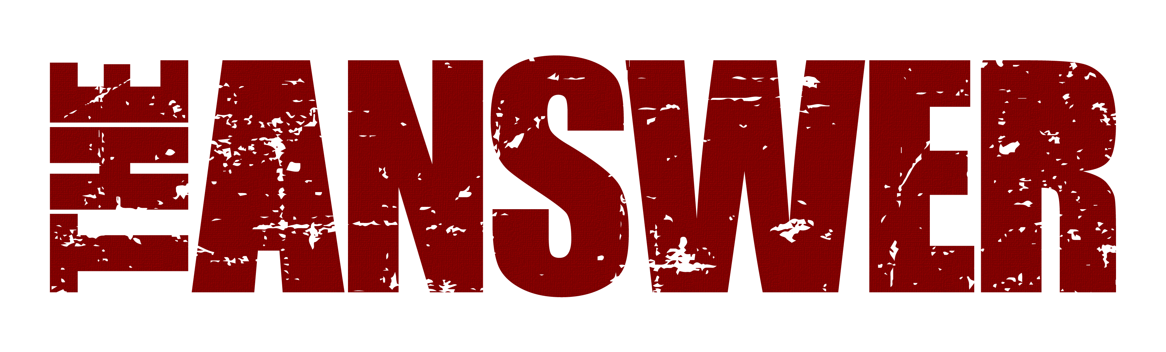
BRAND NEW SINGLE “WILD HEART” IN SUPPORT OF NOV & DEC UK TOUR
NOV 17th 2023
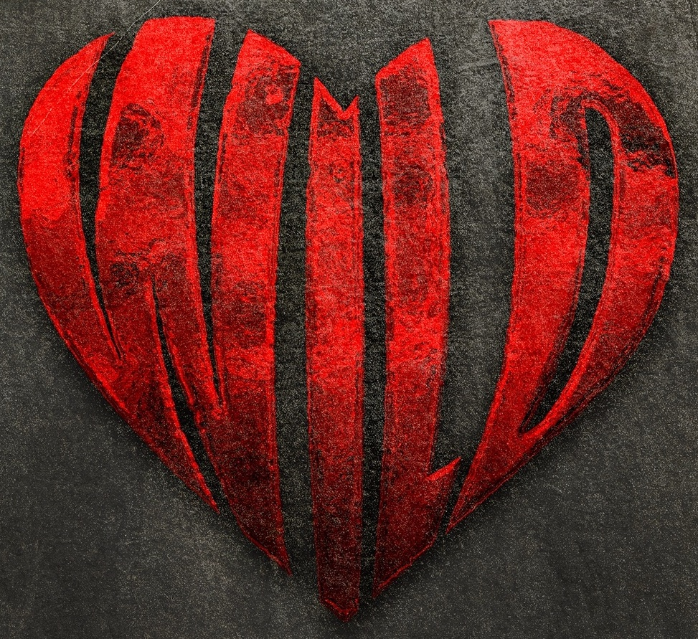
Pre Save Wild Heart Here
After a summer festival blitz including over 12 performances throughout the UK & Europe, The Answer recently managed to squeeze another recording session in at the end of the summer with producer Dan Weller to record a brand new single, titled “WILD HEART”.
Following in the vein of previous singles Blood Brother and Want You To Love Me, this killer new track is a dirty, grotesquely awesome hypnotic rock groove that just oozes confidence and class, showcasing a band that are in a great new creative trajectory.
Says frontman Cormac Neeson “We had a fabulous time this summer playing some great festivals and at the end of August we just decided to charge back into the studio to see if we could capture the same vibe as our Sundowners session. It’s been so liberating just going headlong, no holds barred, into the studio knowing that we have tons of material to fall back on, and this is another of those tracks. We’ve introduced a bit more of a keyboard flavour into our recent material and are thrilled to say that we’ll be bringing [enter name] out on the road in November & December as our live session keyboardist! The set list is going to be something very different to the last tour so we can’t wait to dip into more of the catalogue as well as some of the Sundowners album which we have yet to play live – we can’t wait!!”
Following the success of their recently released and highly acclaimed Sundowners album, The Answer are looking forward to these upcoming 5 new UK dates in November and December with support from special guests Kira Mac. Manchester, London, Wolverhampton, Glasgow and Belfast will get to see the band perform their latest stunning new show, peppered with hits and loads of previously unheard live versions from the much-heralded new record.
“Challenging the boundaries of rock music, a ballsy mammoth 8 tracks from the new album peppered with some of their hits, everything about their comeback feels a little more deliberate, a reminder of how powerful this bands live performance can be” (Moshville Times, Mar ‘23)
“This show is fresh – good time positive feel, unapologetic rock ‘n’ roll (Rock ‘N’ Load Magazine, Mar ‘23)
“An evening of pure rock fury that no-one will forget anytime soon” (The Razors Edge, March ‘23).
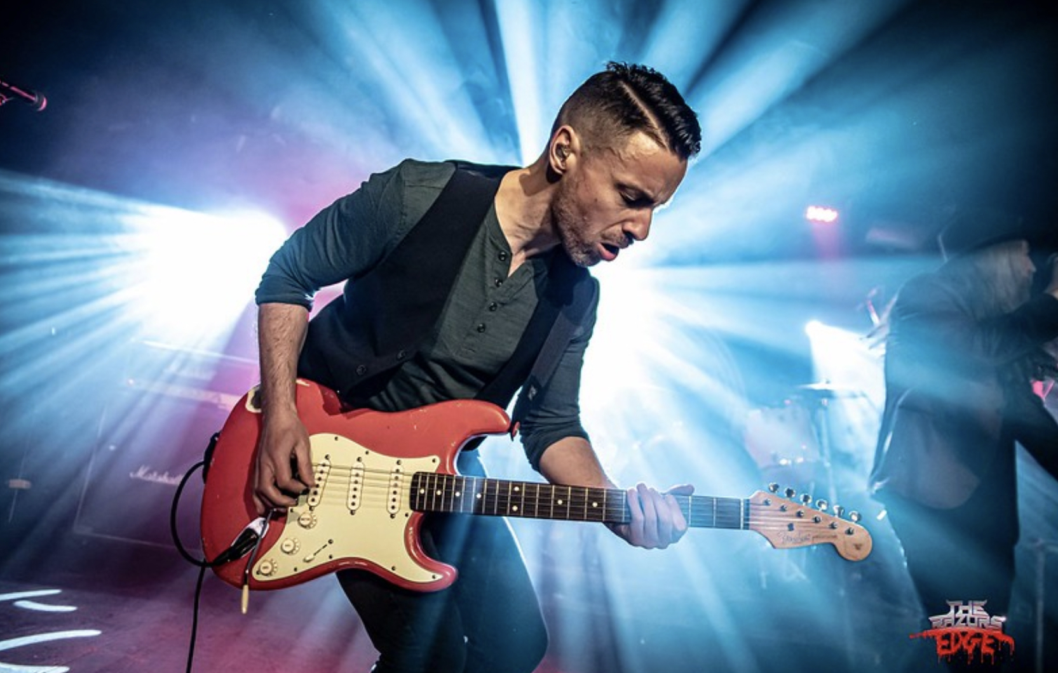

Sundowners was released on March 17th and achieved top 40 album chart positions in UK, Germany and Switzerland including number 1 in the UK national rock album chart. Produced by rising British producer Dan Weller, the album has received rave reviews across the board.

“A serious challenger for album of the year” (Get Ready To Rock) *****

“Don’t accept imitations, The Answer are truly showing everybody how this s**t is done. The kind of album truly great bands make” (Blabbermouth) ****

“This album is the sound of a band with nothing to prove to themselves or anyone else. They slot so neatly alongside the blues-rock giants that came before them.” (Classic Rock Magazine UK) ****

Tickets ON SALE NOW!

UK TOUR DATES
Nov 15th Manchester Academy 2
Nov 16th London Islington Assembly Hall
Nov 17th Wolverhampton KK’s Steel Mill
Nov 18th Glasgow King Tuts
Dec 9th Belfast Limelight 1 (www.ticketmaster.ie)

All UK shows.
http://www.myticket.co.uk/artists/the-answer

Tickets on www.theanswerrock.com

Spotify: http://open.spotify.com/album/5c90Qv0wkAfHFu243e7qxX
Apple: https://music.apple.com/us/album/blood-brother/1640395077?ls=1
Deezer: www.deezer.com/album/347612407

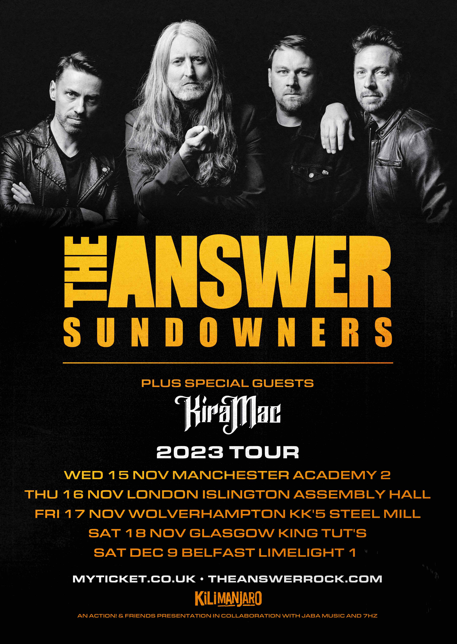

https://www.theanswerrock.com
https://www.facebook.com/theanswerrock
https://twitter.com/theanswerrocks
https://www.instagram.com/theanswerrock/?hl=en
https://open.spotify.com/artist/3STTKsLP1gSzGvOVCtNlWS?si=SYnSAgPTS3-Ji4AQvJbz4w

For more info contact warren@chuffmedia.com

